|  |  |
| --- | --- |
|  | **FPT ACADEMY INTERNATIONAL**  **FPT – APTECH COMPUTER EDUCATION** |

**Centre Name: ACE-HCMC-2-FPT.**

**Address: 590 Cach Mang Thang 8, District 3, Ho Chi Minh City, Viet Nam.**

**ITM College**

|  |  |  |
| --- | --- | --- |
| **Supervisor:** | MR. TRAN PHUOC SINH | |
| **Semester:** | 3 | |
| **Batch No:** | T1.1708.A0 | |
| **Group No:** | 4 | |
| **Order:** | **Full name** | **Roll No.** |
| 1. | HAC NGOC LINH | Student1060398 |
| 2. | TRAN HA HUNG | Student1055556 |
| 3. | VUONG BA PHI | Student1059708 |
| 4. | THACH BAO TOAN | Student1059707 |

October 2018

**Table of Contents:**

This is to certify that

Mr. Hac Ngoc Linh

Mr. Tran Ha Hung

Mr. Vuong Ba Phi

Mr. Thach Bao Toan



have successfully designed and

developed 

Submitted by:

Date of Issue: ________

Authorized Signature: ___________



**REVIEW I 5**

**Acknowledgment 6**

**Problem Definition 7**

1. Introduction 7
2. Project Requirement 7
3. Project Designing 7
4. Functional Logic 9

**Task sheet review 1 12**

**REVIEW II 13**

1. Architecture & Design of the Project 14
2. Algorithms - Data Flowchart 16
   1. Main data flow for guest 16
   2. Login Function (Admin only) 18
   3. Logout Function (Admin only) 19
   4. Insert Data Function (Admin only) 20
   5. Update Data Function (Admin only) 21
   6. Delete Data Function (Admin only) 22
   7. Admission Function (Student only) 23
   8. Confirmed Admission (Admin only) 24
   9. Registration Function (Student only) 25
3. Data Flow Diagram 26
   1. Context Diagram 27
   2. Level 0 DFD 28
   3. Level 1 DFD 29
4. Use Case Diagram 33
   1. Administrator Use Case 34
   2. Staff Use Case 35
   3. Guest Use Case 35
5. Entity–Relationship Design 36
   1. Entity–Relationship Diagram 36
   2. Entities and Properties 37

**Task sheet review 2 44**

**REVIEW III 45**

1. Database Design 46
   1. Database Design Diagram 46
   2. Database Structure 47
2. GUI Design – Front-end 55
   1. Home page 55
   2. Courses 58
   3. Admission 59
   4. Department 63
   5. Faculty 64
   6. Facilities 65
   7. Registration 66
   8. Contact/Feedback 69
   9. Admin login 71
3. GUI Design – Back-end 75
   1. Department management 75
   2. Faculty management 86
   3. Facility management 92
   4. Course management 98
   5. Event management 104
   6. Achievement management 110
   7. Branch management 116
   8. Admission management 122
   9. Admin management 125

**Task Sheet Review III 128**

**REVIEW I**

**Acknowledgment**

We would like to acknowledge all those who have given support and help us make the project a success.

We wish to express our deep gratitude to all teachers who have been devoting their lives to teach us how to stand-alone and walk ahead.

We are grateful to our families who take care and encourage us even though we are successful or failed, also to our friends who are always care of us. They never leave us alone and always look forward to us when we are on any road of the life.

We are much thankful to the entire staff and chairpersons at the Head Office of Aptech Worldwide, Aptech – Vietnam, and FPT – Aptech Center who have been organizing and looking after our studying course.

There are no words to show our appreciation for teachers of FPT Aptech Centre who have been organizing and looking after us during our studying course to finish this project. Our special thanks Mr Tran Phuoc Sinh who works day by day to teach and guide us, e-Project Team at the Head Office who instruct and help us.

Finally, we would like to offer many thanks to all our schoolfellows for their valuable suggestions.

We would like to thank sincerely!

**Problem Definition**

1. **Introduction**

As of today world all the manual paper work like accounting, maintaining records are computerized. Even the college and school admission, result declaration is performed online today. Due to which all the school and colleges felt the need of making the website of their organization. The main purpose of making website is to attract the masses and advertisement of the school, colleges, and their achievements to the people leaving in any area (near or remote). The **ITM** College wants the website of the college to be developed and they have approached you for the same.

1. **Project Requirement**

The College had provided all the content details they want to add in the website. The details of the information and what link the Home page must contain? Name of the links required in the website for navigation. There should be section in the Home Page for Upcoming events in the college, Achievements, New course, Merit list. The Link like **HOME, COURSES, STUDENT REGISTRATION, DEPARTMENTS, FACULTY, FACILITIES, ONLINE ADMISSION, CONTACT US, FEEDBACK, ADMIN LOGIN**.

1. **Project Designing**

**HOME PAGE:** Here there should be an introduction of the college with hyperlink at the top (for navigation) and various sections to highlight the important features of the college. There should be separate section for the Admin Login (where the details of website can be modified and updated).

**COURSES:** Here the details of all the courses must be stated which are available in the college.

**ADMISSION:** Here there will admission form for the students. All the admission form related to the particular subject must be there. Students can download the form or can also fill the form online and submit. Once the online form is submitted then the student will get a unique registration number and this number must be used to check the admission status. If the student status is accepted then they can proceed the online submission *by clicking proceed* button or link and complete the further details like selection of subjects.

**DEPARTMENTS:** Here the details of the entire department must be added (like chemistry, French, Economics, Psychology, Geology and Mathematics).

**FACULTY:** Here it should state the details of the entire faculty (should be categorized according to their departments).

**FACILITIES:** Like what all Facilities are provided in the college such as college canteen, hostel, placement center, gymkhana, college library, administrator office)

**STUDENT REGISTRATION:** here the student can register themselves with the help of their ID (unique) so that they can get the updates of their colleges, assignments, exam time table. If the same student tries to register again with the same ID then an error message must be thrown.

**CONTACT US:** It should state the contact details of the college (must cover all the branches).

**FEEDBACK FORM:** Here the feedback is taken from the end user.

**ADMIN LOGIN:** There should be separate section for login. The admin person will be able to update the data of the website.

1. **Functional Logic**

**ADMISSION PROCEDURE:**

* The Admin will have the responsibilities of checking which student is eligible for the admission.
* When an Online admission form is filling by the student they will provide all the details of the previous education. In the first level of form filling the student is supposed to provide personal details like:
  + Name
  + Father Name
  + Mother Name
  + Date of Birth (as per the certificate)
  + Gender
  + Residential Address
  + Permanent Address
  + Admission for (selecting a stream, field)
  + In tabular format (details of previous exam)
    - University
    - Enrollment number
    - Center
    - Stream
    - Field
    - Marks secured
    - Out of
    - Class Obtained
  + Sports details (if any)
  + Submit (for submitting the details)

Once the candidate click on the submit button a Unique number must be provided to them.

* With the help of the Unique ID they can check the status of the admission like whether waiting, accepted.
* Once the status is confirmed, they can provide further details like specialized subject, optional subject and finally can print the form for seeking admission in the college.

**Hardware / Software Requirements**

1. **Server Requirement**

* Hardware

|  |  |
| --- | --- |
| **Component** | **Requirement** |
| **CPU** | Processor type:  Pentium IV-compatible processor or faster  Processor speed:  Recommended: 2.0 GHz or faster |
| **OS** | Microsoft Windows Server 2012 with IIS |
| **Memory (RAM)** | RAM:  Minimum: 512 MB  Recommended: 2 GB or more |
| **Hard Drive** | Free space:  Minimum: 200 MB  Recommended: 50 GB or more  Maximum: Operating system maximum |

* Software

|  |  |
| --- | --- |
| **Component** | **Requirement** |
| **Microsoft .NET Framework** | Version 4.6 or higher |
| **RDBMS** | Microsoft SQL Server 2017 |

1. **Client Requirement**

* Hardware

|  |  |
| --- | --- |
| **Component** | **Requirement** |
| **CPU** | Processor type:  Pentium III-compatible processor or faster  Processor speed:  Recommended: 1.0 GHz or faster |
| **OS** | All OS (Window, Linux, Android, Mac OS …) |
| **Memory (RAM)** | RAM:  Minimum: 512 MB  Recommended: 1 GB or more  Maximum: Operating system maximum |
| **Hard Drive** | Free space:  Minimum: 10 MB |

* Software

|  |  |
| --- | --- |
| **Component** | **Requirement** |
| **Web Browser** | Chrome, Opera (up to date) |

**Task Sheet Review I**

|  |  |  |  |  |  |
| --- | --- | --- | --- | --- | --- |
| Project Ref. No: 4 | Project Title:  Railway Reservation Manage System | Date of Preparation of Activity Plan | | | |
| No. | Task | Actual Start Date | Actual Days | Team Member Names | Status |
| 01 | Acknowledgment | Oct 26, 2018 | 2 | All Members | Completed |
| 02 | Problem Definition | All Members | Completed |
| 03 | Customer Requirement | All Members | Completed |
| 05 | Hardware/Software | All Members | Completed |
| 06 | Task sheet | All Members | Completed |

|  |  |  |
| --- | --- | --- |
|  | Prepare By: Group 4 | Approved By: Faculty |
| Date: Oct 26, 2018 | Team Leader  Hac Ngoc Linh | Mr. Tran Phuoc Sinh |

**REVIEW II**

1. **Architecture & Design of the Project**

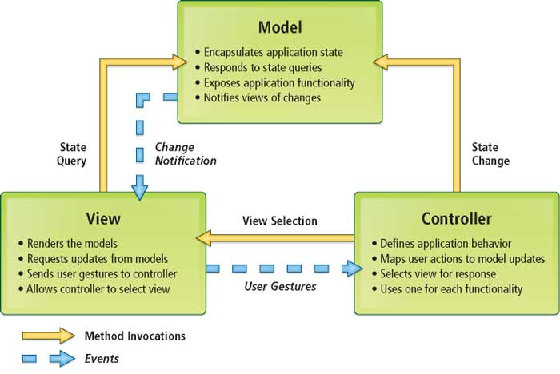

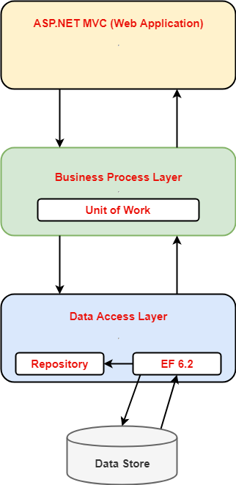

Architecture of the Project

## Presentation Tier:

Is the tier in which the users interact with application. Presentation Tier contents Model, View, Controller used to receive a request and response to User.

Technology: ASP.NET MVC5, Razor, HTML, CSS, JavaScript, Ajax, JQUERY, Twitter Bootstrap

## Business Logic Tier:

Is mainly working as the bridge between Data Tier and Presentation Tier. All the Data passes through the Business Tier before passing to the Presentation Tier.

Technology: ASP.NET

## Data Access Tier:

Is basically the server which stores all the application’s data .Data tier contents Database Tables, Database Views and other means of storing Application Data .

Technology: SQL Server, LINQ

1. **Algorithms - Data Flowchart**

Symbol generates:

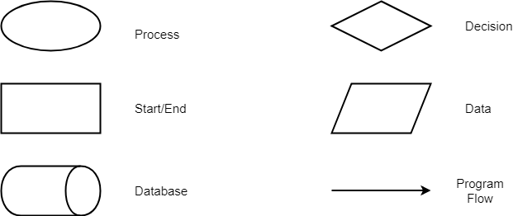

## Main data flow for guest

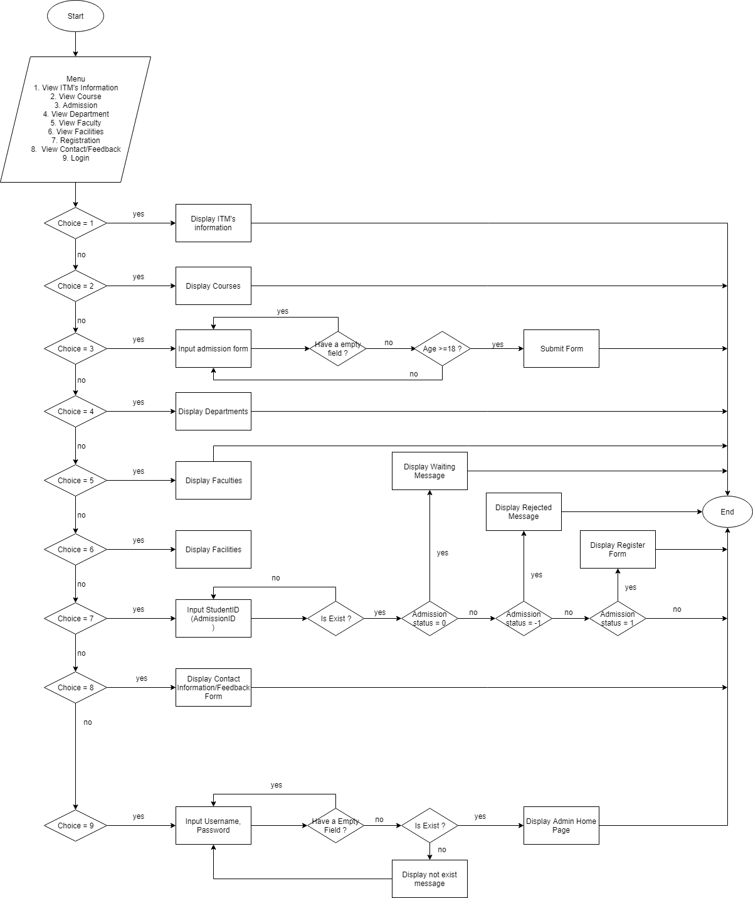

## Login Function (Admin only)

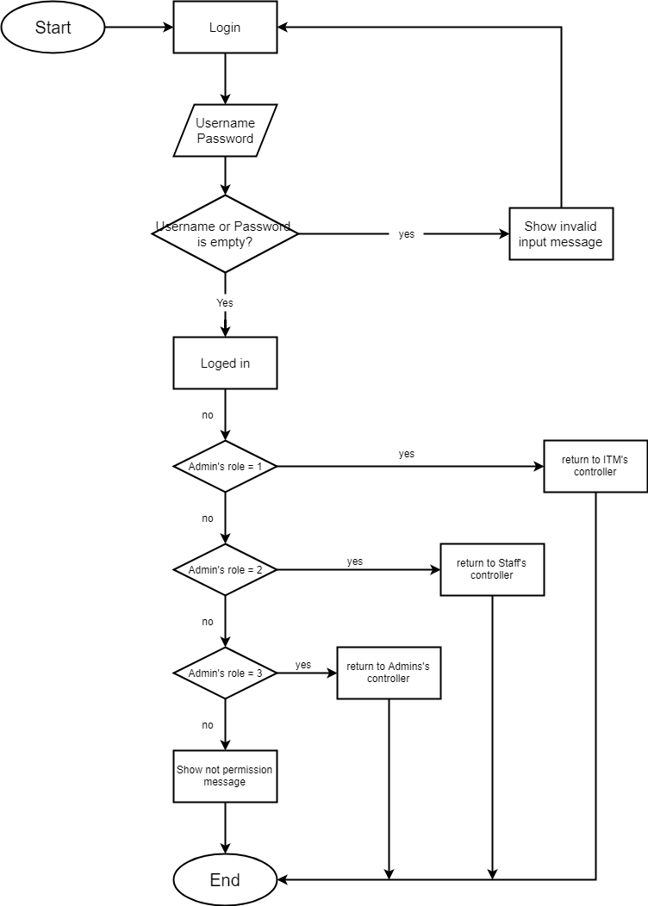

## Logout Function (Admin only)

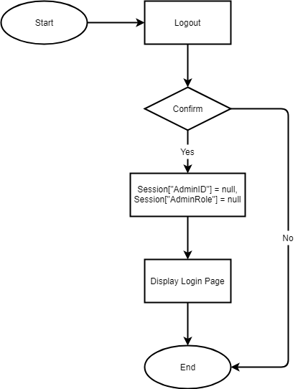

## Insert Data Function (Admin only)

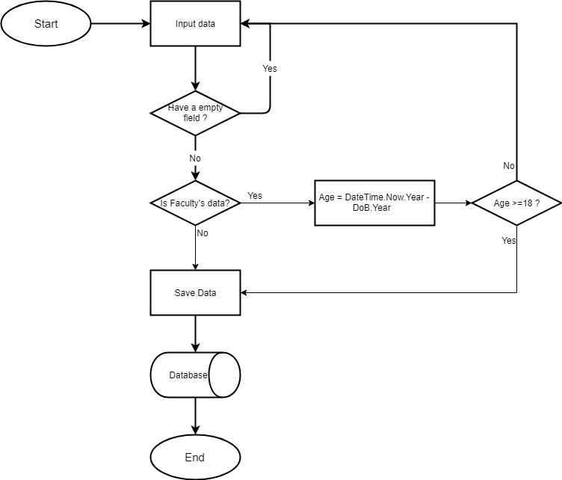

## Update Data Function (Admin only)

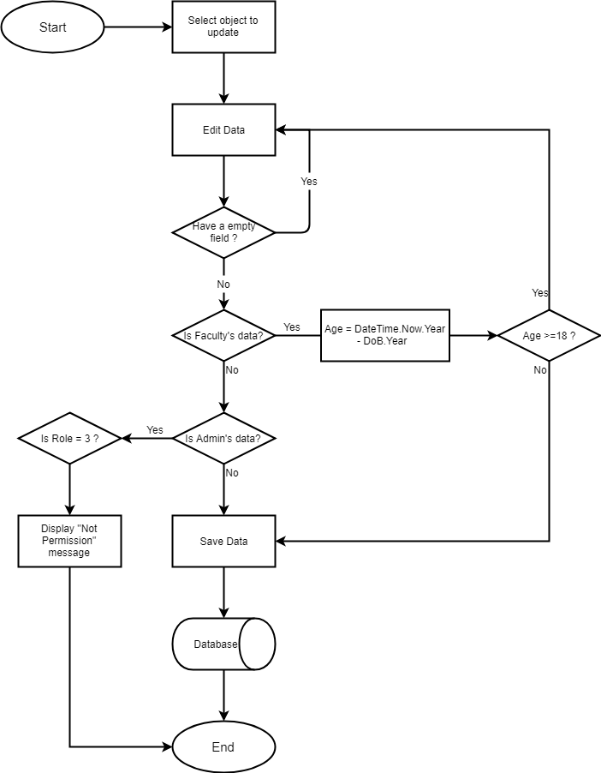

## Delete Data Function (Admin only)

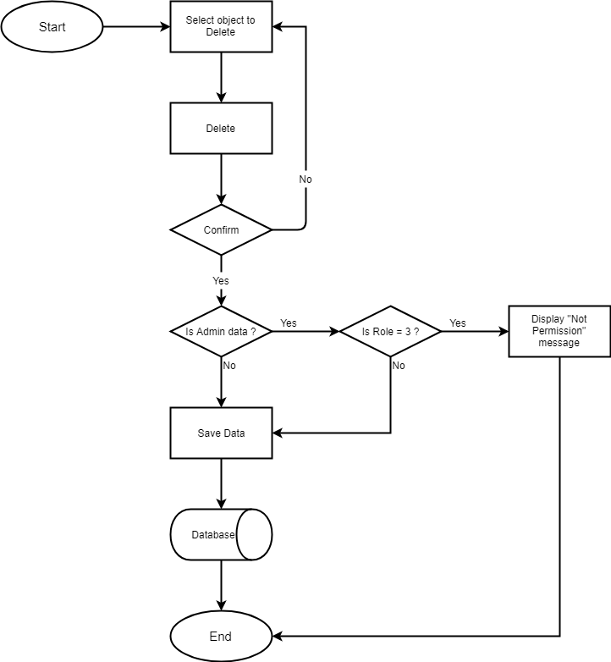

## Admission Function (Student only)

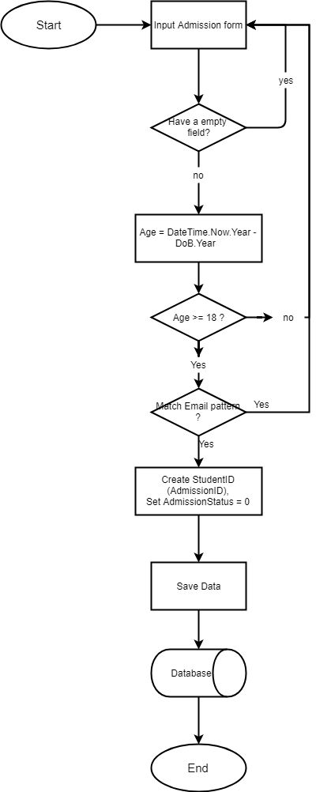

## Confirmed Admission (Admin only)

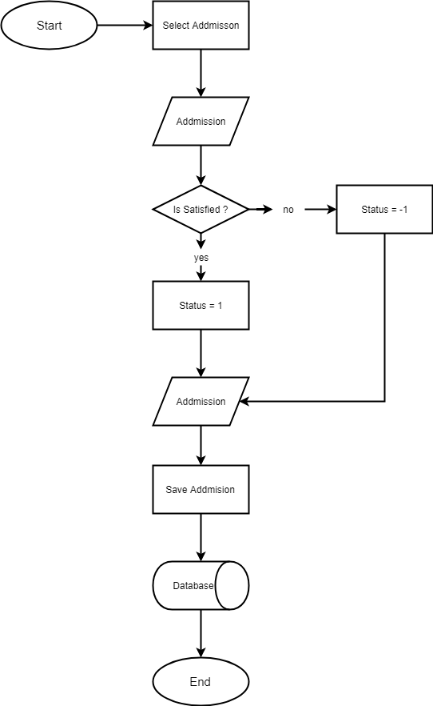

## Registration Function (Student only)

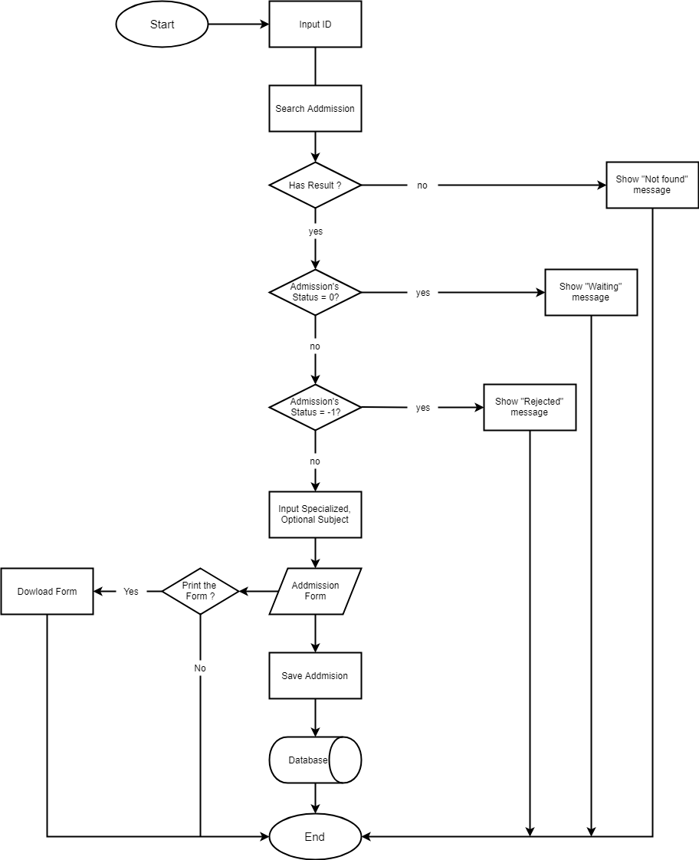

1. **Data Flow Diagram**

**Define:** Data Flows Diagram (DFD) describes the information flow in the system. The next step of system analysis is to consider in detail the information necessary for the implementation for functions discussed above and the one necessary for the improvement of the functions. Modelling tool frequently used for this purpose is DFD. DFD will support 4 main activities:

* **Analysis**: DFD is used to determine requirement of users.
* **Design:** DFD is used to map out plan and illustrate solution to analysis and users while designing a new system.
* **Communication:** One of the strength of DFD is its simplicity and ease to understand to analysts and users.
* **Document:** DFD is used to provide special description of requirement and system design. DFD provide an overview of key functional components of the system but it does not provide any detail on these components. We have to use other tools like database dictionary, process specification to get an idea of which information will be exchanged and how.

**The main components of Context Diagram:**

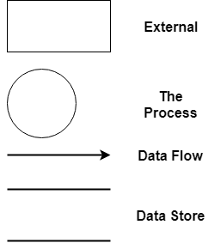

The external factors: External factors can be a person, a group of persons or an organization that are sources of information for the systems and are where system products are transferred to.

The process: Shows the common function of system

The data flow: Describe the movement of information from one part of the system to another.

The data store: The Data Store is used to model a collection of data packets at rest. A store is represented graphically by two parallel lines. The name of a Data Store that identifies the store is the plural of the name of the packets that are carried by flows into and out of the Data Store.

## Context Diagram:

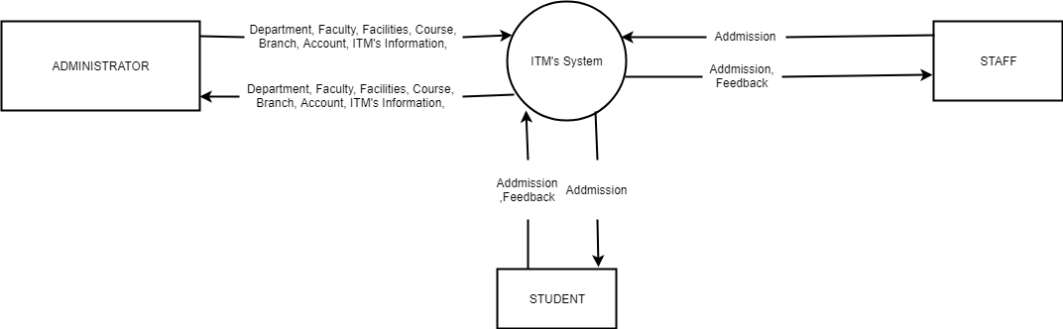

## Level 0 DFD

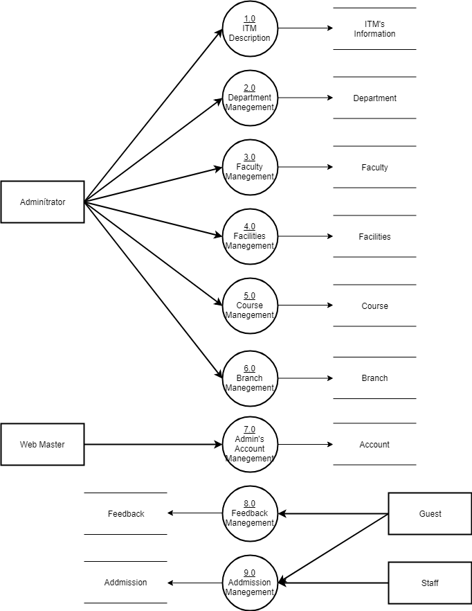

## Level 1 DFD

**3.1 ITM Description**

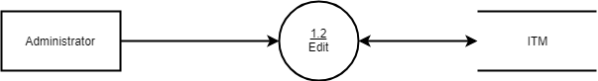

**3.2 Department Management**

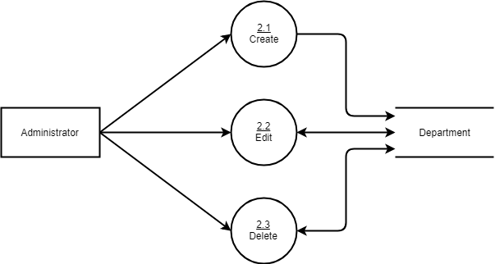

**3.3 Faculty Management**

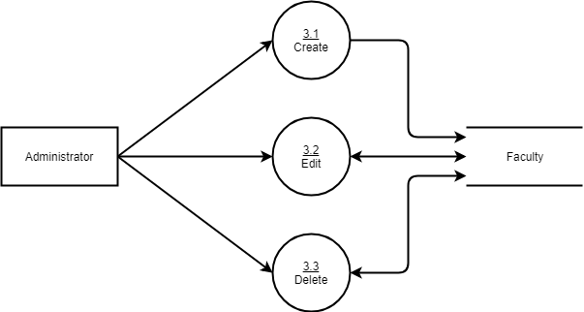

**3.4 Facilities Management**

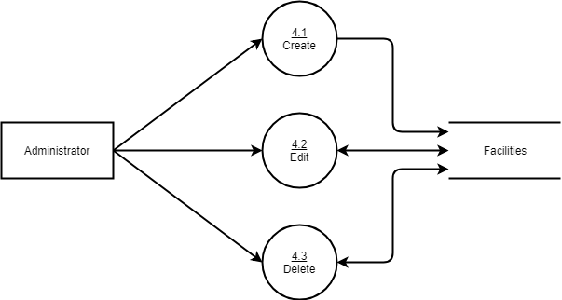

**3.5 Course Management**

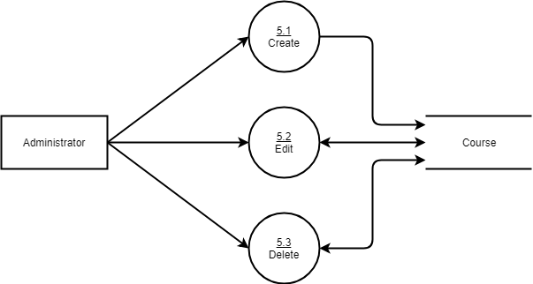

**3.6 Branch Management**

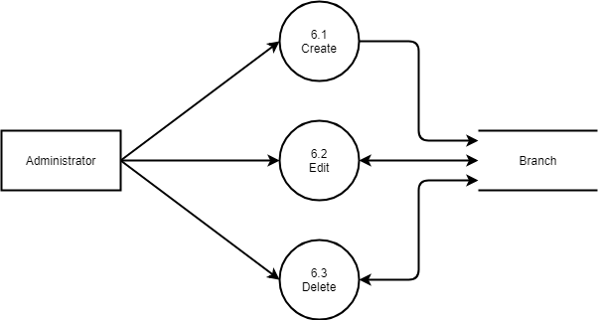

**3.7 Admin’s Account Management**

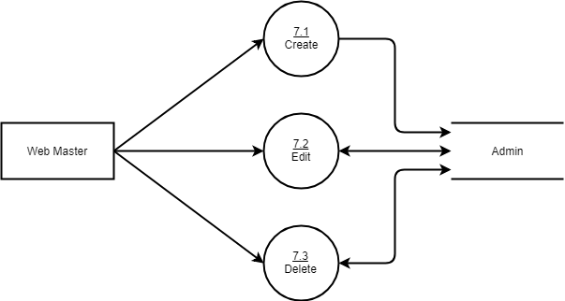

**3.8 Feedback Management**

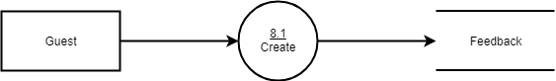

**3.9 Admission Management**

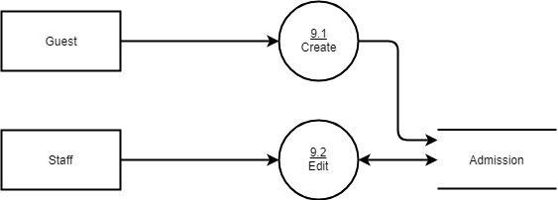

1. **Use Case Diagram**

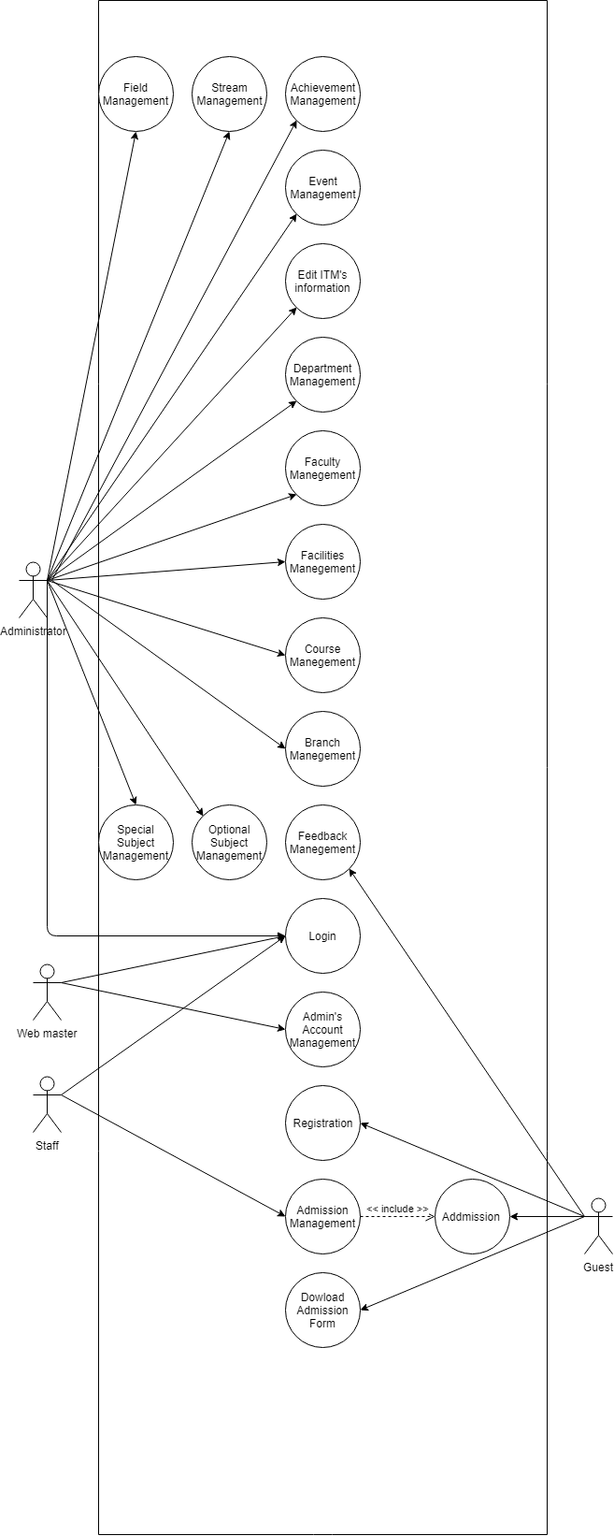

1. **Administrator Use Case**

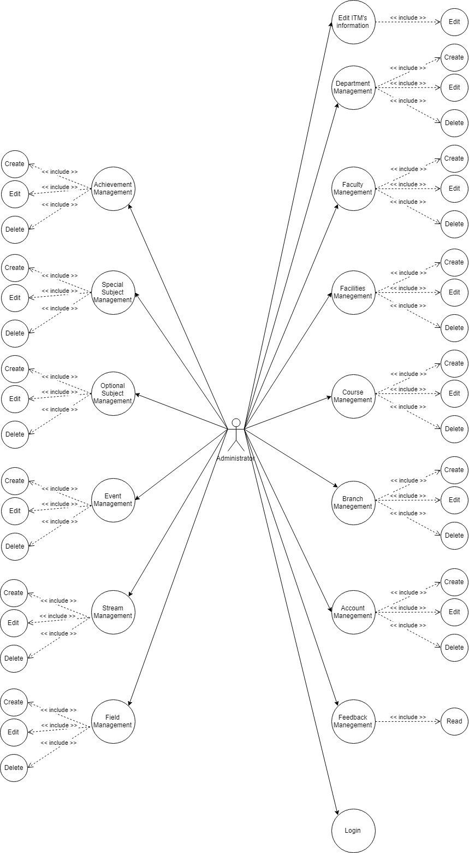

## Staff Use Case

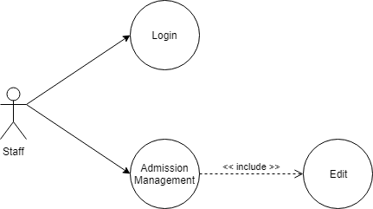

1. **Guest Use Case**

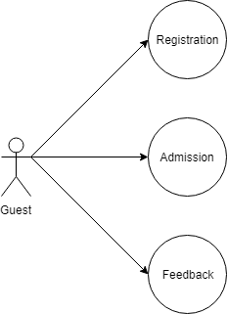

1. Entity–Relationship Design
2. **Entity–Relationship Diagram**

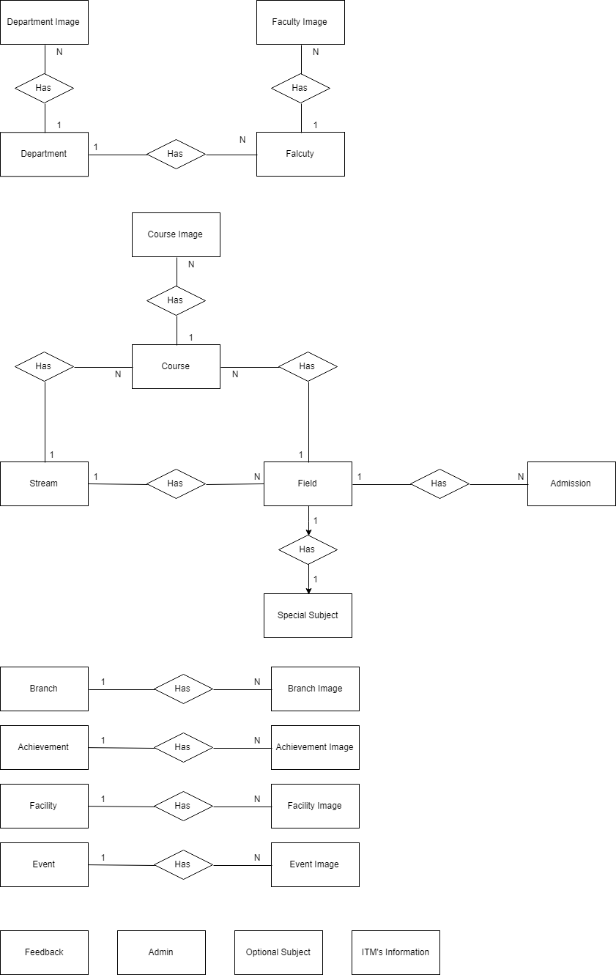

1. **Entities and Properties**

**2.1 Admission Entity & Properties**

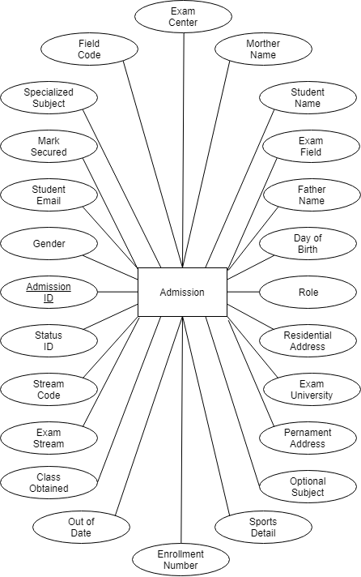

**2.2 Feedback Entity & Properties**

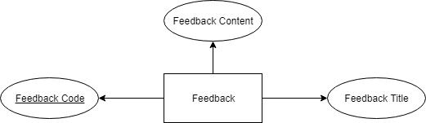

**2.3 Stream Entity & Properties**

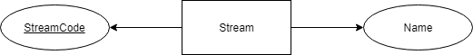

**2.4 Field Entity & Properties**

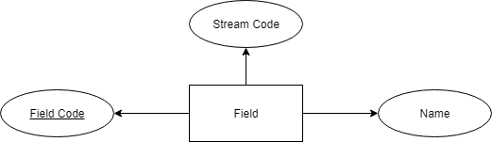

**2.5 ITM Information Entity & Properties**

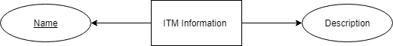

**2.6 Admin Entity & Properties**

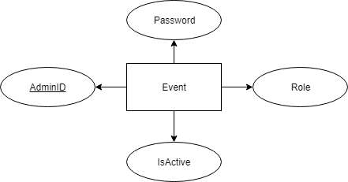

**2.7 Optional Subject Entity & Properties**

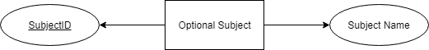

**2.8 Specialized Subject Entity & Properties**

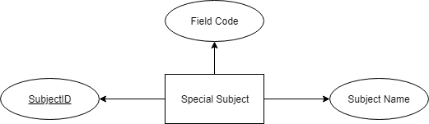

**2.9 Course Entity & Properties**

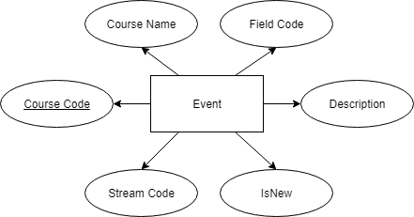

**2.10 Event Entity & Properties**

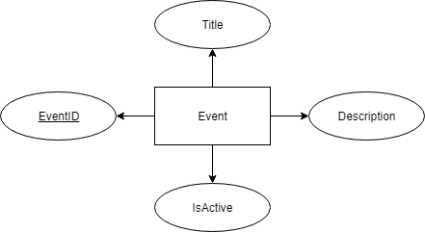

**2.11 Department Entity & Properties**

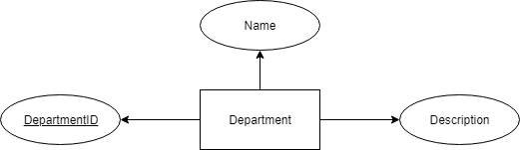

**2.12 Faculty Entity & Properties**

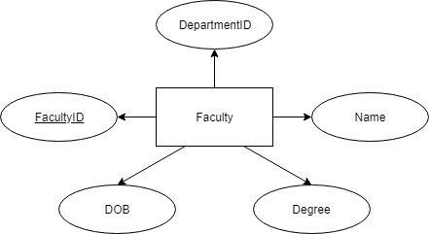

**2.13 Branch Entity & Properties**

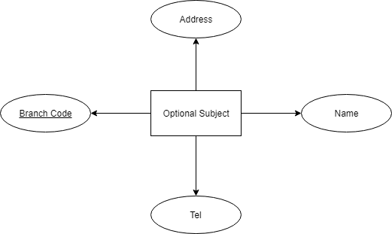

* 1. Achievement Entity & Properties

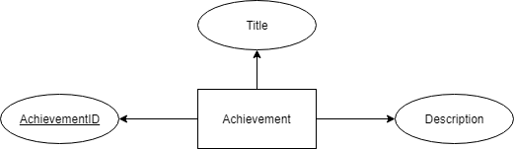

* 1. Facility Entity & Properties

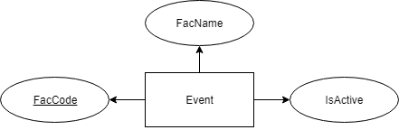

* 1. Image Entity & Properties

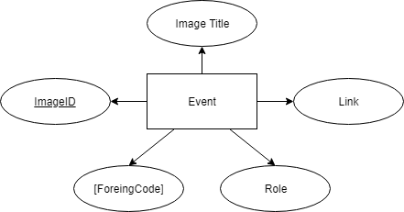

**Task sheet review 2**

|  |  |  |  |  |  |
| --- | --- | --- | --- | --- | --- |
| Project Ref. No: 4 | Project Title:  Railway Reservation Manage System | Date of Preparation of Activity Plan | | | |
| No. | Task | Actual Start Date | Actual Days | Team Member Name | Status |
| 01 | Architecture & Design of the Project | Oct 31, 2018 | 6 | All Members | Completed |
| 02 | Algorithms - Data Flowchart | Tran Ha Hung | Completed |
| 03 | Data Flow Diagram | Thach Bao Toan | Completed |
| 04 | Use Case Diagram | Hac Ngoc Linh | Completed |
| 05 | ERD | Vuong Ba Phi | Completed |

|  |  |  |
| --- | --- | --- |
|  | Prepare By: Group 4 | Approved By: Faculty |
| Date: Oct 31, 2018 | Team Leader  Hac Ngoc Linh | Mr. Tran Phuoc Sinh |

**REVIEW III**

1. Database Design
2. Database Design Diagram

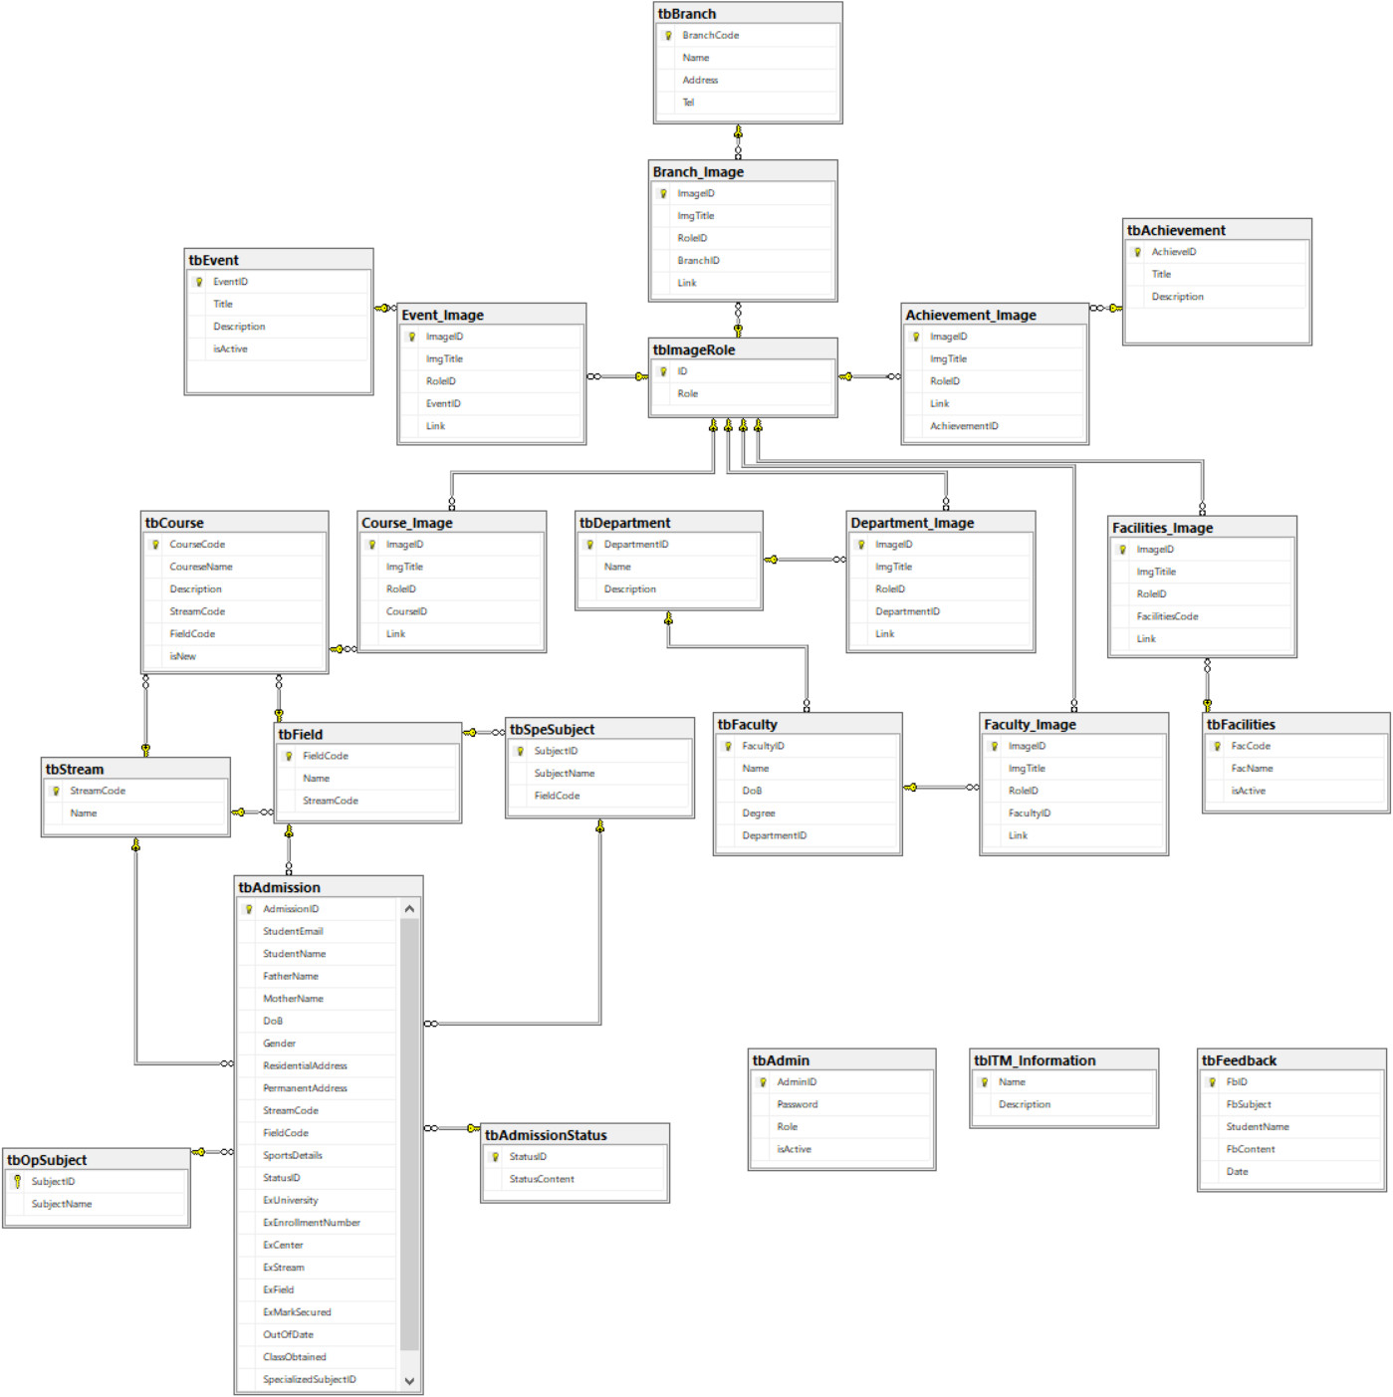

1. Database Structure

2.1 Table Admin

|  |  |  |  |  |  |  |
| --- | --- | --- | --- | --- | --- | --- |
| Field Name | Data Type | Null | Default | Key | Field-Ref | Description |
| AdminID | Varchar(30) | No |  | PK |  | Account for Login |
| Password | Varchar(30) | No |  |  |  | Password for Login |
| Role | int | No |  |  |  | Decentralization |
| isActive | bit | No |  |  |  | Check for Login |

**2.2 Table ITM Information**

|  |  |  |  |  |  |  |
| --- | --- | --- | --- | --- | --- | --- |
| Field Name | Data Type | Null | Default | Key | Field-Ref | Description |
| Name | Varchar(30) | No |  | PK |  | Web Content Title |
| Description | text | No |  |  |  | Web Content |

**2.3 Table Feedback**

|  |  |  |  |  |  |  |
| --- | --- | --- | --- | --- | --- | --- |
| Field Name | Data Type | Null | Default | Key | Field-Ref | Description |
| FbID | int | No |  | PK |  | Feedback ID |
| FbSubject | Varchar(100) | No |  |  |  | Feedback Subject |
| StudentName | Varchar(50) |  |  |  |  |  |
| FbContent | text | No |  |  |  | Problem Feedback |
| Date | Date | No |  |  |  | The date when feedback submitted |

**2.4 Table Admission Status**

|  |  |  |  |  |  |  |
| --- | --- | --- | --- | --- | --- | --- |
| Field Name | Data Type | Null | Default | Key | Field-Ref | Description |
| StausID | int | No |  | PK |  | Field ID |
| StatusContent | Varchar(30) | No |  |  |  | Status Content |

**2.5 Table Admission**

|  |  |  |  |  |  |  |
| --- | --- | --- | --- | --- | --- | --- |
| Field Name | Data Type | Null | Default | Key | Field-Ref | Description |
| AdmissionID | Varchar(50) | No |  | PK |  | Field ID |
| StudentEmail | Varchar(50) | No |  |  |  | Student Email |
| StudentName | Varchar(50) | No |  |  |  | Student Name of Admission |
| FatherName | Varchar(50) | No |  |  |  | Father of Student |
| MotherName | Varchar(50) | No |  |  |  | Mother of Student |
| DoB | date | No |  |  |  | Day of Birth |
| Gender | bit | No |  |  |  | Student Sex |
| ResidentialAddress | text | No |  |  |  | Address |
| PermanentAddress | Text | No |  |  |  | Hometown |
| StreamCode | Varchar(30) | No |  |  |  | Stream Student choose of ITM |
| FieldCode | Varchar(30) | No |  |  |  | Field Student choose of ITM |
| SportsDetails | Varchar(100) | No |  |  |  | Sports talent |
| StatusID | Int | Yes | **0** | **FK** |  | To know the status of Admission (Wait, Accept, Fail) |
| ExUniversiy | Varchar(50) | No |  |  |  | Ex-University |
| ExEnrollmentNumber | Varchar(30) | No |  |  |  | ID of last exam |
| ExCenter | Varchar(50) | No |  |  |  | Center of last exam |
| ExStream | Varchar(50) | No |  | **FK** |  | Ex-Stream |
| ExField | Varchar(50) | No |  | **FK** |  | Ex-Field |
| ExMarkSecured | float | No |  |  |  | Mark of last exam |
| OutOfDate | date | No |  |  |  | Time of last mark expires |
| ClassObtained | Varchar(1) | No |  |  |  | Classifying classes |
| SpecializedSubjectID | Varchar(30) | Yes |  |  |  | Compulsory subject |
| OptionalSubjectID | Varchar(30) | Yes |  |  |  | Optional Subject |

**2.5 Table Admin**

|  |  |  |  |  |  |  |
| --- | --- | --- | --- | --- | --- | --- |
| Field Name | Data Type | Null | Default | Key | Field-Ref | Description |
| AdminID | Varchar(30) | No |  | PK |  | Account for Login |
| Password | Varchar(30) | No |  |  |  | Password for Login |
| Role | int | No |  |  |  | Decentralization |
| isActive | bit | No |  |  |  | Check for Login |

**2.6 Table Special Subject**

|  |  |  |  |  |  |  |
| --- | --- | --- | --- | --- | --- | --- |
| Field Name | Data Type | Null | Default | Key | Field-Ref | Description |
| SubjectID | Varchar(30) | No |  | PK |  | Field ID |
| SubjectName | Varchar(50) | No |  |  |  | Name of Subject |
| FieldCode | Varchar(30) | No |  | **FK** |  | Name of Field |

**2.7 Table Field**

|  |  |  |  |  |  |  |
| --- | --- | --- | --- | --- | --- | --- |
| Field Name | Data Type | Null | Default | Key | Field-Ref | Description |
| FieldCode | Varchar(30) | No |  | PK |  | Field ID |
| Name | Varchar(50) | No |  |  |  | Name of Field |
| StreamCode | Varchar(30) | No |  | **FK** |  | Name of Stream of the Field |

**2.8 Table Stream**

|  |  |  |  |  |  |  |
| --- | --- | --- | --- | --- | --- | --- |
| Field Name | Data Type | Null | Default | Key | Field-Ref | Description |
| StreamCode | Varchar(30) | No |  | PK |  | Field ID |
| Name | Varchar(50) | No |  |  |  | Name of Stream |

**2.9 Table Course**

|  |  |  |  |  |  |  |
| --- | --- | --- | --- | --- | --- | --- |
| Field Name | Data Type | Null | Default | Key | Field-Ref | Description |
| CourseCode | Varchar(30) | No |  | PK |  | Field ID |
| CourseName | Varchar(50) | No |  |  |  | Name of Course |
| Description | text | No |  |  |  | About the Course |
| StreamCode | Varchar(30) | No |  | **FK** |  | Stream of Course |
| FieldCode | Varchar(30) | No |  | **FK** |  | Field of Course |
| isNew | bit | No |  |  |  | Status of Course |

**2.10 Table Facilities**

|  |  |  |  |  |  |  |
| --- | --- | --- | --- | --- | --- | --- |
| Field Name | Data Type | Null | Default | Key | Field-Ref | Description |
| FacCode | Varchar(30) | No |  | PK |  | Field ID |
| FacName | Varchar(50) | No |  |  |  | Name of Facility |
| isActive | bit | No |  |  |  | Status of Facility |

**2.11 Table Facility Image**

|  |  |  |  |  |  |  |
| --- | --- | --- | --- | --- | --- | --- |
| Field Name | Data Type | Null | Default | Key | Field-Ref | Description |
| ImageID | Varchar(30) | No |  | PK |  | Field ID |
| ImgTitle | Varchar(50) | No |  |  |  | Title of Image |
| RoleID | Int | No |  |  |  | Format of Image |
| FacilitiesID | Varchar(30) | No |  | **FK** |  | Facility ID |
| Link | Varchar(100) | No |  |  |  | Path of Image |

**2.12 Table Event**

|  |  |  |  |  |  |  |
| --- | --- | --- | --- | --- | --- | --- |
| Field Name | Data Type | Null | Default | Key | Field-Ref | Description |
| EventID | Varchar(30) | No |  | PK |  | Field ID |
| Title | Varchar(50) | No |  |  |  | Title of Event |
| Description | text | No |  |  |  | About Event |
| isActive | bit | No |  |  |  | Status of Event |

**2.13 Table Event Image**

|  |  |  |  |  |  |  |
| --- | --- | --- | --- | --- | --- | --- |
| Field Name | Data Type | Null | Default | Key | Field-Ref | Description |
| ImageID | Varchar(30) | No |  | PK |  | Field ID |
| ImgTitle | Varchar(50) | No |  |  |  | Title of Image |
| RoleID | Int | No |  |  |  | Format of Image |
| EventID | Varchar(30) | No |  | **FK** |  | Event ID |
| Link | Varchar(100) | No |  |  |  | Path of Image |

**2.14 Table Faculty**

|  |  |  |  |  |  |  |
| --- | --- | --- | --- | --- | --- | --- |
| Field Name | Data Type | Null | Default | Key | Field-Ref | Description |
| FacultyID | Varchar(30) | No |  | PK |  | Field ID |
| Name | Varchar(50) | No |  |  |  | Name of Faculty |
| DoB | date | No |  |  |  | Date of Birth |
| Degree | Varchar(100) | No |  |  |  | Degree of Faculty |
| DepartmentID | Varchar(30) | No |  | **FK** |  | Department ID |

**2.15 Table Faculty Image**

|  |  |  |  |  |  |  |
| --- | --- | --- | --- | --- | --- | --- |
| Field Name | Data Type | Null | Default | Key | Field-Ref | Description |
| ImageID | Varchar(30) | No |  | PK |  | Field ID |
| ImgTitle | Varchar(50) | No |  |  |  | Title of Image |
| RoleID | Int | No |  |  |  | Format of Image |
| FacultyID | Varchar(30) | No |  | **FK** |  | Faculty ID |
| Link | Varchar(100) | No |  |  |  | Path of Image |

**2.16 Table Course Image**

|  |  |  |  |  |  |  |
| --- | --- | --- | --- | --- | --- | --- |
| Field Name | Data Type | Null | Default | Key | Field-Ref | Description |
| ImageID | Varchar(30) | No |  | PK |  | Field ID |
| ImgTitle | Varchar(50) | No |  |  |  | Title of Image |
| RoleID | Int | No |  |  |  | Format of Image |
| CourseID | Varchar(30) | No |  | **FK** |  | Course ID |
| Link | Varchar(100) | No |  |  |  | Path of Image |

**2.17 Table Achievement**

|  |  |  |  |  |  |  |
| --- | --- | --- | --- | --- | --- | --- |
| Field Name | Data Type | Null | Default | Key | Field-Ref | Description |
| AchieveID | Varchar(30) | No |  | PK |  | Field ID |
| Title | Varchar(50) | No |  |  |  | Title of Achievement |
| Description | text | No |  |  |  | About Achievement |

**2.18 Table Achievement Image**

|  |  |  |  |  |  |  |
| --- | --- | --- | --- | --- | --- | --- |
| Field Name | Data Type | Null | Default | Key | Field-Ref | Description |
| ImageID | Varchar(30) | No |  | PK |  | Field ID |
| ImgTitle | Varchar(50) | No |  |  |  | Title of Image |
| RoleID | Int | No |  |  |  | Format of Image |
| AchievementID | Varchar(30) | No |  | **FK** |  | Achievement ID |
| Link | Varchar(100) | No |  |  |  | Path of Image |

**2.19 Table Department**

|  |  |  |  |  |  |  |
| --- | --- | --- | --- | --- | --- | --- |
| Field Name | Data Type | Null | Default | Key | Field-Ref | Description |
| DepartmentID | Varchar(30) | No |  | PK |  | Field ID |
| Name | Varchar(50) | No |  |  |  | Name of Department |
| Description | text | No |  |  |  | About Department |

**2.20 Table Department Image**

|  |  |  |  |  |  |  |
| --- | --- | --- | --- | --- | --- | --- |
| Field Name | Data Type | Null | Default | Key | Field-Ref | Description |
| ImageID | Varchar(30) | No |  | PK |  | Field ID |
| ImgTitle | Varchar(50) | No |  |  |  | Title of Image |
| RoleID | Int | No |  |  |  | Format of Image |
| DepartmentID | Varchar(30) | No |  | **FK** |  | Department ID |
| Link | Varchar(100) | No |  |  |  | Path of Image |

**2.21 Table Branch**

|  |  |  |  |  |  |  |
| --- | --- | --- | --- | --- | --- | --- |
| Field Name | Data Type | Null | Default | Key | Field-Ref | Description |
| BranchCode | Varchar(30) | No |  | PK |  | Field ID |
| Name | Varchar(50) | No |  |  |  | Name of Branch |
| Address | Varchar(100) | No |  |  |  | Address of Branch |
| Tel | Varchar(20) | No |  | **FK** |  | Phone number |

**2.22 Table Branch Image**

|  |  |  |  |  |  |  |
| --- | --- | --- | --- | --- | --- | --- |
| Field Name | Data Type | Null | Default | Key | Field-Ref | Description |
| ImageID | Varchar(30) | No |  | PK |  | Field ID |
| ImgTitle | Varchar(50) | No |  |  |  | Title of Image |
| RoleID | int | No |  |  |  | Format of Image |
| BranchID | Varchar(30) | No |  | **FK** |  | Branch ID |
| Link | Varchar(100) | No |  |  |  | Path of Image |

**2.23 Table Image Role**

|  |  |  |  |  |  |  |
| --- | --- | --- | --- | --- | --- | --- |
| Field Name | Data Type | Null | Default | Key | Field-Ref | Description |
| ID | int | No |  | PK |  | Field ID |
| Role | Varchar(20) | No |  |  |  | Format of Image |

1. GUI Design – Front-end:
2. Home page:



|  |  |  |  |  |  |  |
| --- | --- | --- | --- | --- | --- | --- |
| Navigation | | | | | | |
| No. | Name | Type | Validation | Event | Description | Status |
| 1 | Home | Hyberlink |  | Click | URL to Home | Enable |
| 2 | Course | Hyberlink |  | Click | URL to Courses | Enable |
| 3 | Admission | Hyberlink |  | Click | URL to Admission | Enable |
| 4 | Registration | Hyberlink |  | Click | URL to Registration | Enable |
| 5 | Department | Hyberlink |  | Click | URL to Departments | Enable |
| 6 | Faculty | Hyberlink |  | Click | URL to Falculties | Enable |
| 7 | Facilities | Hyberlink |  | Click | URL to Facilities | Enable |
| 8 | Contact/ Feedback | Hyberlink |  | Click | URL to Contact | Enable |
| 9 | Login | Hyberlink |  | Click | URL to Login | Enable |



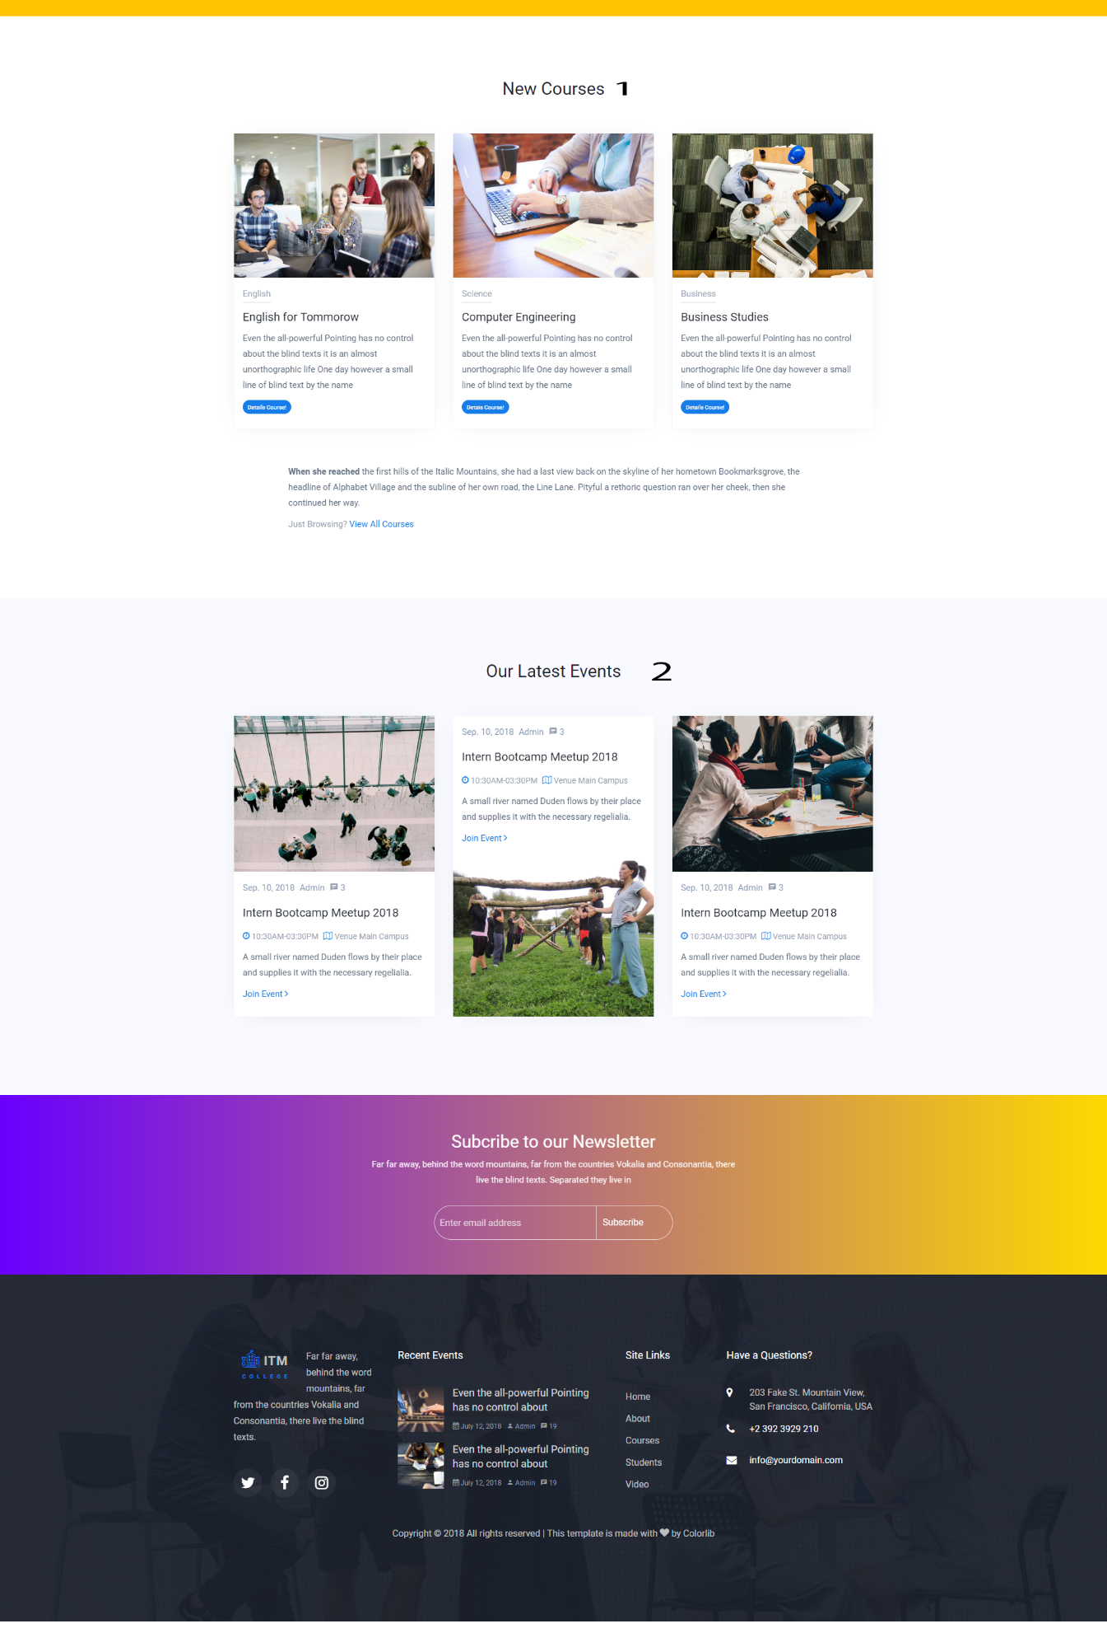

1. Courses:



1. Admission:

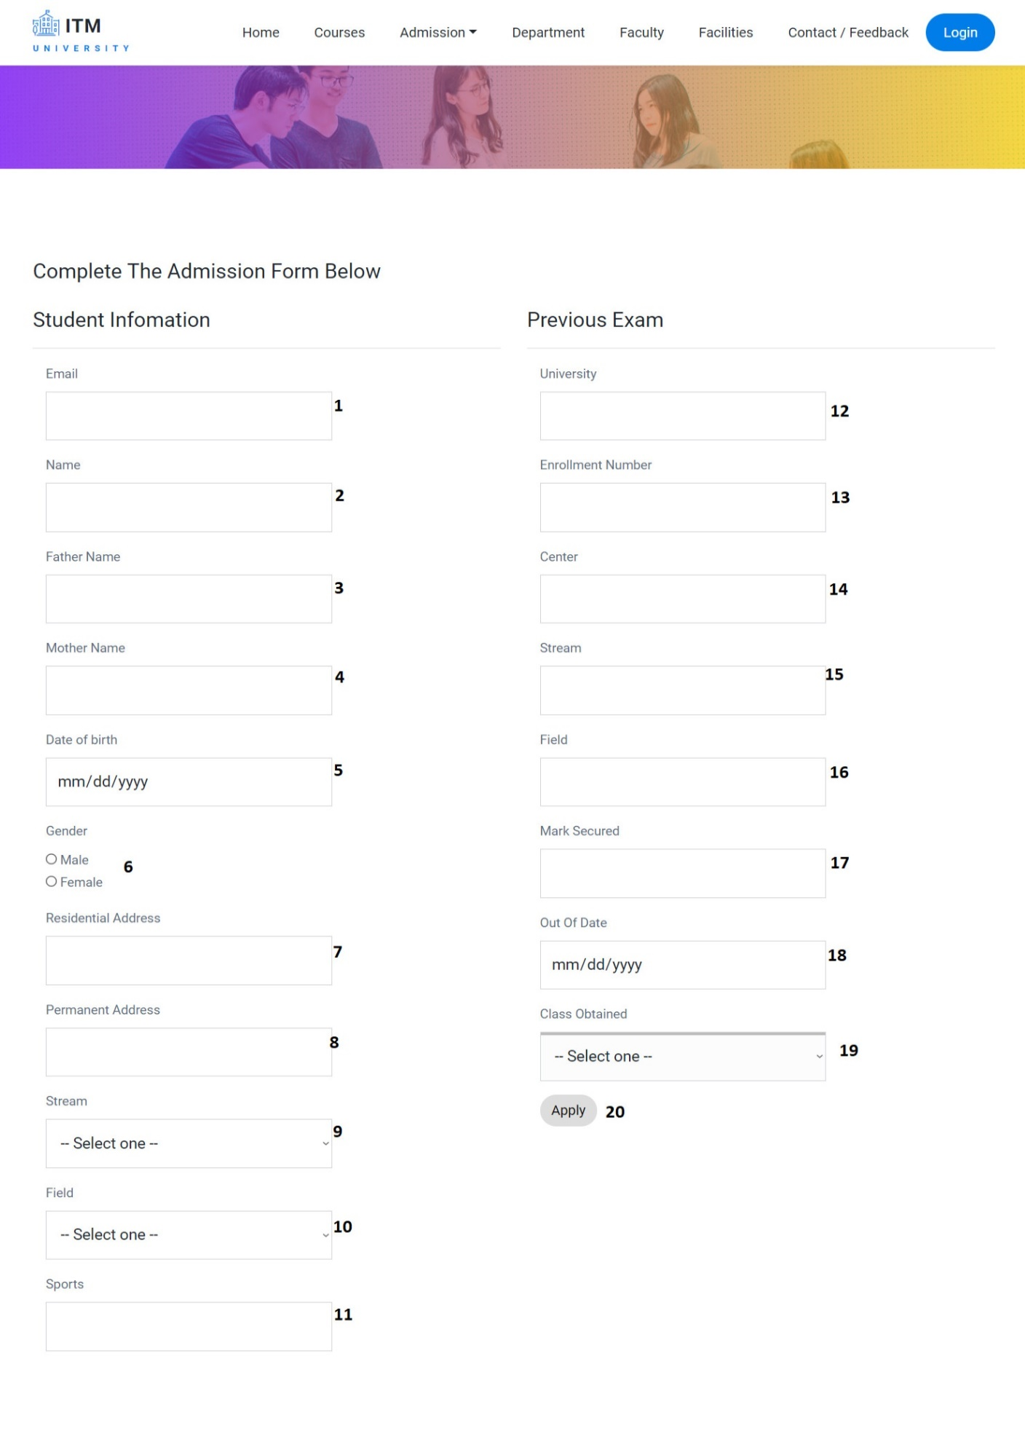

|  |  |  |  |  |  |  |
| --- | --- | --- | --- | --- | --- | --- |
| Admission Form | | | | | | |
| No | Name | Type | Validation | Event | Description | Status |
| 1 | StudentEmail | Text box |  | Input | Input student email | Enable |
| 2 | StudentName | Text box |  | Input | Input student name | Enable |
| 3 | FatherName | Text box |  | Input | Input father name | Enable |
| 4 | MotherName | Text box |  | Input | Input mother name | Enable |
| 5 | DoB | Text box |  | Input | Input date of birth | Enable |
| 6 | Gender | Radio |  | Click | Input gender | Enable |
| 7 | Residential Adress | Text box |  | Input | Input residential address | Enable |
| 8 | Permanent Adress | Text box |  | Input | Input permanent address | Enable |
| 9 | tbStream.Name | Text box |  | Input | Input stream name | Enable |
| 10 | tbField.Name | Text box |  | Input | Input field name | Enable |
| 11 | SportsDetails | Text box |  | Input | Input sports | Enable |
| 12 | ExUniversity | Text box |  | Input | Input previous university | Enable |
| 13 | ExEnrollmentNumber | Text box |  | Input | Input enrollment number (Previous Exam) | Enable |
| 14 | ExCenter | Text box |  | Input | Input center name (Previous Exam) | Enable |
| 15 | ExStream | Text box |  | Input | Input stream (Previous Exam) | Enable |
| 16 | ExField | Text box |  | Input | Input field  (Previous Exam) | Enable |
| 17 | ExMarkSecured | Text box |  | Input | Input mark secured  (Previous Exam) | Enable |
| 18 | OutOfDate | Text box |  | Input | Input out of date of previous exam | Enable |
| 19 | ClassObtained | Text box |  | Input | Input class obtained  (Previous Exam) | Enable |
| 20 | btnApply | Button |  | Click | Submit admission form | Enable |

* Some code review:

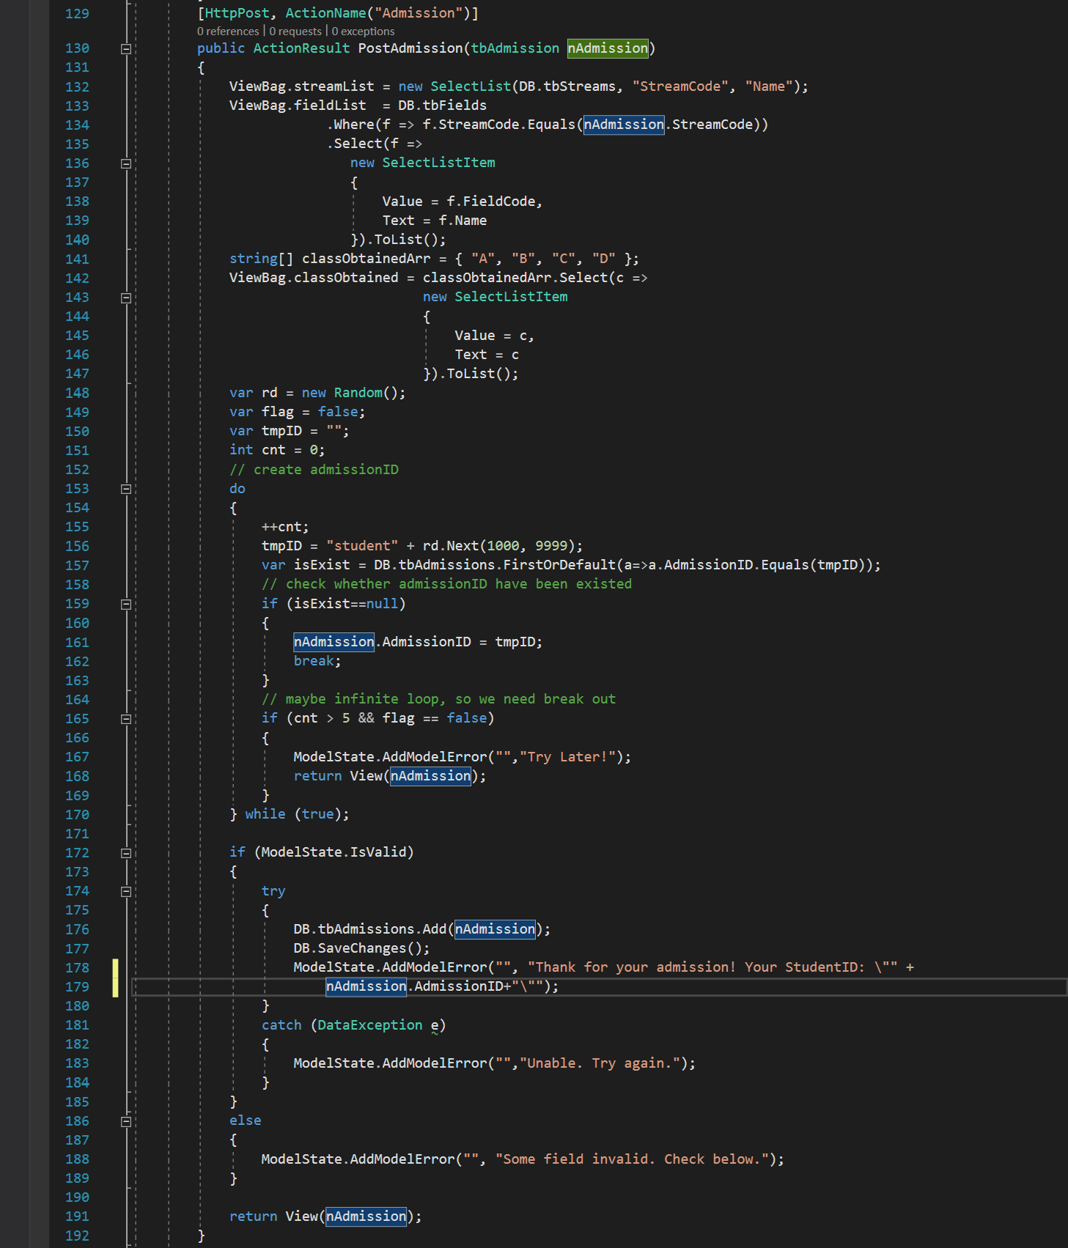

* Create unique AdmissionID (studentID)

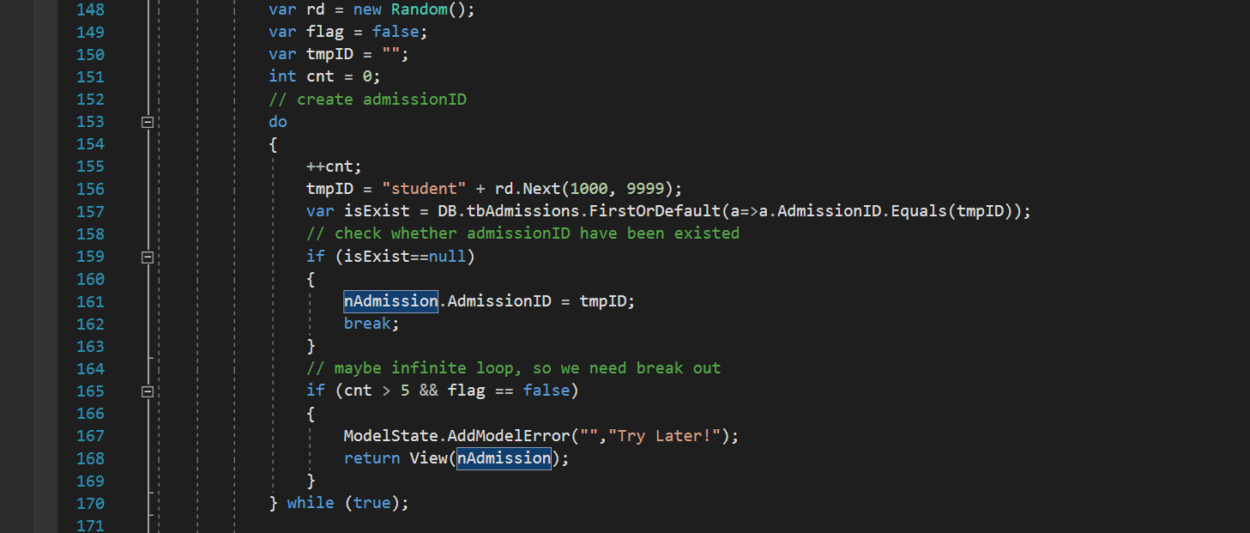

1. Department:



1. Faculty:



1. Facilities:

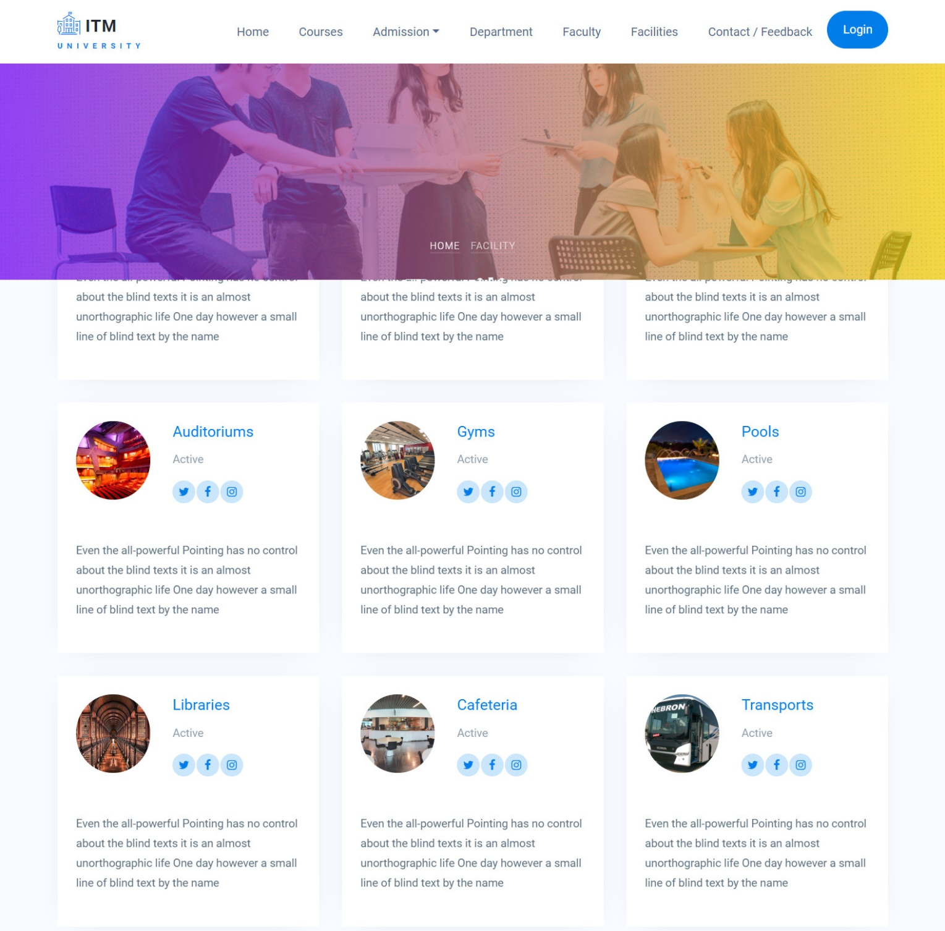

1. Registration:

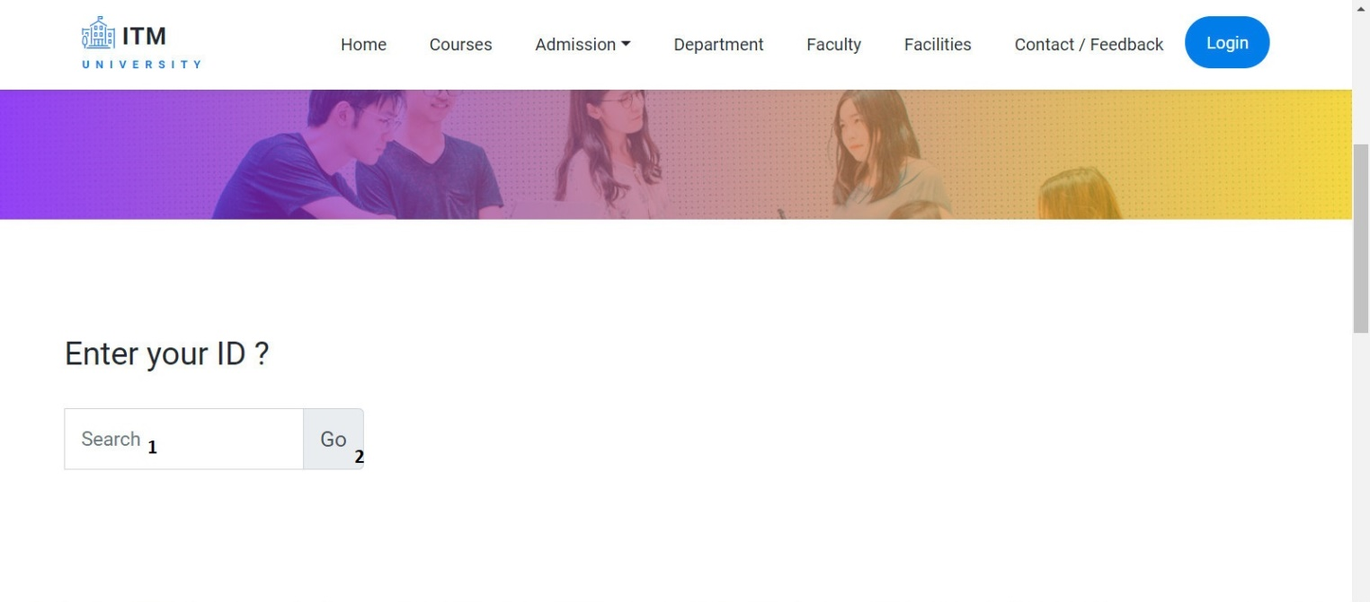

|  |  |  |  |  |  |  |
| --- | --- | --- | --- | --- | --- | --- |
| Search Admission Form | | | | | | |
| No | Name | Type | Validation | Event | Description | Status |
| 1 | AdmissionID | input |  | input | Input AdmissionID (studentID) to registration | Enable |
| 2 | btnSearch | button |  | click | Submit Form | Enable |

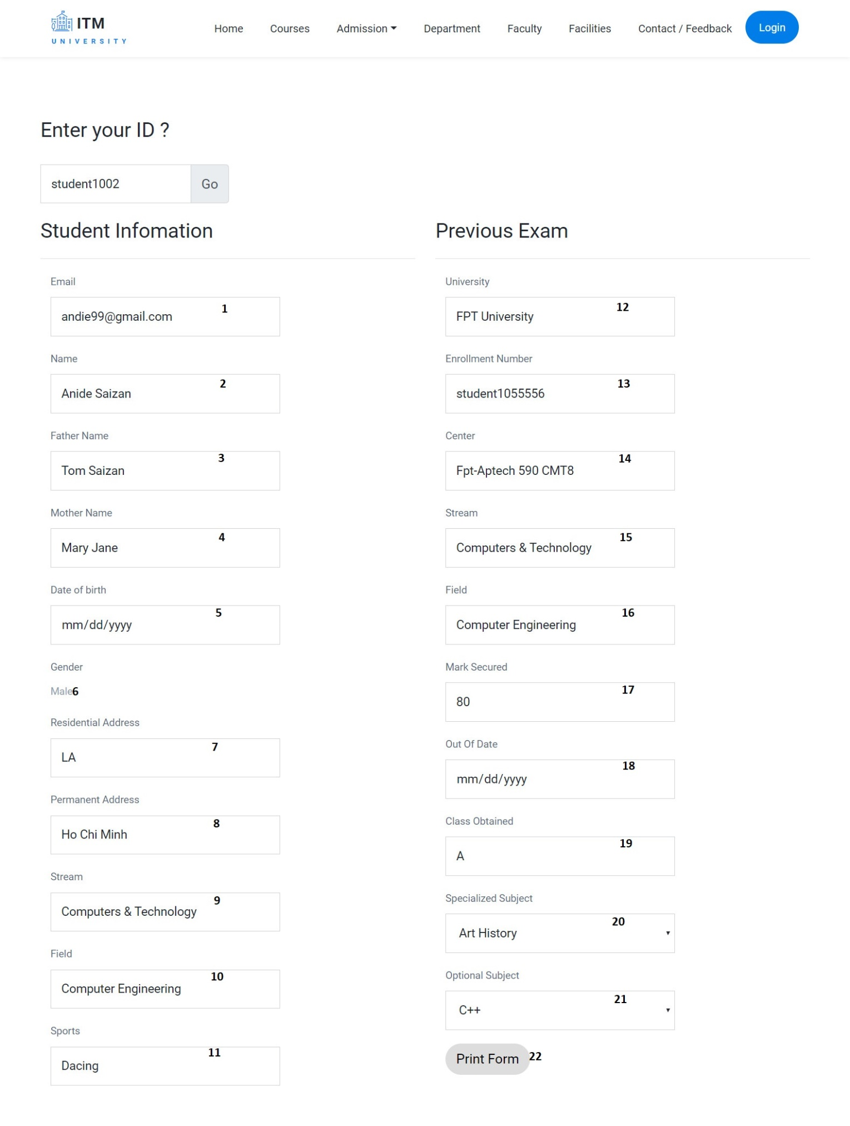

|  |  |  |  |  |  |  |
| --- | --- | --- | --- | --- | --- | --- |
| Registration Form | | | | | | |
| No | Name | Type | Validation | Event | Description | Status |
| 1 | StudentEmail | Text box |  |  | Display student email | Disable |
| 2 | StudentName | Text box |  |  | Display student name | Disable |
| 3 | FatherName | Text box |  |  | Display father name | Disable |
| 4 | MotherName | Text box |  |  | Display mother name | Disable |
| 5 | DoB | Text box |  |  | Display date of birth | Disable |
| 6 | txtGender | Text |  |  | Display gender | Disable |
| 7 | Residential Adress | Text box |  |  | Display residential address | Disable |
| 8 | Permanent Adress | Text box |  |  | Display permanent address | Disable |
| 9 | tbStream.Name | Text box |  |  | Display stream name | Disable |
| 10 | tbField.Name | Text box |  |  | Display field name | Disable |
| 11 | SportsDetails | Text box |  |  | Display sports | Disable |
| 12 | ExUniversity | Text box |  |  | Display previous university | Disable |
| 13 | ExEnrollmentNumber | Text box |  |  | Display previous enrollment number | Disable |
| 14 | ExCenter | HyperLink |  |  | Display center name (previous exam) | Disable |
| 15 | ExStream | Text box |  |  | Display previous exam’s stream | Disable |
| 16 | ExField | Text box |  |  | Display previous exam’s field | Disable |
| 17 | ExMarkSecured | Text box |  |  | Display previous exam’s mark | Disable |
| 18 | OutOfDate | Text box |  |  | Display out of date of previous exam | Disable |
| 19 | ClassObtained | Text box |  |  | Display previous exam’s class obtained | Disable |
| 20 | SpecializedSubjectID | Dropdown List |  | Select option | Select specialized subject | Enable |
| 21 | OptionalSubjectID | Dropdown List |  | Select option | Select optional subject | Enable |
| 22 | btnPrint | button |  | Click | Print registration form | Enable |

1. Contact/Feedback:

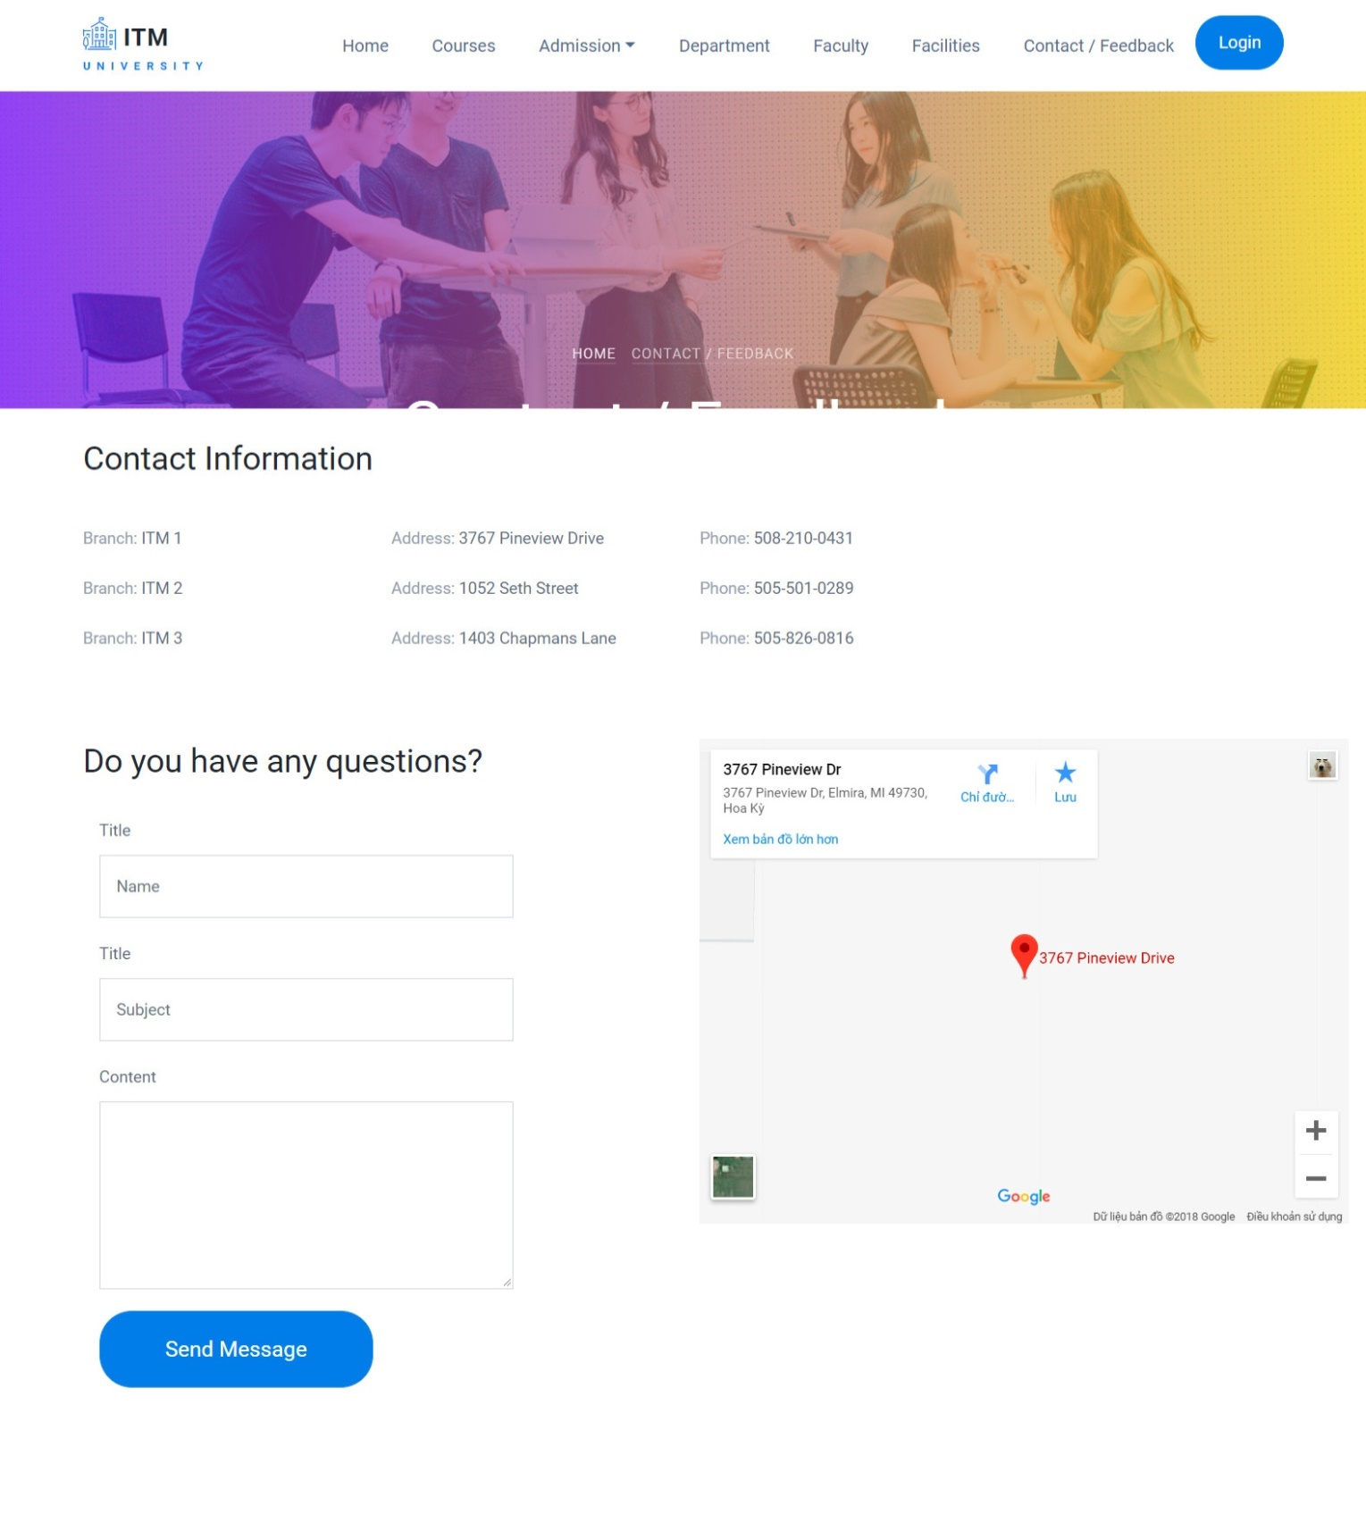

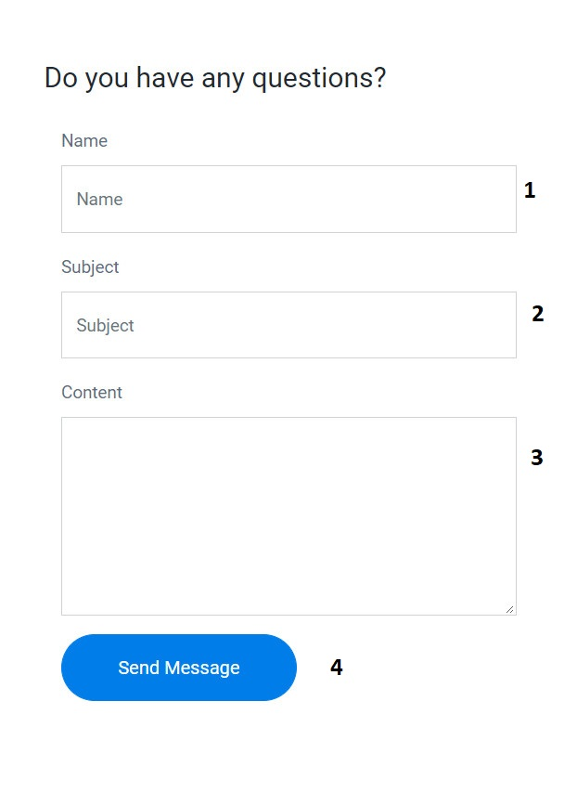

|  |  |  |  |  |  |  |
| --- | --- | --- | --- | --- | --- | --- |
| Feedback Form | | | | | | |
| No | Name | Type | Validation | Event | Description | Status |
| 1 | StudentName | Text box | Not null | Input | Input guest’s name | Enable |
| 2 | FbSubject | Text box | Not null | input | Input feedback subject | Enable |
| 3 | FbContent | Text box | Not null | Input | Input feedback content | Enable |
| 3 | btnSubmit | button |  | click | Button for submit form | Enable |

1. Admin login:

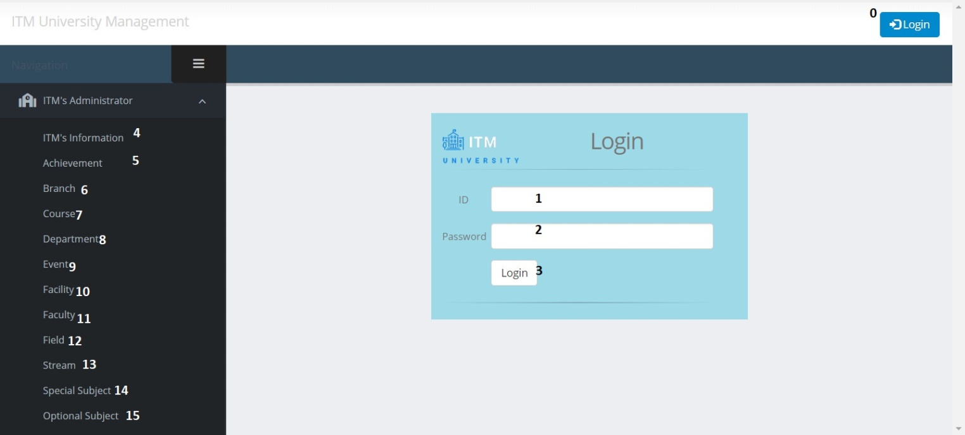

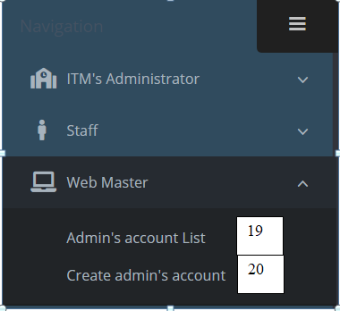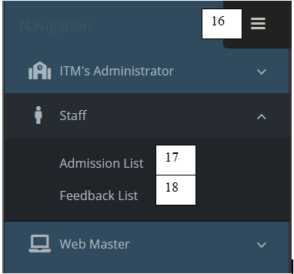

|  |  |  |  |  |  |  |
| --- | --- | --- | --- | --- | --- | --- |
| Login page | | | | | | |
| No | Name | Type | Validation | Event | Description | Status |
| 0 | btnLogin | button |  | Click | Url to Login page | Enable |
| 1 | ID | Text box | Not null | Input | Input admin id | Enable |
| 2 | Password | Text box | Not null | Input | Input password | Enable |
| 3 | btnSubmit | Button |  | Click | Submit for login | Enable |
| 4 | ITM’s Information | HyperLink |  | Click | URL to ITM_Infor action (ITM controller) | Enable |
| 5 | Achievement | HyperLink |  | Click | URL to AchievementPost action (ITM controller) | Enable |
| 6 | Branch | HyperLink |  | Click | URL to BranchPost action (ITM controller) | Enable |
| 7 | Course | HyperLink |  | Click | URL to CoursePost action (ITM controller) | Enable |
| 8 | Department | HyperLink |  | Click | URL to Departments action (ITM controller) | Enable |
| 9 | Event | HyperLink |  | Click | URL to EventPost action (ITM controller) | Enable |
| 10 | Facilities | HyperLink |  | Click | URL to Facilities action (ITM controller) | Enable |
| 11 | Faculty | HyperLink |  | Click | URL to Faculties action (ITM controller) | Enable |
| 12 | Field | HyperLink |  | Click | URL to Fields action (ITM controller) | Enable |
| 13 | Stream | HyperLink |  | Click | URL to Streams action (ITM controller) | Enable |
| 14 | Special Subject | HyperLink |  | Click | URL to SpecialSubjects action (ITM controller) | Enable |
| 15 | Optional Subject | HyperLink |  | Click | URL to OptionalSubjects action (ITM controller) | Enable |
| 16 | Toggle Menu |  |  | Click | Open submenu | Enable |
| 17 | Admission List |  |  | Click | URL to AdmissionList action(Staff controller) | Enable |
| 18 | Feedback List |  |  | Click | URL to FeedbackList action (Staff controller) | Enable |
| 19 | Admin’s Account List |  |  | Click | URL to Index action (admin controller) | Enable |
| 20 | Create admin account |  |  | Click | URL to Create action(admin controller) | Enable |

* Some code review:
* Login:

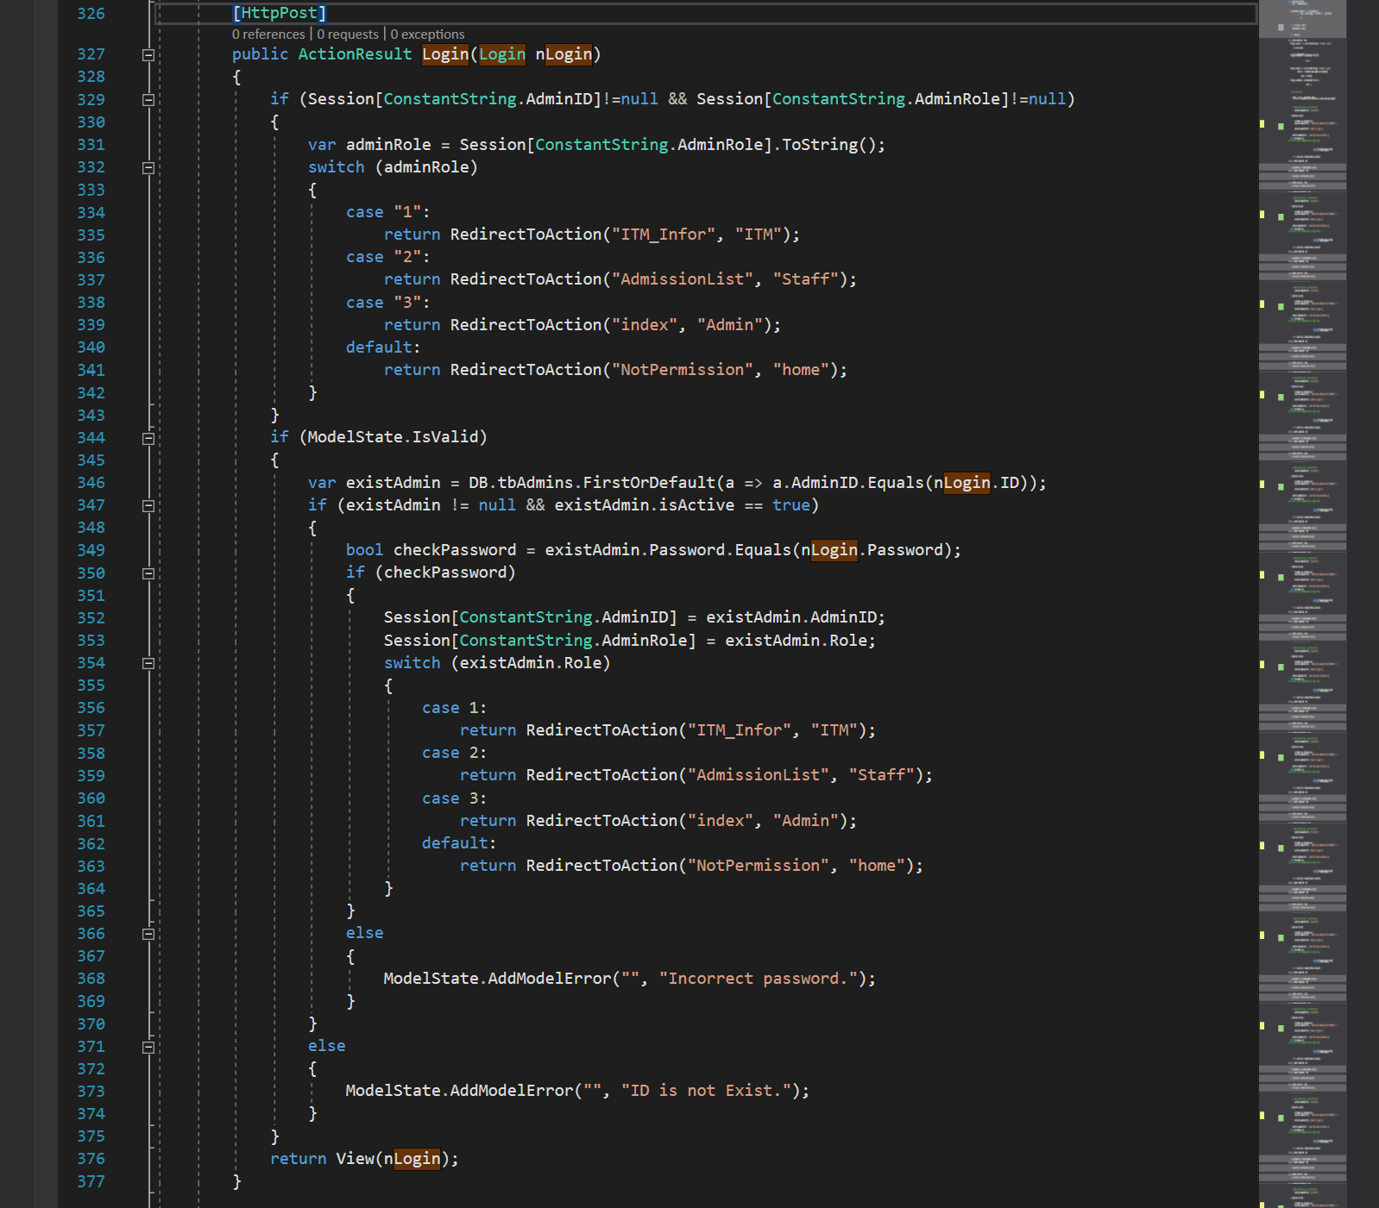

* Logout:

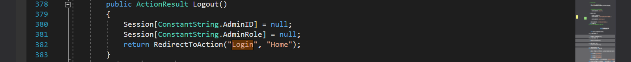

* Authorize:

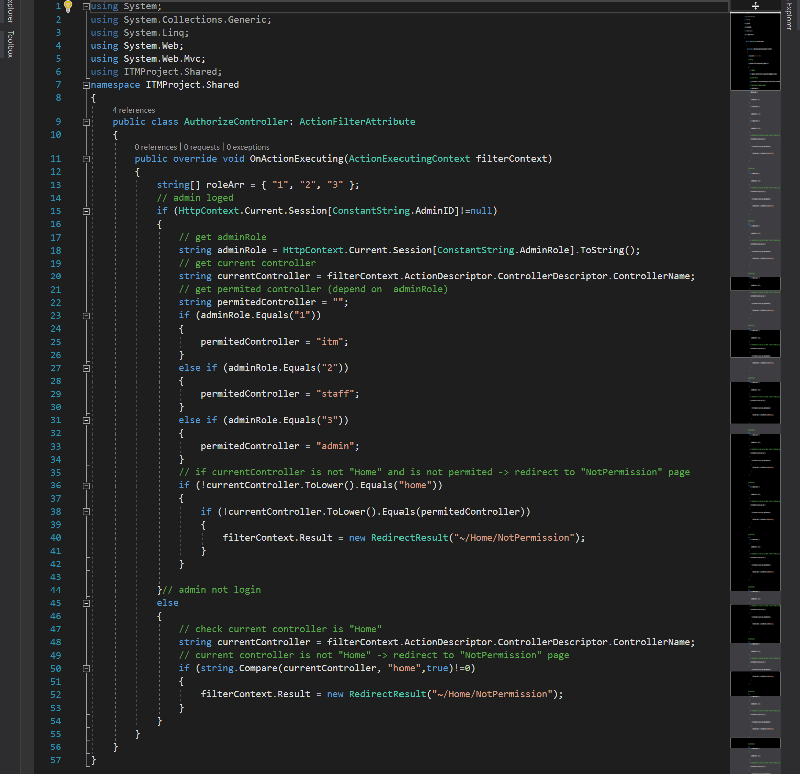

1. GUI Design – Back-end:
2. Department management

**a. Department Post List**

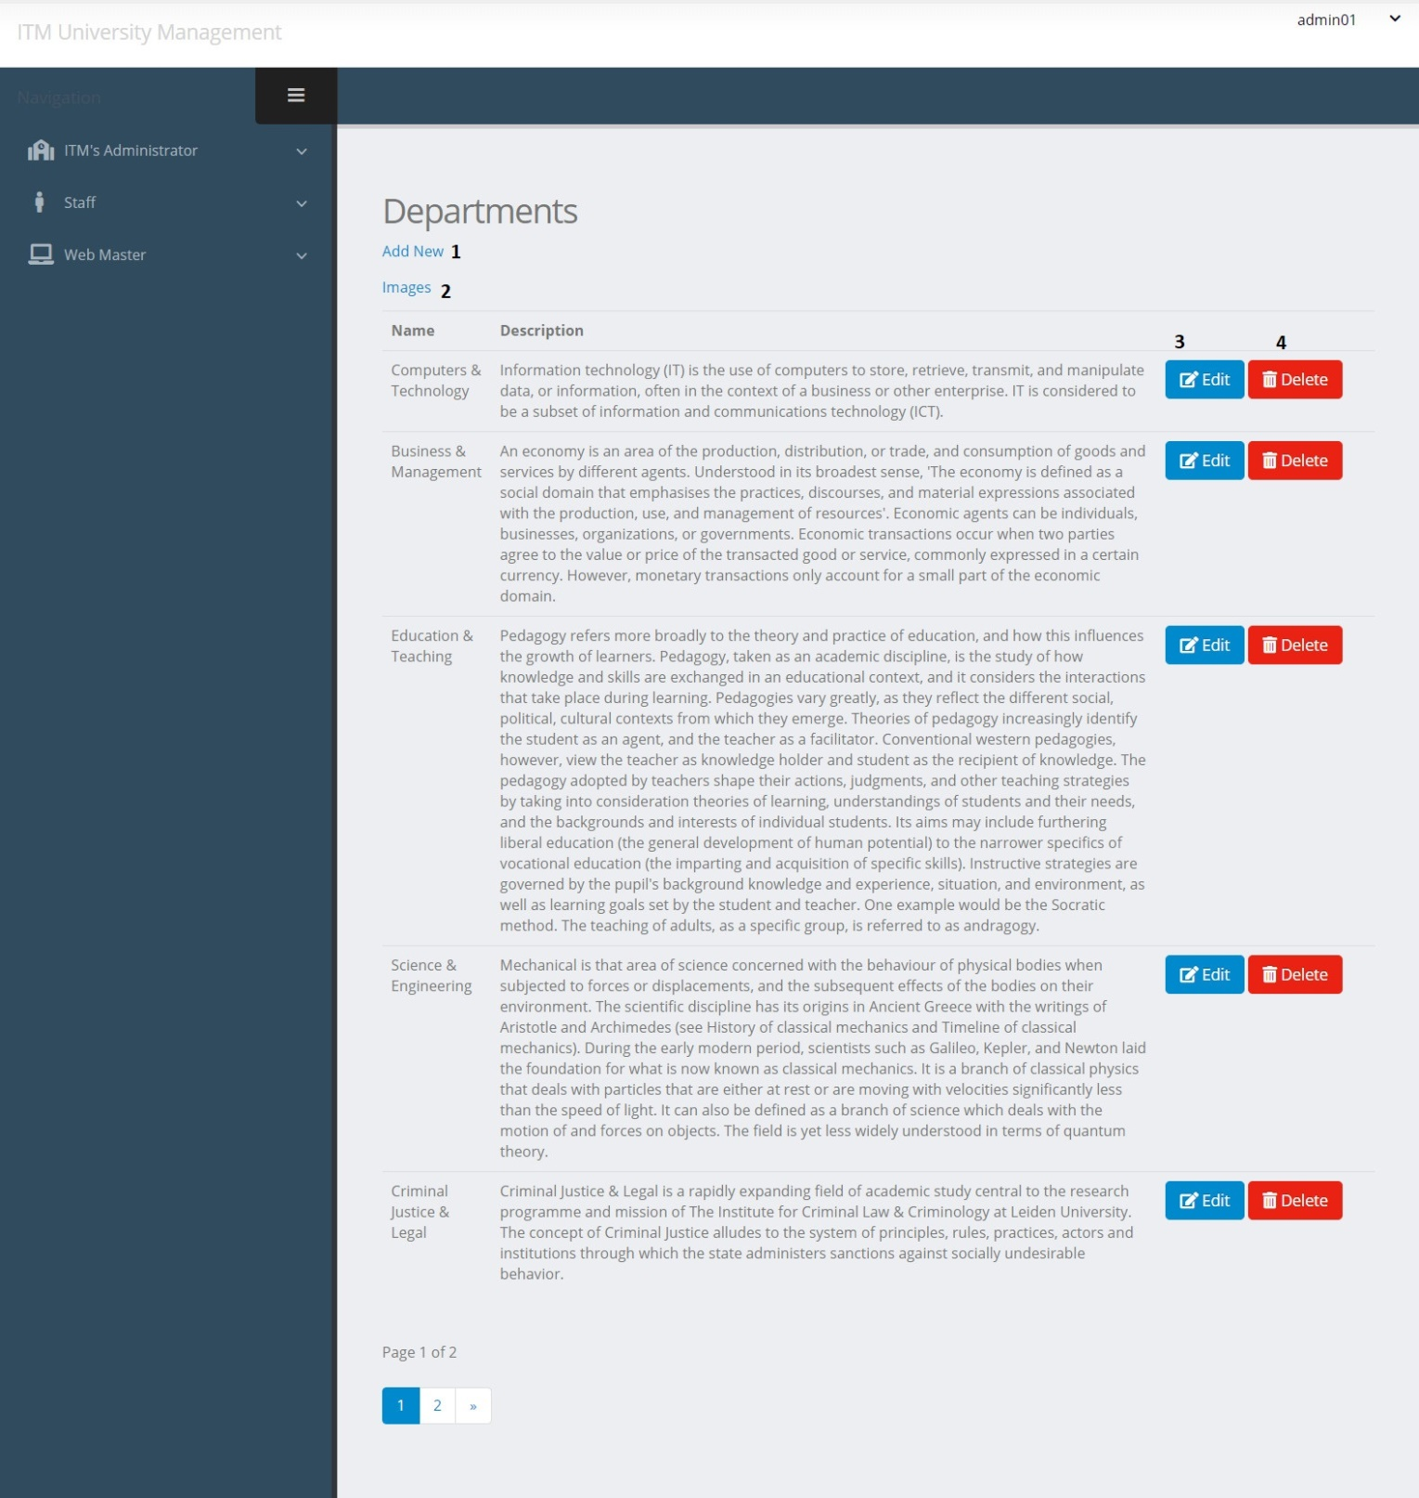

|  |  |  |  |  |  |  |
| --- | --- | --- | --- | --- | --- | --- |
| Department Post | | | | | | |
| No. | Name | Type | Validation | Event | Description | Status |
| 1 | Create | Hyberlink |  | Click | Create new Department Post | Enable |
| 2 | Images | Hyberlink |  | Click | Url to Department Images | Enable |
| 3 | btnEdit | Button |  | Click | Edit Department Post | Enable |
| 4 | btnDelete | Button |  | Click | Delete Department Post | Enable |

* Some code review:
* Get department list:

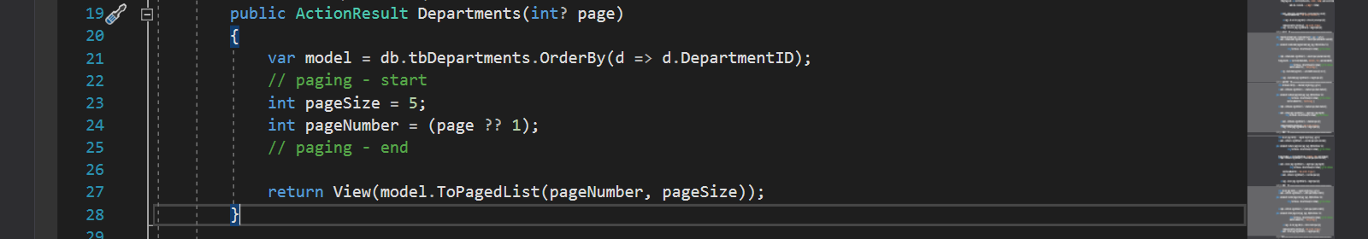

**b. Department Image List**

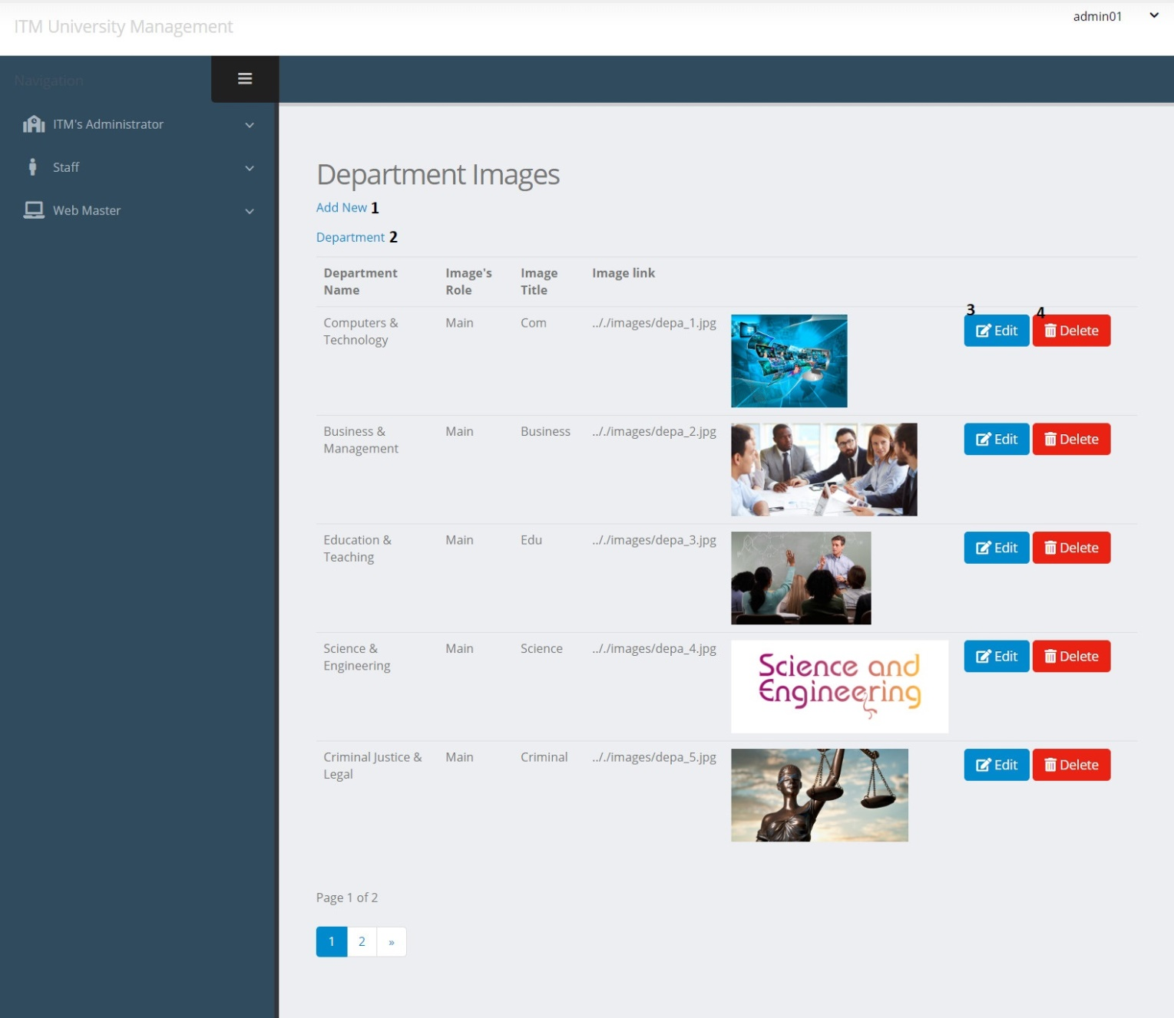

|  |  |  |  |  |  |  |
| --- | --- | --- | --- | --- | --- | --- |
| Department Image | | | | | | |
| No. | Name | Type | Validation | Event | Description | Status |
| 1 | Create | Hyberlink |  | Click | Create new Department Image | Enable |
| 2 | Department | PageList |  | Click | View Department List | Enable |
| 3 | btnEdit | Button |  | Click | Edit Department Image | Enable |
| 4 | btnDelete | Button |  | Click | Delete Department Image | Enable |

* Some code review:

- Get Department image list:

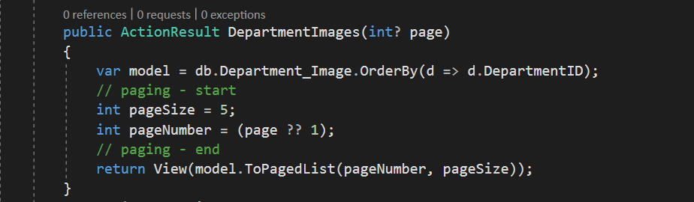

**c. Create Department Post**

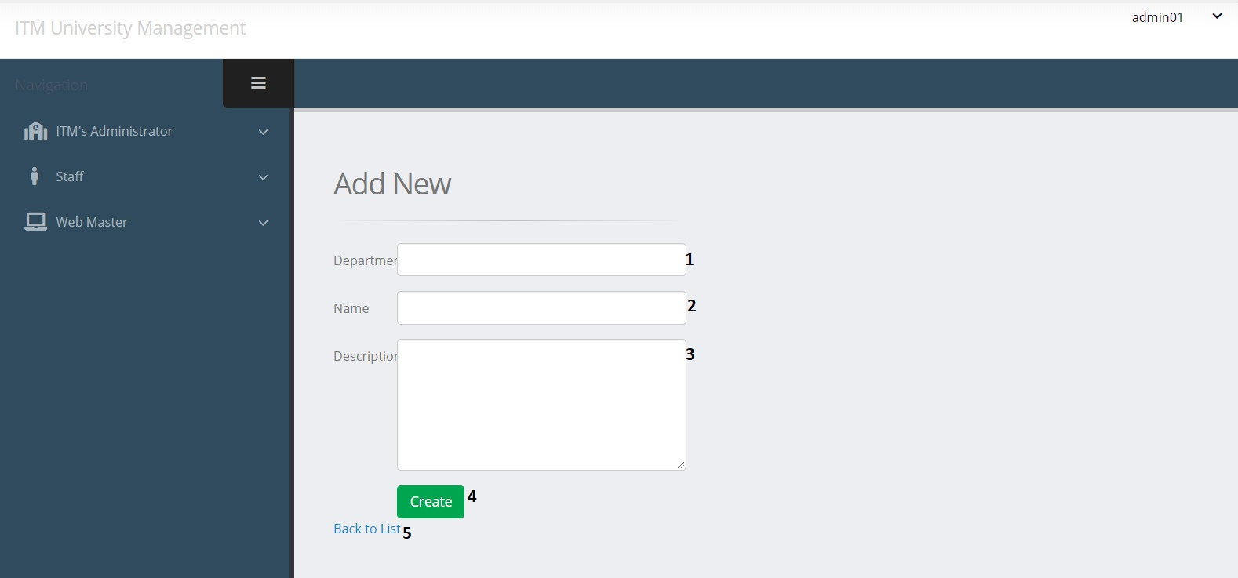

|  |  |  |  |  |  |  |
| --- | --- | --- | --- | --- | --- | --- |
| Create Department Post | | | | | | |
| No. | Name | Type | Validation | Event | Description | Status |
| 1 | DepartmentID | TextField | 0 <= Length <= 30 | Input | Input Department ID | Enable |
| 2 | Name | TextField | 0 <= Length <= 50 | Input | Input Department Name | Enable |
| 3 | Description | TextField |  | Input | Input Description | Enable |
| 4 | btnCreate | Button |  | Click | Submit form Create | Enable |
| 5 | Back to list | Hyberlink |  | Click | View Department list | Enable |

* Some code review:
* Create Deparment:

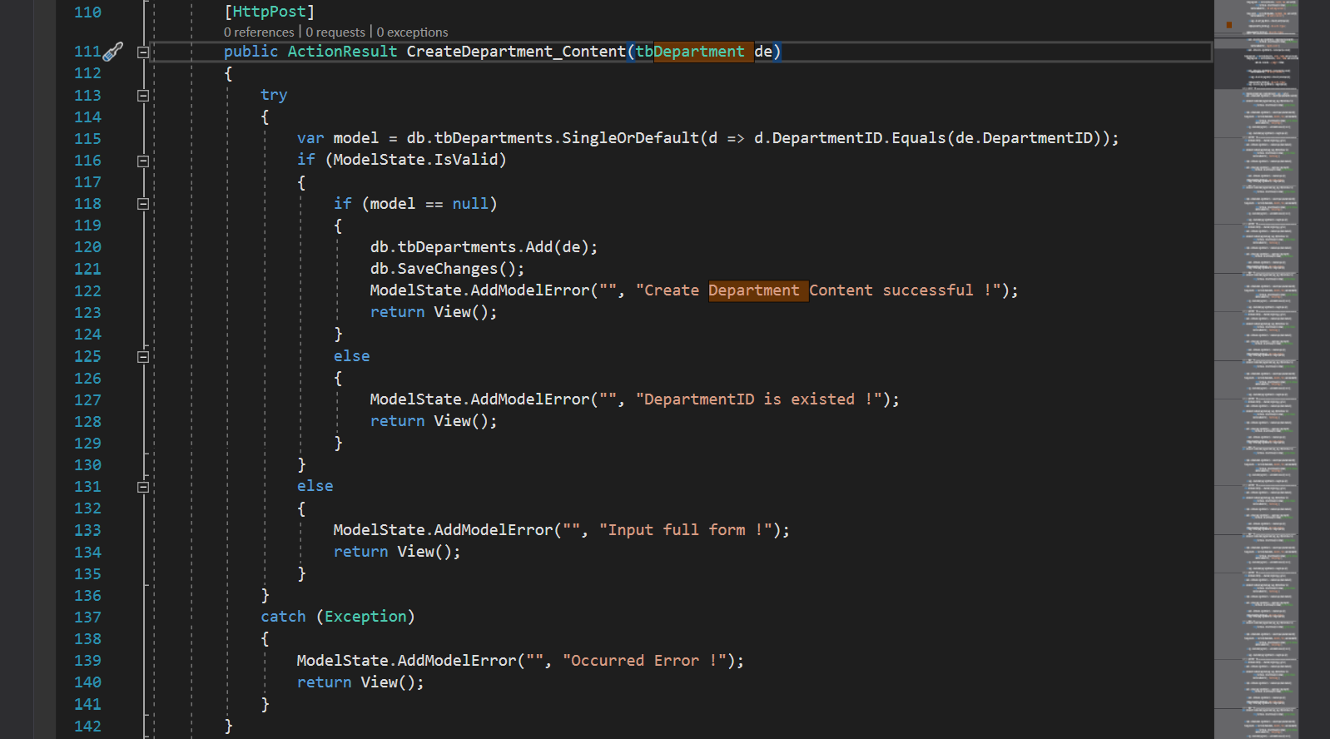

**d. Create Department Image**

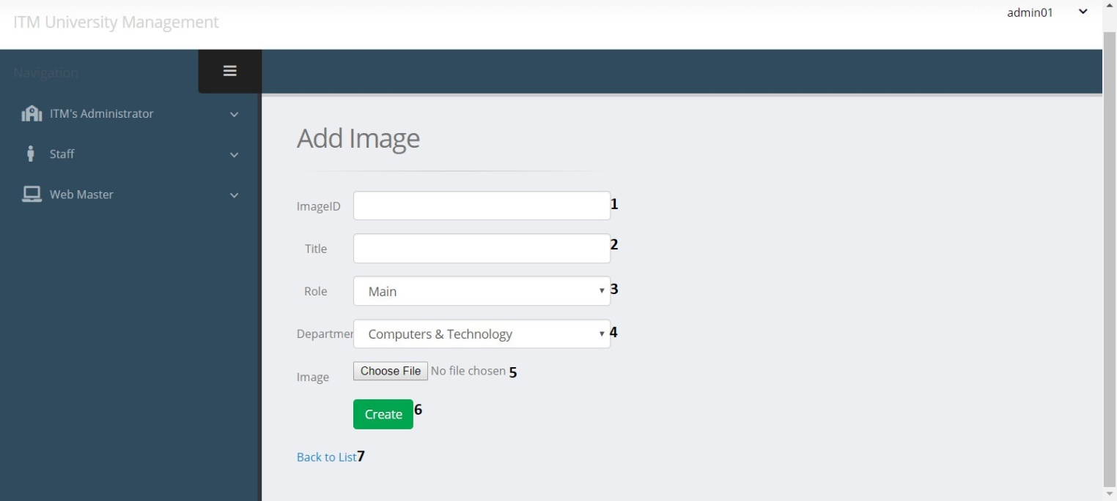

|  |  |  |  |  |  |  |
| --- | --- | --- | --- | --- | --- | --- |
| Create Department Image | | | | | | |
| No. | Name | Type | Validation | Event | Description | Status |
| 1 | ImageID | TextField | 0 <= Length <= 30 | Input | Input Image ID | Enable |
| 2 | ImgTitle | TextField | 0 <= Length <= 50 | Input | Input Image Title | Enable |
| 3 | RoleID | Dropdown |  | Click | Choose Role | Enable |
| 4 | DepartmentID | Dropdown |  | Click | Choose Department | Enable |
| 5 | Link | File | 0 <= Length <=100 | Click | Path of Image | Enable |
| 6 | btnCreate | Button |  | Click | Submit form Create | Enable |
| 7 | Back to list | Hyberlink |  | Click | View Department Image List | Enable |

* Some code review:
* Create Department Image:

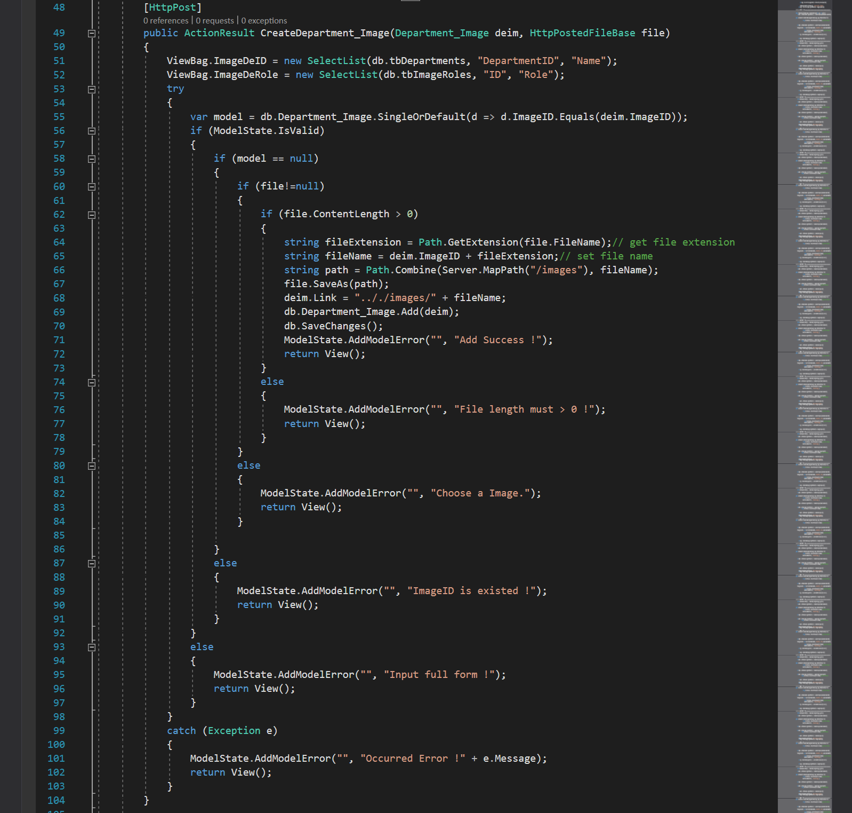

**e. Edit Department Post**

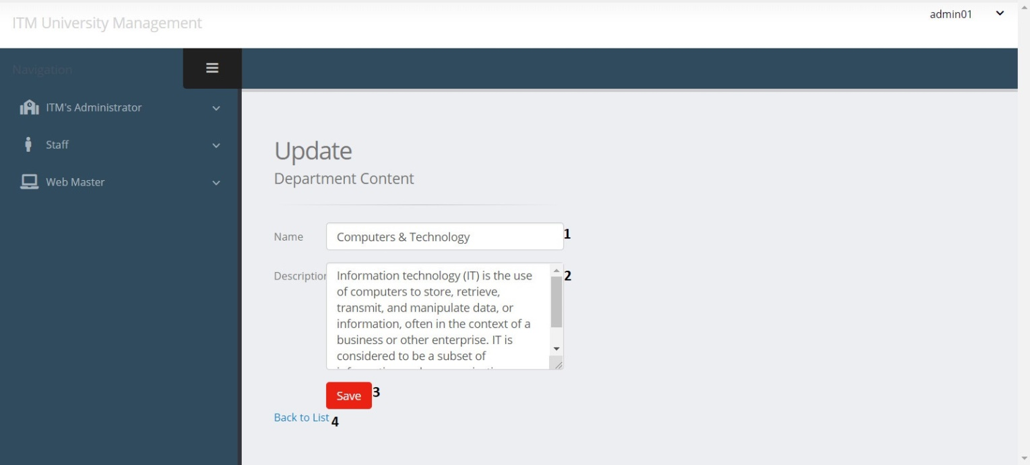

|  |  |  |  |  |  |  |
| --- | --- | --- | --- | --- | --- | --- |
| Edit Department Post | | | | | | |
| No. | Name | Type | Validation | Event | Description | Status |
| 1 | Name | TextField | 0 <= Length <= 50 | Input | Input Department Name | Enable |
| 2 | Description | TextField |  | Input | Input Description | Enable |
| 3 | btnSave | Button |  | Click | Submit form Edit | Enable |
| 4 | Back to list | Hyberlink |  | Click | View Department Image List | Enable |

* Some code review:
* Edit Department:

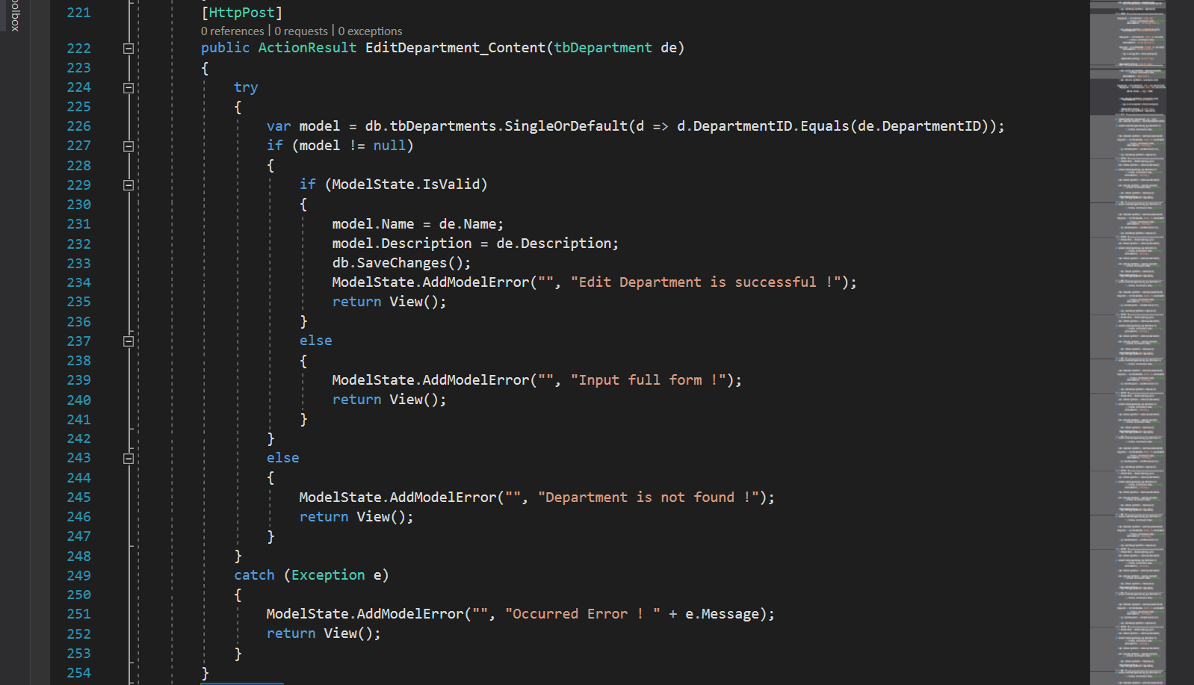

**f. Edit Department Image**

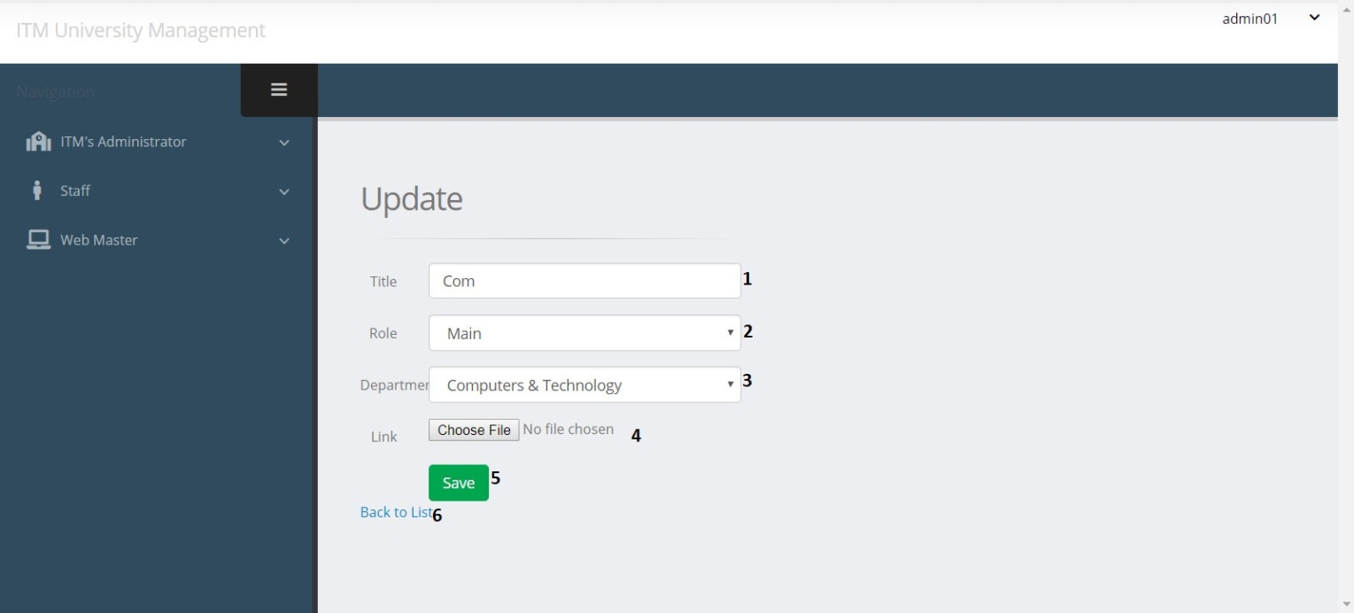

|  |  |  |  |  |  |  |
| --- | --- | --- | --- | --- | --- | --- |
| Edit Department Image | | | | | | |
| No. | Name | Type | Validation | Event | Description | Status |
| 1 | ImgTitle | TextField | 0 <= Length <= 50 | Input | Input Image Title | Enable |
| 2 | Role | Dropdown |  | Click | Choose Role | Enable |
| 3 | DepartmentID | Dropdown |  | Click | Choose Department | Enable |
| 4 | Link | File | 0 <= Length<= 100 | Click | Path of Image | Enable |
| 5 | btnSave | Button |  | Click | Submit form Edit | Enable |
| 6 | Back to list | Hyberlink |  | Click | View Department List | Enable |

* Some code review:
* Edit Department Image:

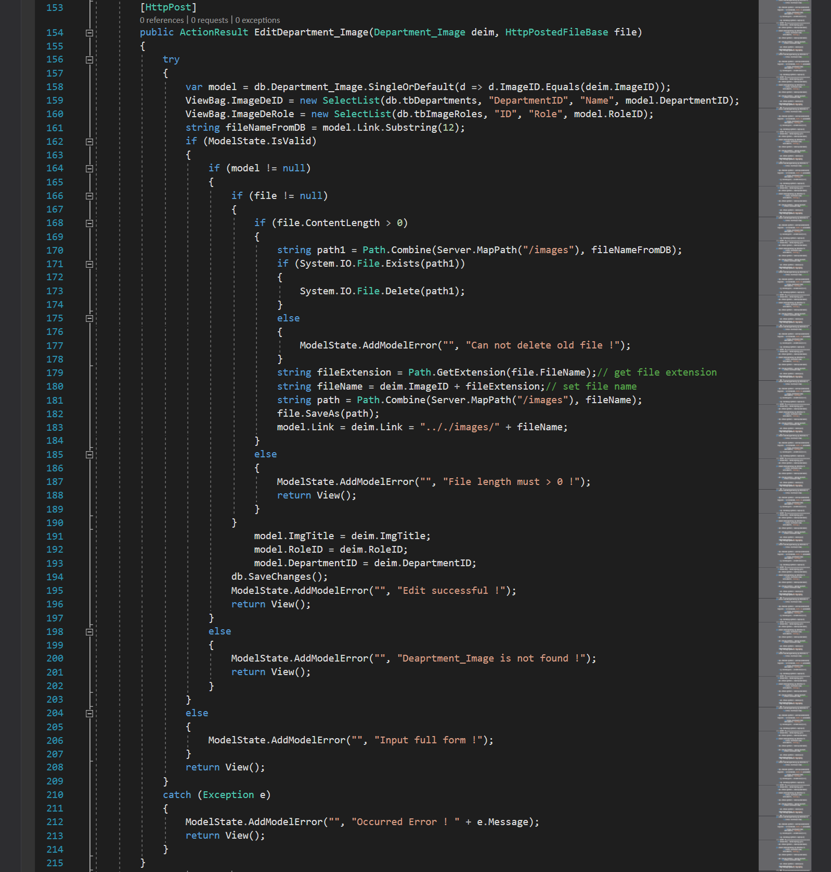

* Delete Department:

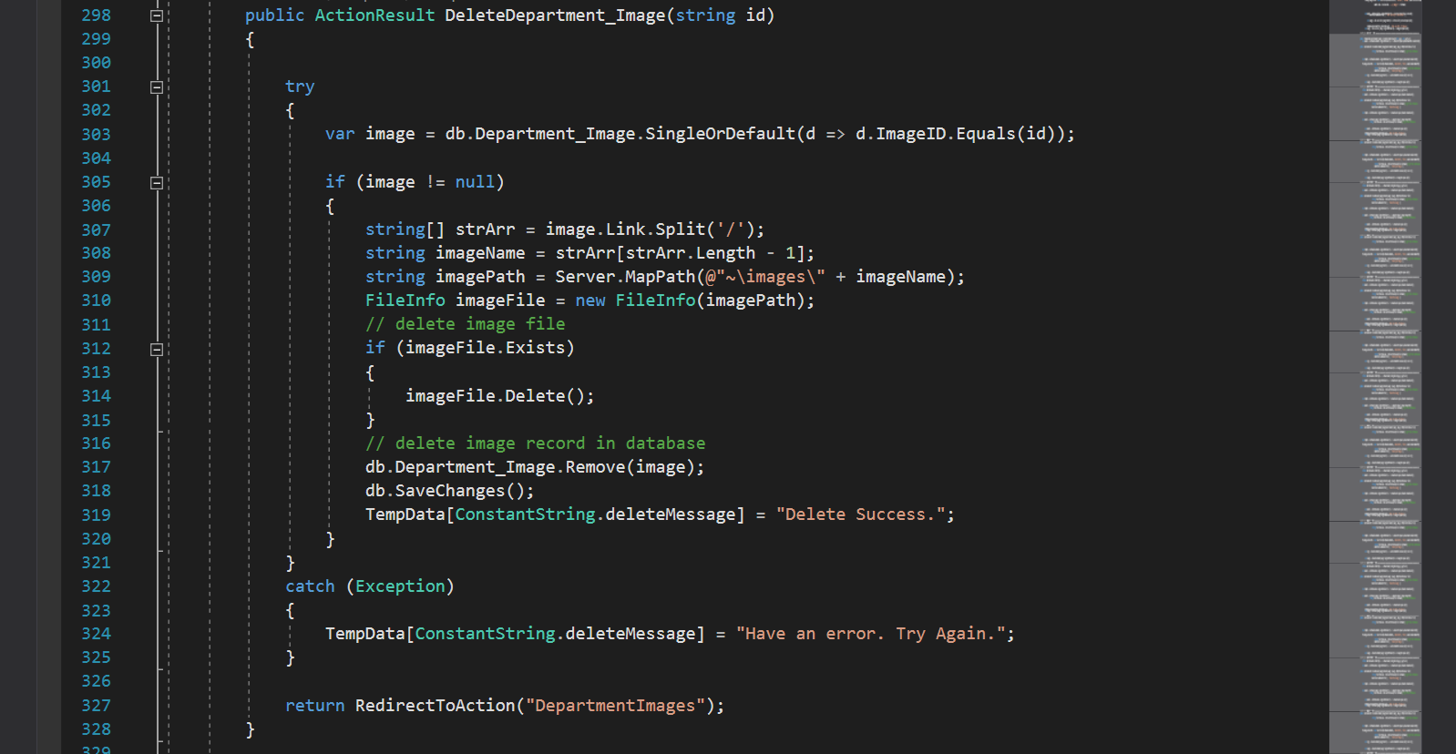

* Delete Department Image:

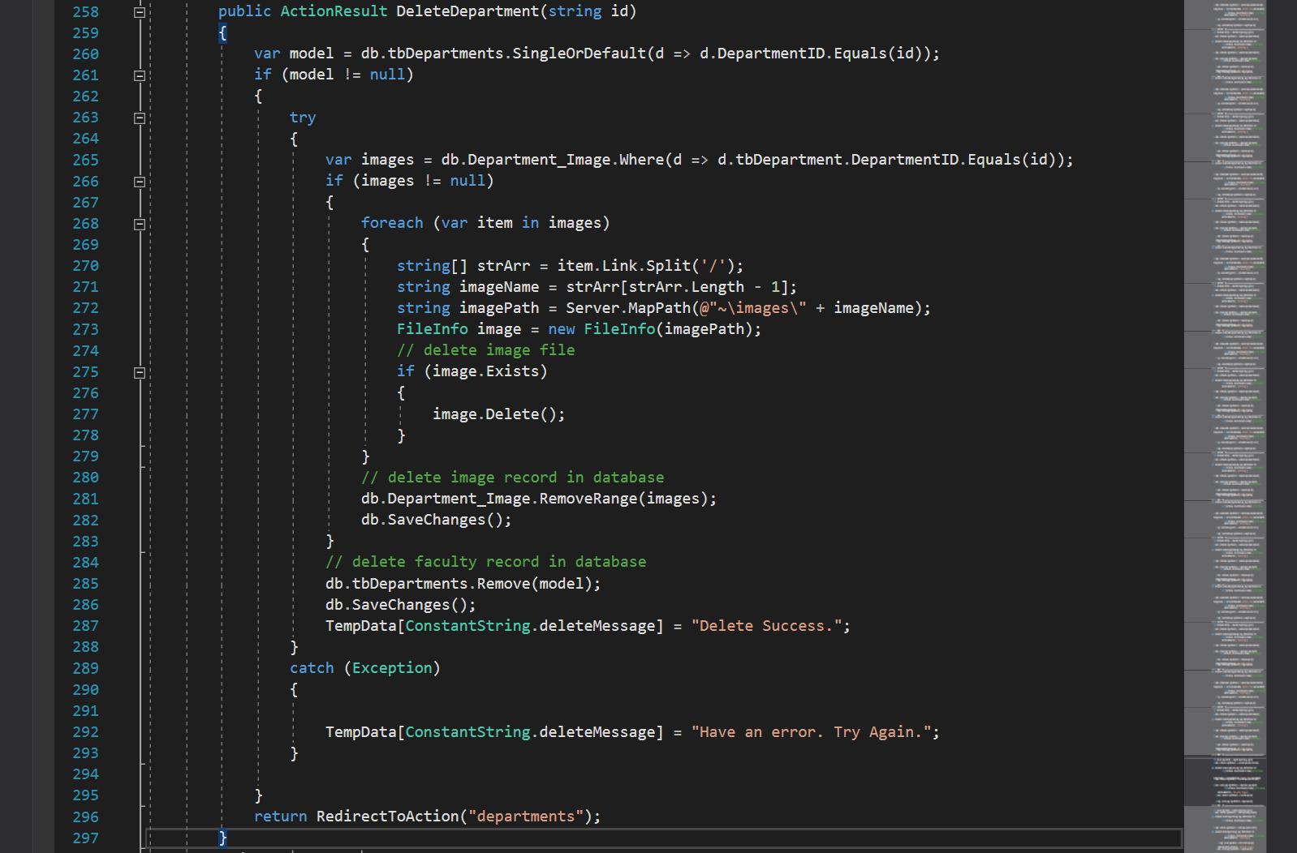

1. Faculty management

**a. Faculty Post List**

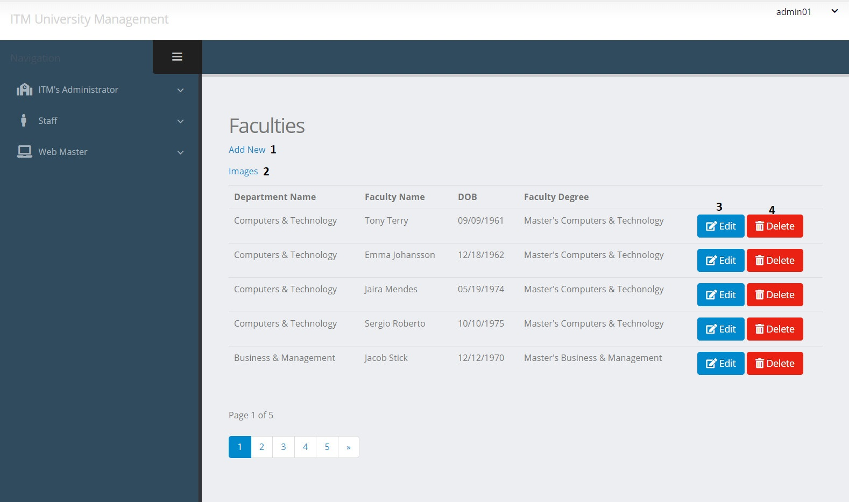

|  |  |  |  |  |  |  |
| --- | --- | --- | --- | --- | --- | --- |
| Faculty Post | | | | | | |
| No. | Name | Type | Validation | Event | Description | Status |
| 1 | Create | Hyberlink |  | Click | Create new Faculty Post | Enable |
| 2 | Images | Hyberlink |  | Click | View Faculty Images list | Enable |
| 3 | btnEdit | Button |  | Click | Edit Faculty Post | Enable |
| 4 | btnDelete | Button |  | Click | Delete Faculty Post | Enable |

**b. Faculty Image List**

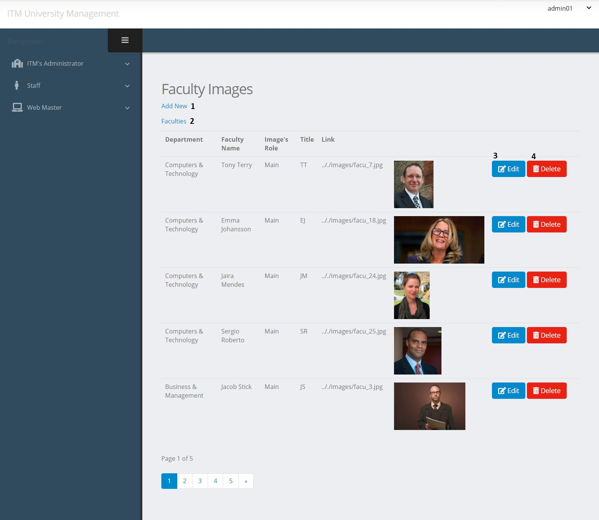

|  |  |  |  |  |  |  |
| --- | --- | --- | --- | --- | --- | --- |
| Faculty Image | | | | | | |
| No. | Name | Type | Validation | Event | Description | Status |
| 1 | Create | Hyberlink |  | Click | Create new Faculty Image | Enable |
| 2 | Faculty | Hyberlink |  | Click | View Faculty List | Enable |
| 3 | btnEdit | Button |  | Click | Edit Faculty Image | Enable |
| 4 | btnDelete | Button |  | Click | Delete Faculty Image | Enable |

**c. Create Faculty Post**

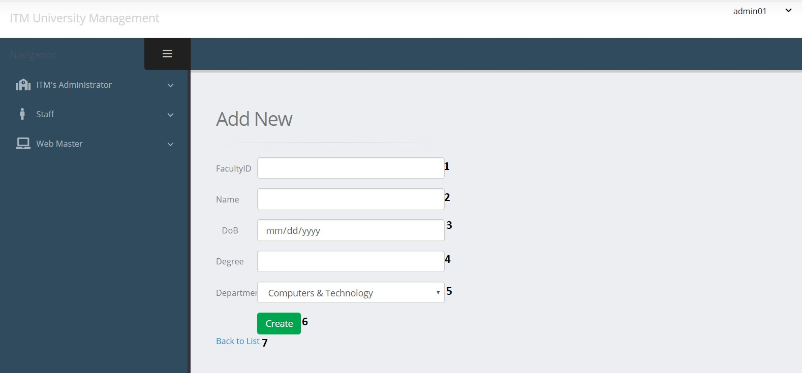

|  |  |  |  |  |  |  |
| --- | --- | --- | --- | --- | --- | --- |
| Create Faculty Post | | | | | | |
| No. | Name | Type | Validation | Event | Description | Status |
| 1 | FaculID | TextField | 0 <= Length <= 30 | Input | Input Faculty ID | Enable |
| 2 | Name | TextField | 0 <= Length <= 50 | Input | Input Faculty Name | Enable |
| 3 | DoB | TextField | Datetime | Input | Input Faculty Day of Birth | Enable |
| 4 | Degree | TextField | 0 <= Length <= 20 | Click | Input Degree of Faculty | Enable |
| 5 | Department | Dropdown |  | Click | Choose Department | Enable |
| 6 | btnCreate | Button |  | Click | Submit form Create | Enable |
| 7 | Back to list | Hyberlink |  | Click | URL to faculty list | Enable |

**d. Create Faculty Image**

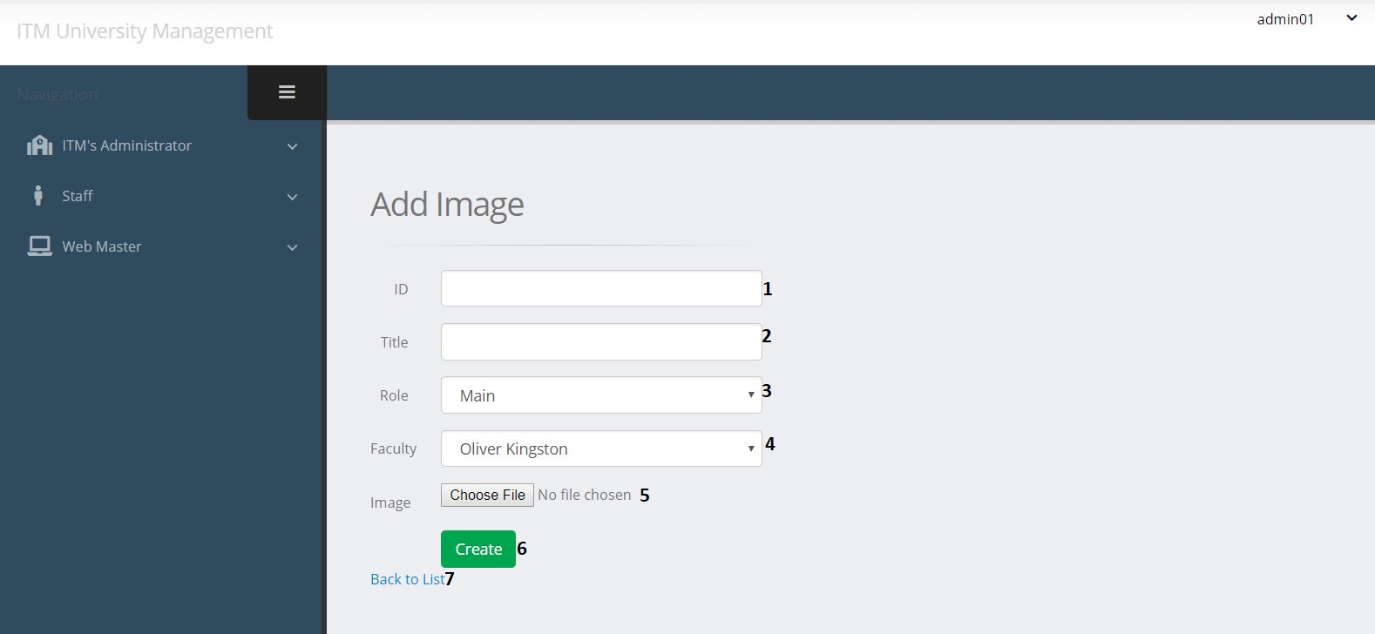

|  |  |  |  |  |  |  |
| --- | --- | --- | --- | --- | --- | --- |
| Create Faculty Image | | | | | | |
| No. | Name | Type | Validation | Event | Description | Status |
| 1 | ImageID | TextField | 0 <= Length <= 30 | Input | Input Image ID | Enable |
| 2 | ImgTitle | TextField | 0 <= Length <= 50 | Input | Input Image Title | Enable |
| 3 | Role | Dropdown |  | Click | Choose Role | Enable |
| 4 | FaculID | Dropdown |  | Click | Choose Faculty | Enable |
| 5 | Link | File | 0 <= Length<= 100 | Click | Path of Image | Enable |
| 6 | btnCreate | Button |  | Click | Submit form Create | Enable |
| 7 | Back to list | Hyberlink |  | Click | URL to faculty image list | Enable |

**e. Edit Faculty Post**

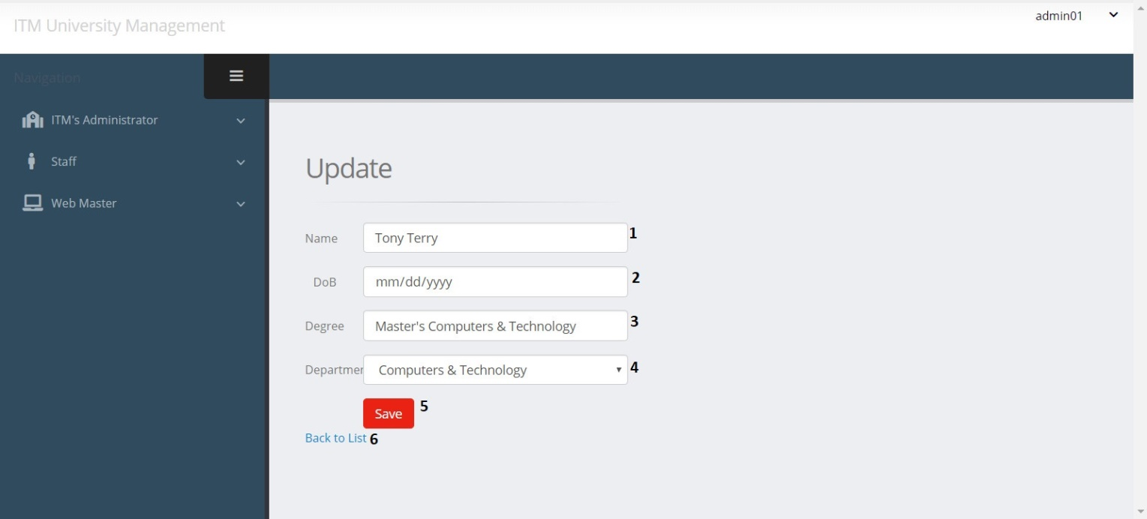

|  |  |  |  |  |  |  |
| --- | --- | --- | --- | --- | --- | --- |
| Edit Faculty Post | | | | | | |
| No. | Name | Type | Validation | Event | Description | Status |
| 1 | Name | TextField | 0 <= Length <= 50 | Input | Input Faculty Name | Enable |
| 2 | DoB | TextField | Datetime | Input | Input Faculty Day of Birth | Enable |
| 3 | Degree | TextField | 0 <= Length <= 20 | Click | Input Degree of Faculty | Enable |
| 4 | Department | Dropdown |  | Click | Choose Department | Enable |
| 5 | btnSave | Button |  | Click | Submit form Edit | Enable |
| 6 | Back to list | Hyberlink |  | Click | View faculty list | Enable |

**f. Edit Faculty Image**

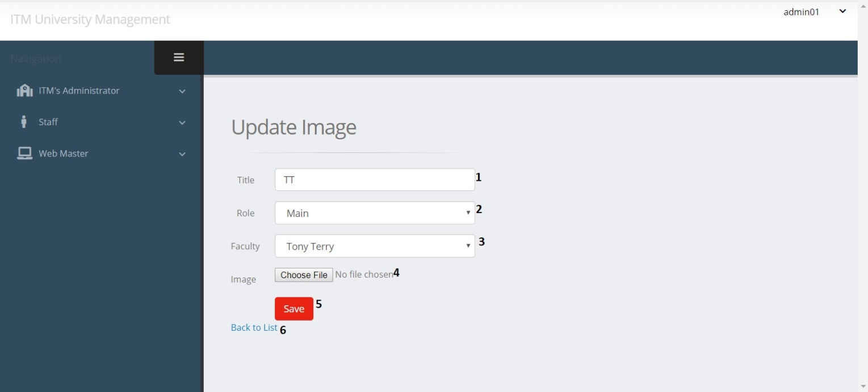

|  |  |  |  |  |  |  |
| --- | --- | --- | --- | --- | --- | --- |
| Edit Faculty Image | | | | | | |
| No. | Name | Type | Validation | Event | Description | Status |
| 1 | ImgTitle | TextField | 0 <= Length <= 50 | Input | Input Image Title | Enable |
| 2 | Role | Dropdown |  | Click | Choose Role | Enable |
| 3 | FaculID | Dropdown |  | Click | Choose Faculty | Enable |
| 4 | Link | File | 0 <= Length<= 100 | Click | Path of Image | Enable |
| 5 | btnSave | Button |  | Click | Submit form Edit | Enable |
| 6 | Back to list | Hyberlink |  | Click | View faculty image list | Enable |

1. Facility management

**a. Facility Post List**

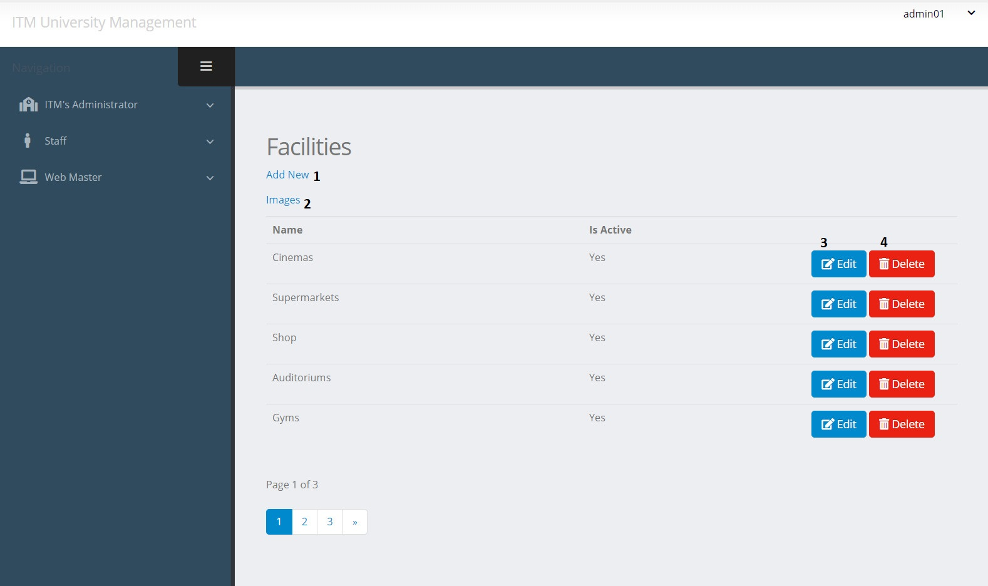

|  |  |  |  |  |  |  |
| --- | --- | --- | --- | --- | --- | --- |
| Facility Post | | | | | | |
| No. | Name | Type | Validation | Event | Description | Status |
| 1 | Create | Hyberlink |  | Click | Create new Facility Post | Enable |
| 2 | Images | Hyberlink |  | Click | View Facility image list | Enable |
| 3 | btnEdit | Button |  | Click | Edit Facility Post | Enable |
| 4 | btnDelete | Button |  | Click | Delete Facility Post | Enable |

**b. Facility Image List**

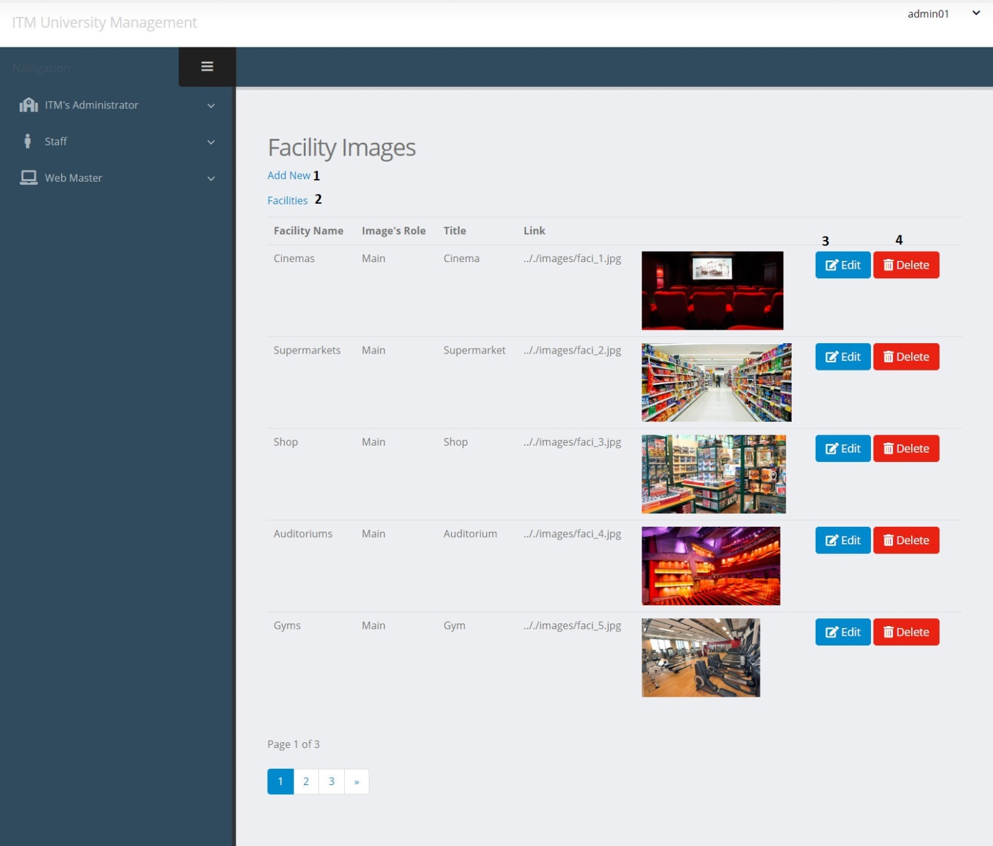

|  |  |  |  |  |  |  |
| --- | --- | --- | --- | --- | --- | --- |
| Facility Image | | | | | | |
| No. | Name | Type | Validation | Event | Description | Status |
| 1 | Create | Hyberlink |  | Click | Create new Facility Image | Enable |
| 2 | Facilities | Hyberlink |  | Click | View Facility List | Enable |
| 3 | btnEdit | Button |  | Click | Edit Facility Image | Enable |
| 4 | btnDelete | Button |  | Click | Delete Facility Image | Enable |

**c. Create Facility Post**

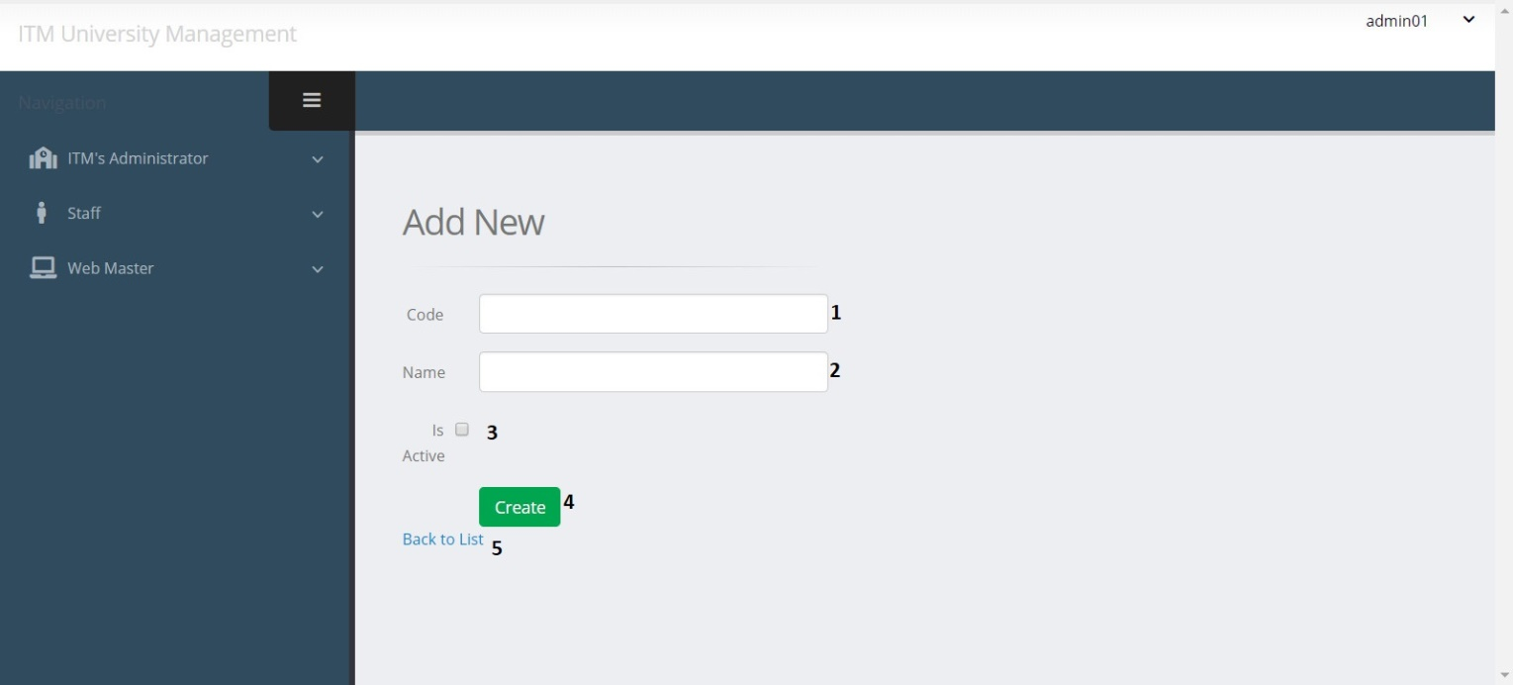

|  |  |  |  |  |  |  |
| --- | --- | --- | --- | --- | --- | --- |
| Create Facility Post | | | | | | |
| No. | Name | Type | Validation | Event | Description | Status |
| 1 | FacCode | TextField | 0 <= Length <= 30 | Input | Input Facility ID | Enable |
| 2 | Name | TextField | 0 <= Length <= 50 | Input | Input Facility Name | Enable |
| 3 | isActive | Checkbox |  | Click | Check if Facility is Active | Enable |
| 4 | btnCreate | Button |  | Click | Submit form Create | Enable |
| 5 | Back to list | Hyberlink |  | Click | View facility list | Enable |

**d. Create Facility Image**

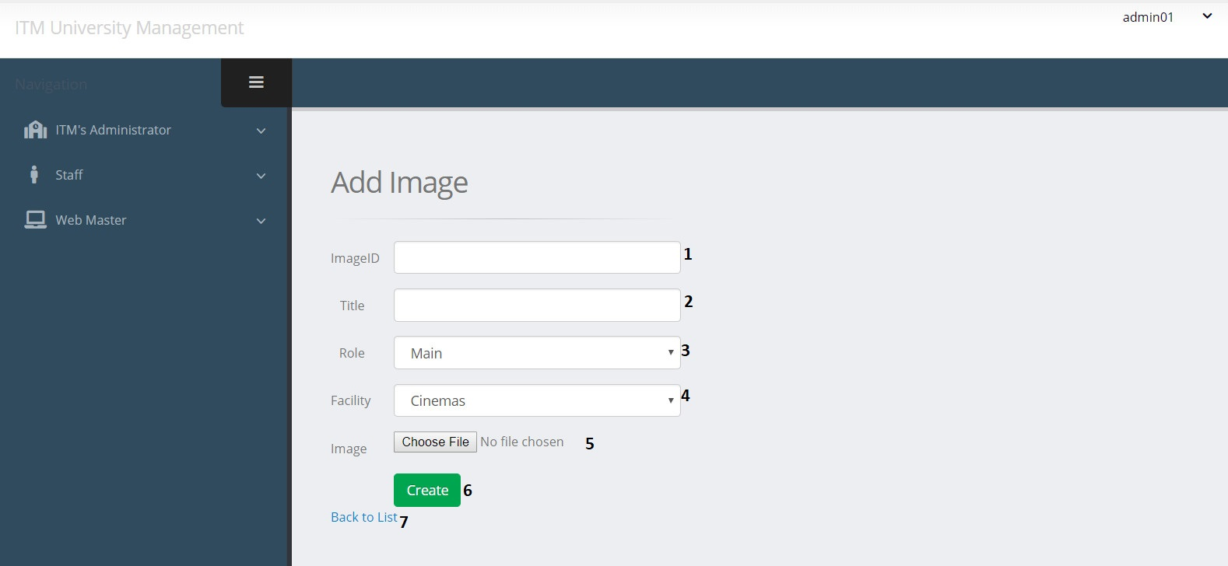

|  |  |  |  |  |  |  |
| --- | --- | --- | --- | --- | --- | --- |
| Create Facility Image | | | | | | |
| No. | Name | Type | Validation | Event | Description | Status |
| 1 | ImageID | TextField | 0 <= Length <= 30 | Input | Input Image ID | Enable |
| 2 | ImgTitle | TextField | 0 <= Length <= 50 | Input | Input Image Title | Enable |
| 3 | Role | Dropdown |  | Click | Choose Role | Enable |
| 4 | FaciliID | Dropdown |  | Click | Choose Facility | Enable |
| 5 | Link | File | 0 <= Length<= 100 | Click | Path of Image | Enable |
| 6 | btnCreate | Button |  | Click | Submit form Create | Enable |
| 7 | Back to list | Hyberlink |  | Click | View facility image list | Enable |

**e. Edit Facility Post**

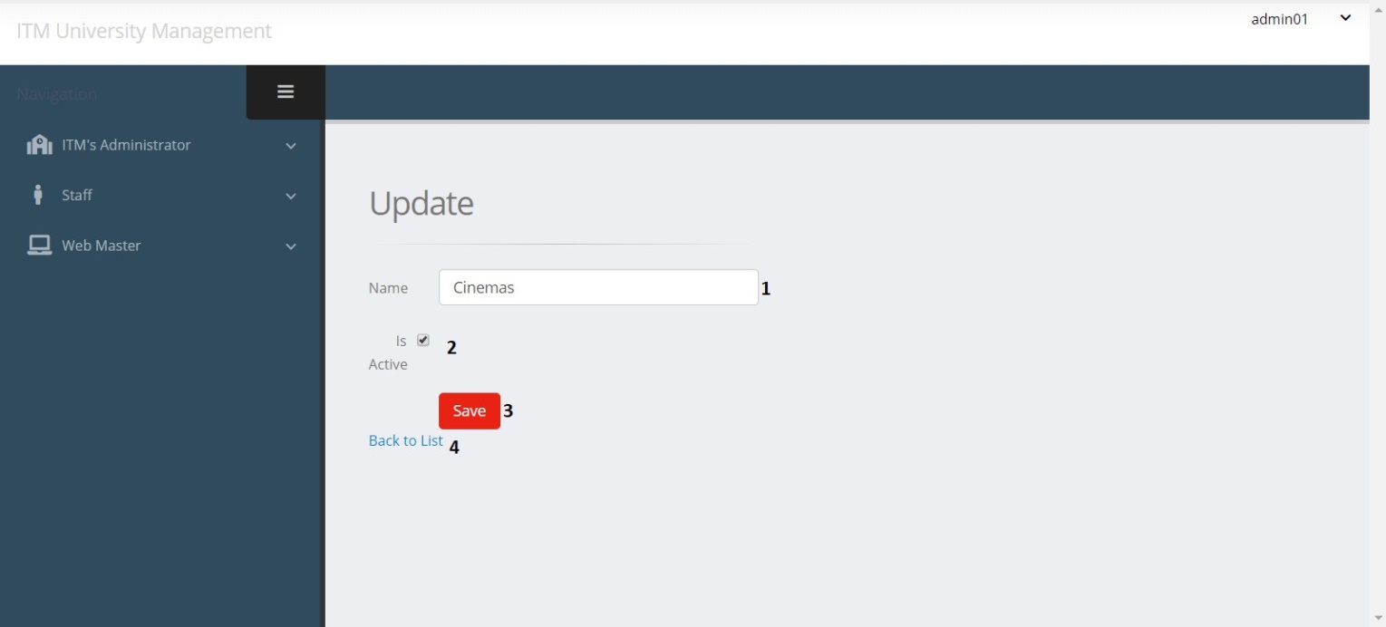

|  |  |  |  |  |  |  |
| --- | --- | --- | --- | --- | --- | --- |
| Edit Facility Post | | | | | | |
| No. | Name | Type | Validation | Event | Description | Status |
| 1 | Name | TextField | 0 <= Length <= 50 | Input | Input Facility Name | Enable |
| 2 | isActive | RadioButton |  | Click | Check if Facility is Active | Enable |
| 3 | btnSave | Button |  | Click | Submit form Edit | Enable |
| 4 | Back to list | Hyberlink |  | Click | View facility list | Enable |

**f. Edit Facility Image**

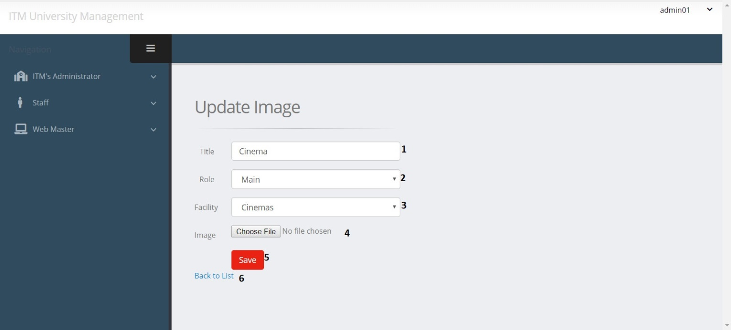

|  |  |  |  |  |  |  |
| --- | --- | --- | --- | --- | --- | --- |
| Edit Facility Image | | | | | | |
| No. | Name | Type | Validation | Event | Description | Status |
| 1 | ImgTitle | TextField | 0 <= Length <= 50 | Input | Input Image Title | Enable |
| 2 | Role | Dropdown |  | Click | Choose Role | Enable |
| 3 | FacCode | Dropdown |  | Click | Choose Facility | Enable |
| 4 | Link | File | 0 <= Length<= 100 | Click | Path of Image | Enable |
| 5 | btnSave | Button |  | Click | Submit form Edit | Enable |
| 6 | Back to list | Hyberlink |  | Click | View facility image list | Enable |

1. Course management

**a. Course Post List**

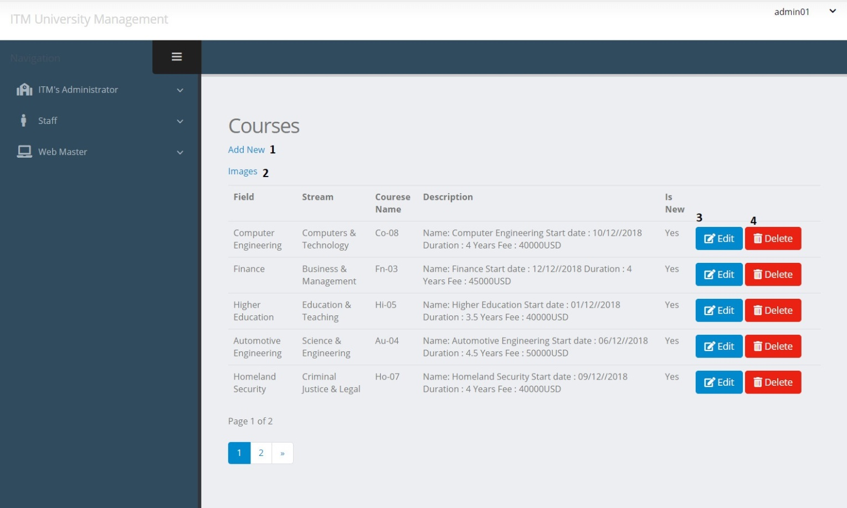

|  |  |  |  |  |  |  |
| --- | --- | --- | --- | --- | --- | --- |
| Course Post | | | | | | |
| No. | Name | Type | Validation | Event | Description | Status |
| 1 | Create | Hyberlink |  | Click | Create new Course Post | Enable |
| 2 | Images | Hyberlink |  | Click | View course Image list | Enable |
| 3 | btnEdit | Button |  | Click | Edit Course Post | Enable |
| 4 | btnDelete | Button |  | Click | Delete Course Post | Enable |

**b. Course Image List**

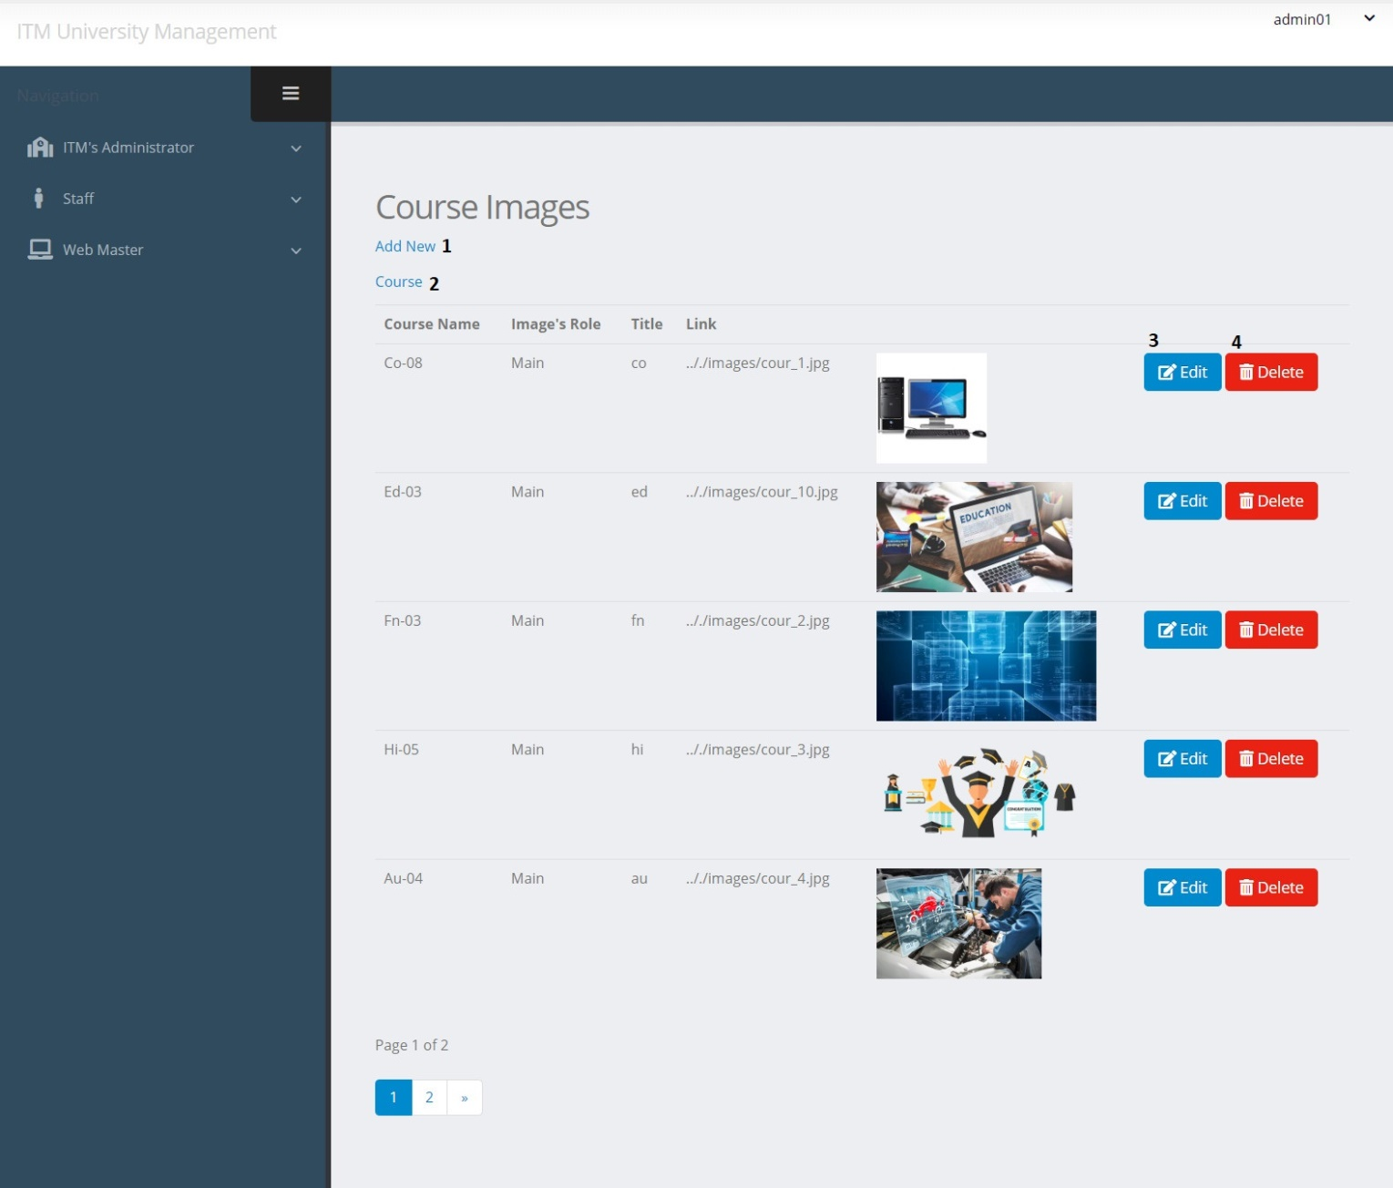

|  |  |  |  |  |  |  |
| --- | --- | --- | --- | --- | --- | --- |
| Course Image | | | | | | |
| No. | Name | Type | Validation | Event | Description | Status |
| 1 | Create | Hyberlink |  | Click | Create new Course Image | Enable |
| 2 | Course | PageList |  | Click | View Course List | Enable |
| 3 | btnEdit | Button |  | Click | Edit Course Image | Enable |
| 4 | btnDelete | Button |  | Click | Delete Course Image | Enable |

**c. Create Course Post**

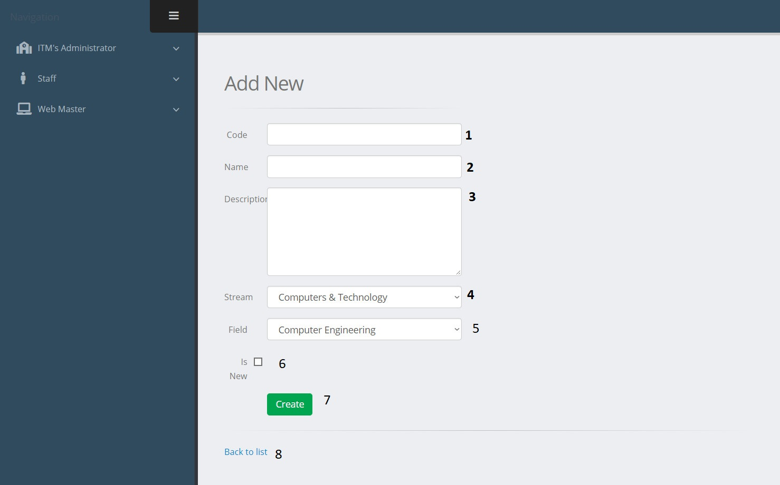

|  |  |  |  |  |  |  |
| --- | --- | --- | --- | --- | --- | --- |
| Create Course Post | | | | | | |
| No. | Name | Type | Validation | Event | Description | Status |
| 1 | CourseID | TextField | 0 <= Length <= 30 | Input | Input Course ID | Enable |
| 2 | Name | TextField | 0 <= Length <= 50 | Input | Input Course Name | Enable |
| 3 | Description | TextField |  | Input | About Course | Enable |
| 4 | Stream | Dropdown |  | Click | Choose Stream for Course | Enable |
| 5 | Field | Dropdown |  | Click | Choose Field for Course | Enable |
| 6 | isNew | RadioButton |  | Click | Check if Course is New | Enable |
| 7 | btnCreate | Button |  | Click | Submit form Create | Enable |
| 8 | Back to list | Hyberlink |  | Click | View Course list | Enable |

**d. Create Course Image**

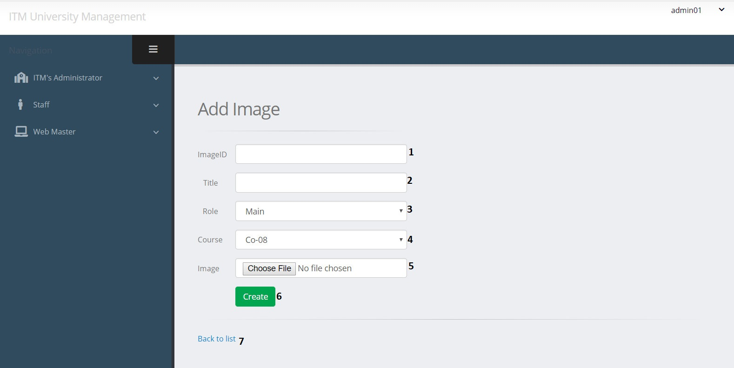

|  |  |  |  |  |  |  |
| --- | --- | --- | --- | --- | --- | --- |
| Create Course Image | | | | | | |
| No. | Name | Type | Validation | Event | Description | Status |
| 1 | ImageID | TextField | 0 <= Length <= 30 | Input | Input Image ID | Enable |
| 2 | ImgTitle | TextField | 0 <= Length <= 50 | Input | Input Image Title | Enable |
| 3 | Role | Dropdown |  | Click | Choose Role | Enable |
| 4 | CourseID | Dropdown |  | Click | Choose Course | Enable |
| 5 | Link | File | 0 <= Length<= 100 | Click | Path of Image | Enable |
| 6 | btnCreate | Button |  | Click | Submit form Create | Enable |
| 7 | Back to list | Hyberlink |  | Click | View Course Image List | Enable |

**e. Edit Course Post**

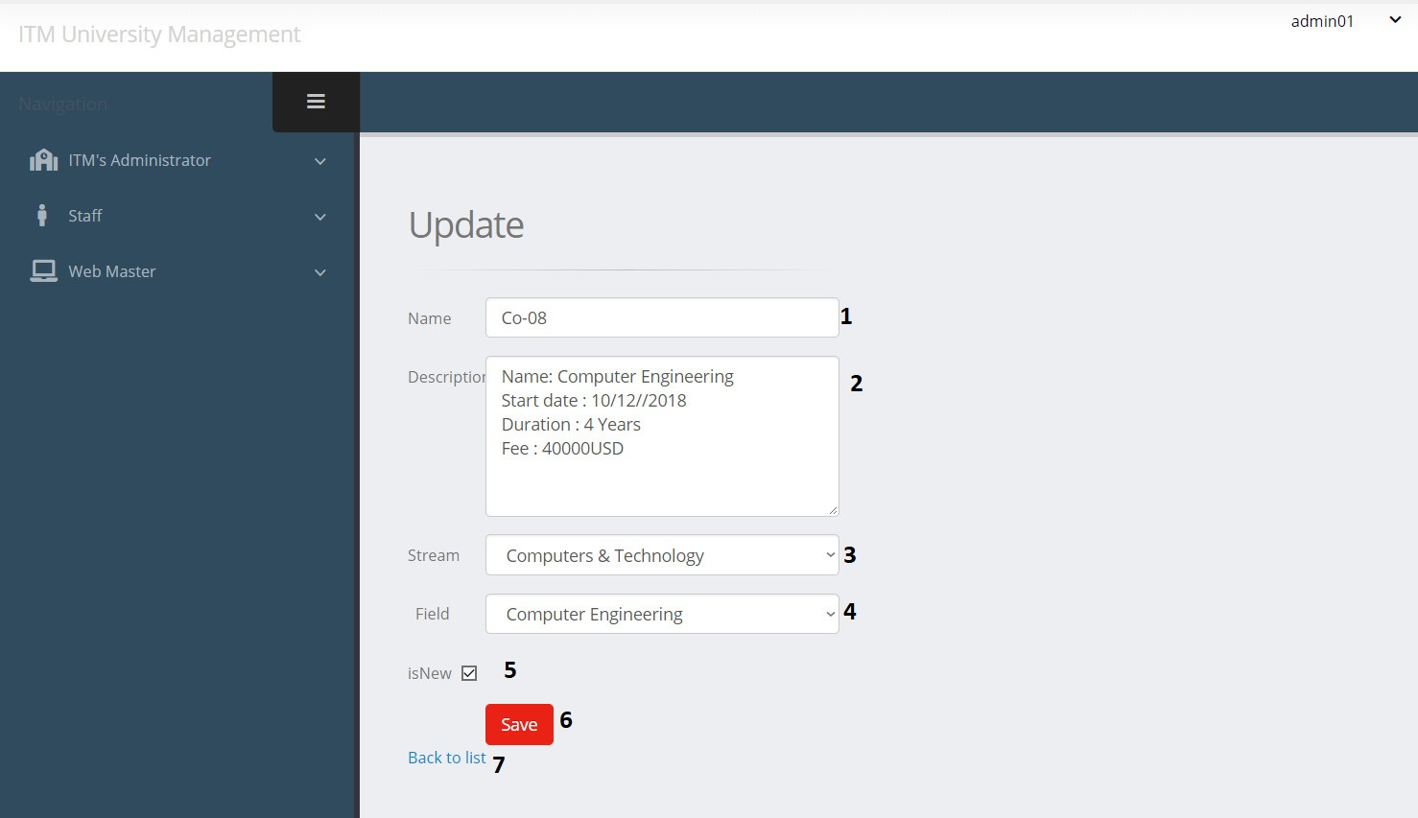

|  |  |  |  |  |  |  |
| --- | --- | --- | --- | --- | --- | --- |
| Edit Course Post | | | | | | |
| No. | Name | Type | Validation | Event | Description | Status |
| 1 | Name | TextField | 0 <= Length <= 50 | Input | Input Course Name | Enable |
| 2 | Description | TextField |  | Input | About Course | Enable |
| 3 | Stream | Dropdown |  | Click | Choose Stream for Course | Enable |
| 4 | Field | Dropdown |  | Click | Choose Field for Course | Enable |
| 5 | isNew | RadioButton |  | Click | Check if Course is New | Enable |
| 6 | btnSave | Button |  | Click | Submit form Edit | Enable |
| 7 | Back to list | Hyberlink |  | Click | View course list | Enable |

**f. Edit Course Image**

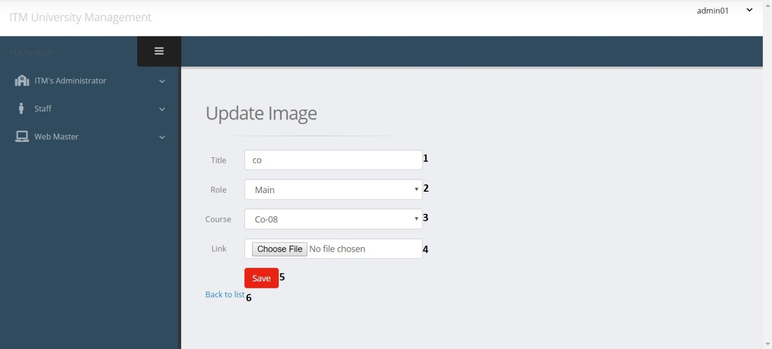

|  |  |  |  |  |  |  |
| --- | --- | --- | --- | --- | --- | --- |
| Edit Course Image | | | | | | |
| No. | Name | Type | Validation | Event | Description | Status |
| 1 | ImgTitle | TextField | 0 <= Length <= 50 | Input | Input Image Title | Enable |
| 2 | Role | Dropdown |  | Click | Choose Role | Enable |
| 3 | CourseID | Dropdown |  | Click | Choose Course | Enable |
| 4 | Link | File | 0 <= Length<= 100 | Click | Path of Image | Enable |
| 5 | btnSave | Button |  | Click | Submit form Edit | Enable |
| 6 | Back | Hyberlink |  | Click | View course image list | Enable |

1. Event management

**a. Event Post List**

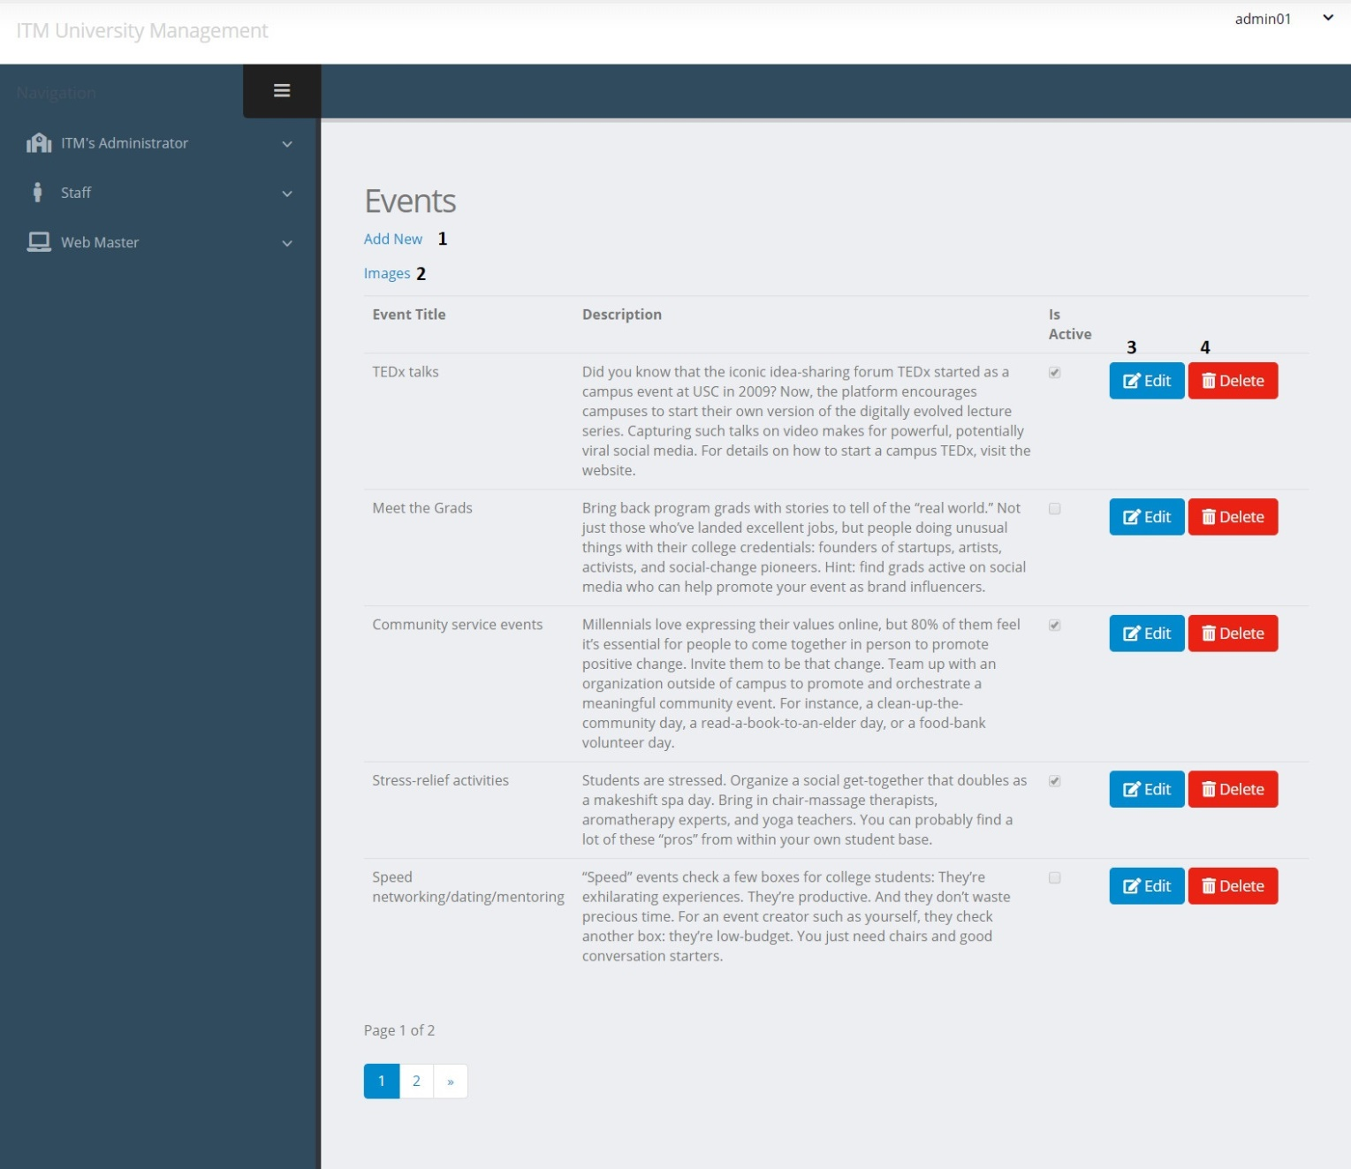

|  |  |  |  |  |  |  |
| --- | --- | --- | --- | --- | --- | --- |
| Event Post | | | | | | |
| No. | Name | Type | Validation | Event | Description | Status |
| 1 | Create | Hyberlink |  | Click | Create new Event Post | Enable |
| 2 | Images | Hyberlink |  | Click | View Event Image list | Enable |
| 3 | btnEdit | Button |  | Click | Edit Event Post | Enable |
| 4 | btnDelete | Button |  | Click | Delete Event Post | Enable |

**b. Event Image List**

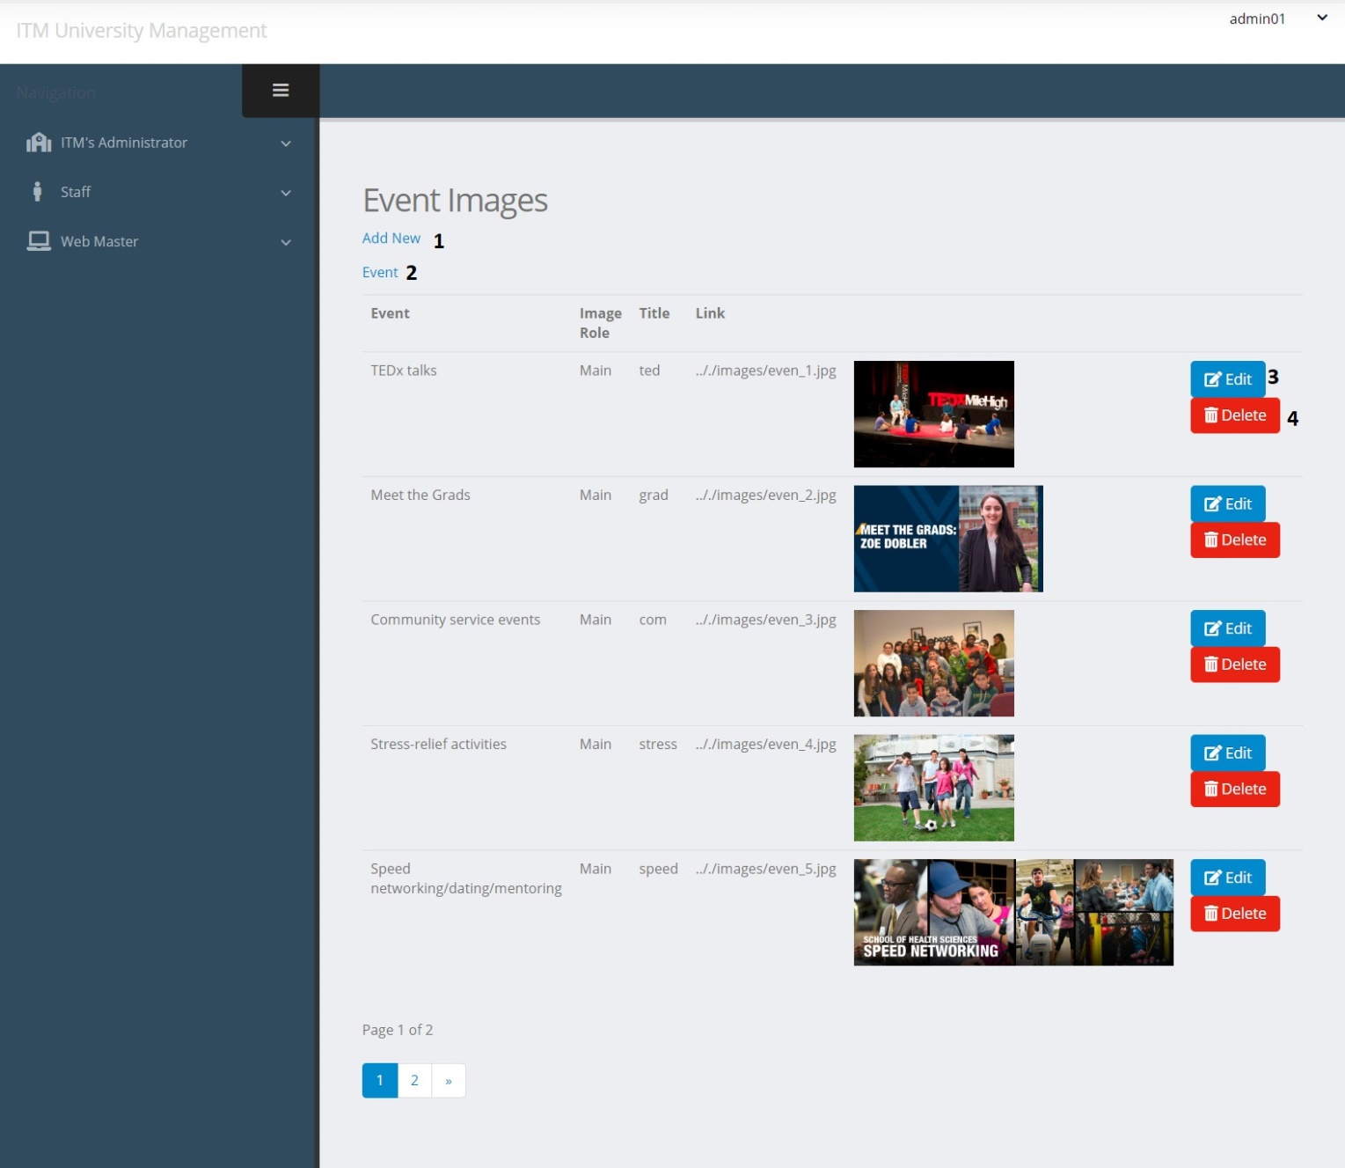

|  |  |  |  |  |  |  |
| --- | --- | --- | --- | --- | --- | --- |
| Event Image | | | | | | |
| No. | Name | Type | Validation | Event | Description | Status |
| 1 | Create | Hyberlink |  | Click | Create new Event Image | Enable |
| 2 | Event | Hyberlink |  | Click | View Event List | Enable |
| 3 | btnEdit | Button |  | Click | Edit Event Image | Enable |
| 4 | btnDelete | Button |  | Click | Delete Event Image | Enable |

**c. Create Event Post**

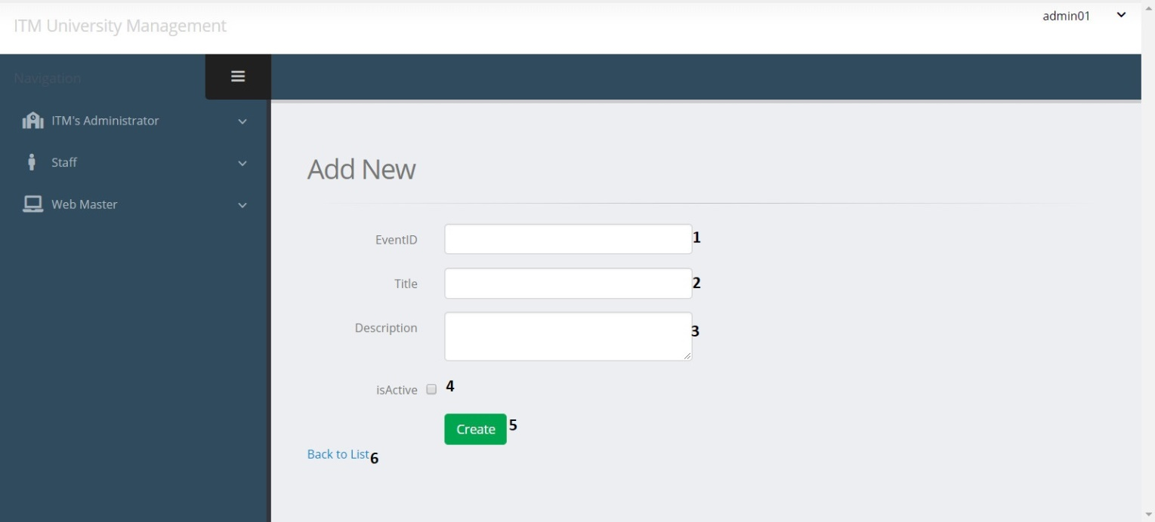

|  |  |  |  |  |  |  |
| --- | --- | --- | --- | --- | --- | --- |
| Create Event Post | | | | | | |
| No. | Name | Type | Validation | Event | Description | Status |
| 1 | EventID | TextField | 0 <= Length <= 30 | Input | Input Event ID | Enable |
| 2 | Title | TextField | 0 <= Length <= 50 | Input | Input Event Title | Enable |
| 3 | Description | TextField |  | Input | About Event | Enable |
| 4 | isActive | RadioButton |  | Click | Check if Event is Active | Enable |
| 5 | btnCreate | Button |  | Click | Submit form Create | Enable |
| 6 | Back to list | Hyberlink |  | Click | View event list | Enable |

**d. Create Event Image**

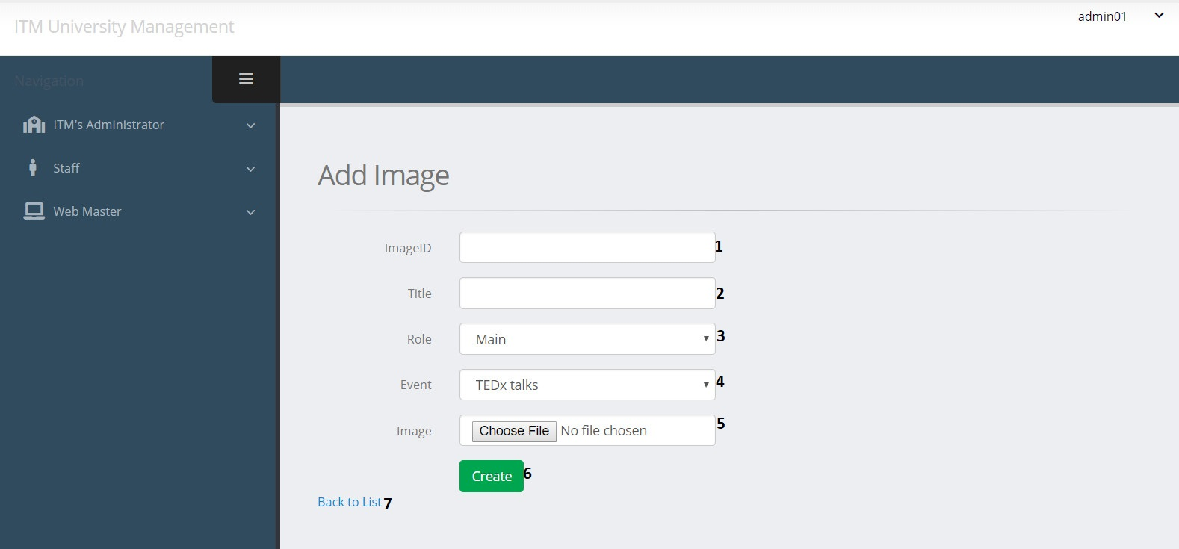

|  |  |  |  |  |  |  |
| --- | --- | --- | --- | --- | --- | --- |
| Create Event Image | | | | | | |
| No. | Name | Type | Validation | Event | Description | Status |
| 1 | ImageID | TextField | 0 <= Length <= 30 | Input | Input Image ID | Enable |
| 2 | ImgTitle | TextField | 0 <= Length <= 50 | Input | Input Image Title | Enable |
| 3 | Role | Dropdown |  | Click | Choose Role | Enable |
| 4 | EventID | Dropdown |  | Click | Choose Event | Enable |
| 5 | Link | File | 0 <= Length<= 100 | Click | Path of Image | Enable |
| 6 | btnCreate | Button |  | Click | Submit form Create | Enable |
| 7 | Back to list | Hyberlink |  | Click | View event image list | Enable |

**e. Edit Event Post**



|  |  |  |  |  |  |  |
| --- | --- | --- | --- | --- | --- | --- |
| Edit Event Post | | | | | | |
| No. | Name | Type | Validation | Event | Description | Status |
| 1 | Title | TextField | 0 <= Length <= 50 | Input | Input Event Title | Enable |
| 2 | Description | TextField |  | Input | About Event | Enable |
| 3 | isActive | RadioButton |  | Click | Check if Event is Active | Enable |
| 4 | btnSave | Button |  | Click | Submit form Edit | Enable |
| 5 | Back to list | Hyberlink |  | Click | View event list | Enable |

**f. Edit Event Image**

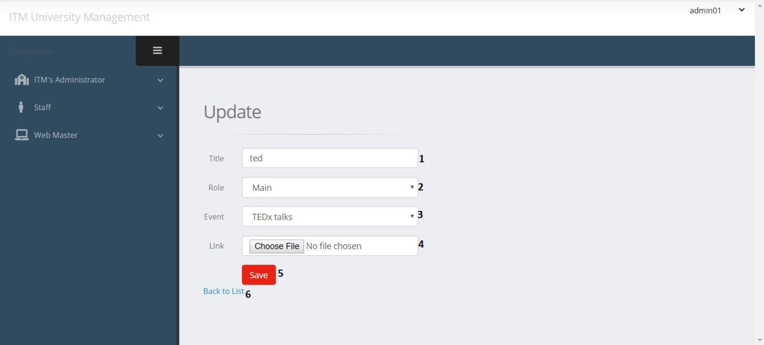

|  |  |  |  |  |  |  |
| --- | --- | --- | --- | --- | --- | --- |
| Create Achievement Image | | | | | | |
| No. | Name | Type | Validation | Event | Description | Status |
| 1 | ImgTitle | TextField | 0 <= Length <= 50 | Input | Input Image Title | Enable |
| 2 | Role | Dropdown |  | Click | Choose Role | Enable |
| 3 | EventID | Dropdown |  | Click | Choose Event | Enable |
| 4 | Link | File | 0 <= Length<= 100 | Click | Path of Image | Enable |
| 5 | btnSave | Button |  | Click | Submit form Edit | Enable |
| 6 | Back to list | Hyberlink |  | Click | View event image list | Enable |

1. Achievement management

a. Achievement Post List

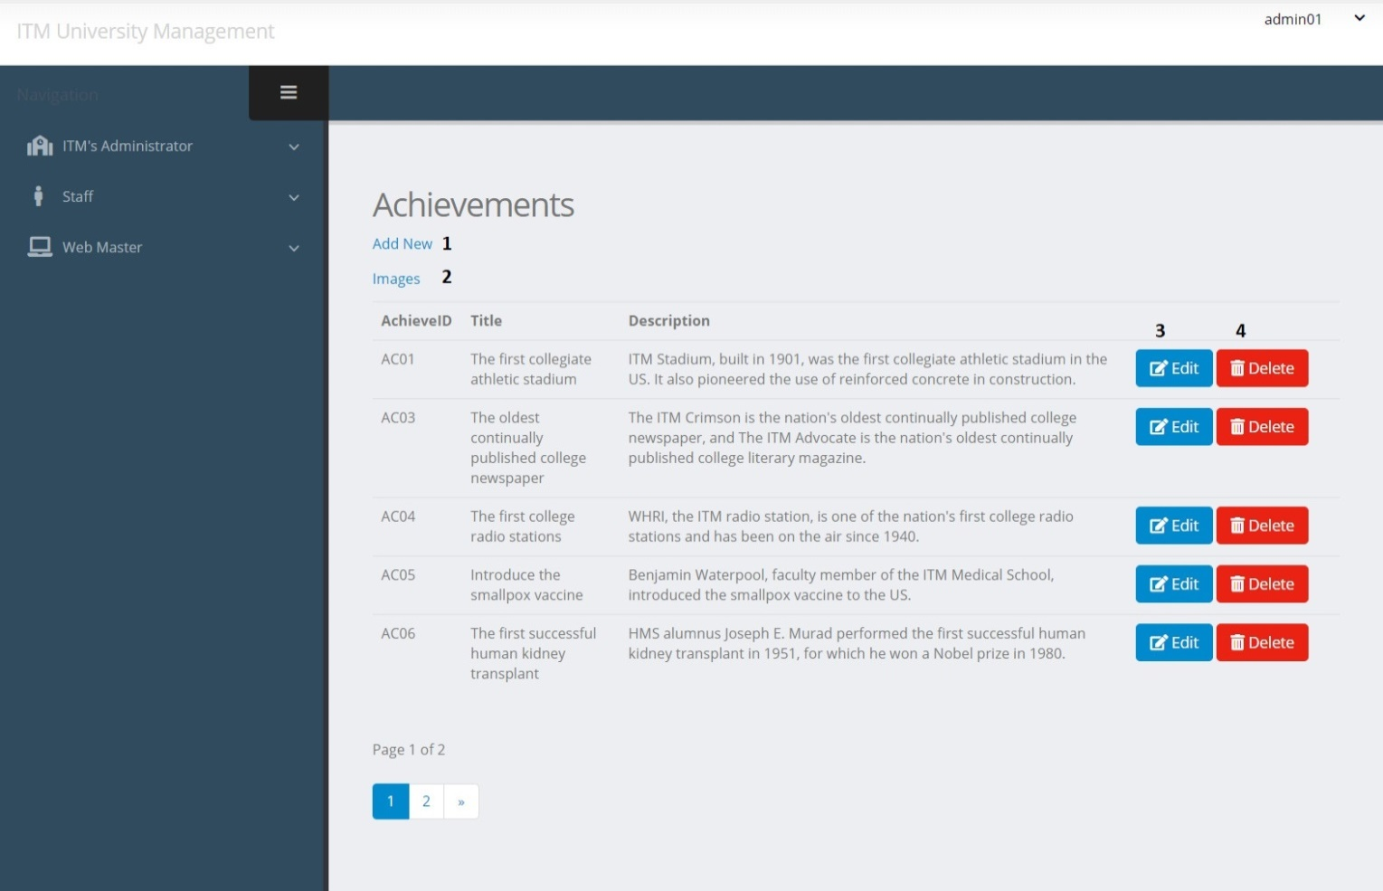

|  |  |  |  |  |  |  |
| --- | --- | --- | --- | --- | --- | --- |
| Achievement Post | | | | | | |
| No. | Name | Type | Validation | Event | Description | Status |
| 1 | Create | Hyberlink |  | Click | Create new Achievement Post | Enable |
| 2 | Images | Hyberlink |  | Click | View echivement image list | Enable |
| 3 | btnEdit | Button |  | Click | Edit Achievement Post | Enable |
| 4 | btnDelete | Button |  | Click | Delete Achievement Post | Enable |

**b. Achievement Image List**

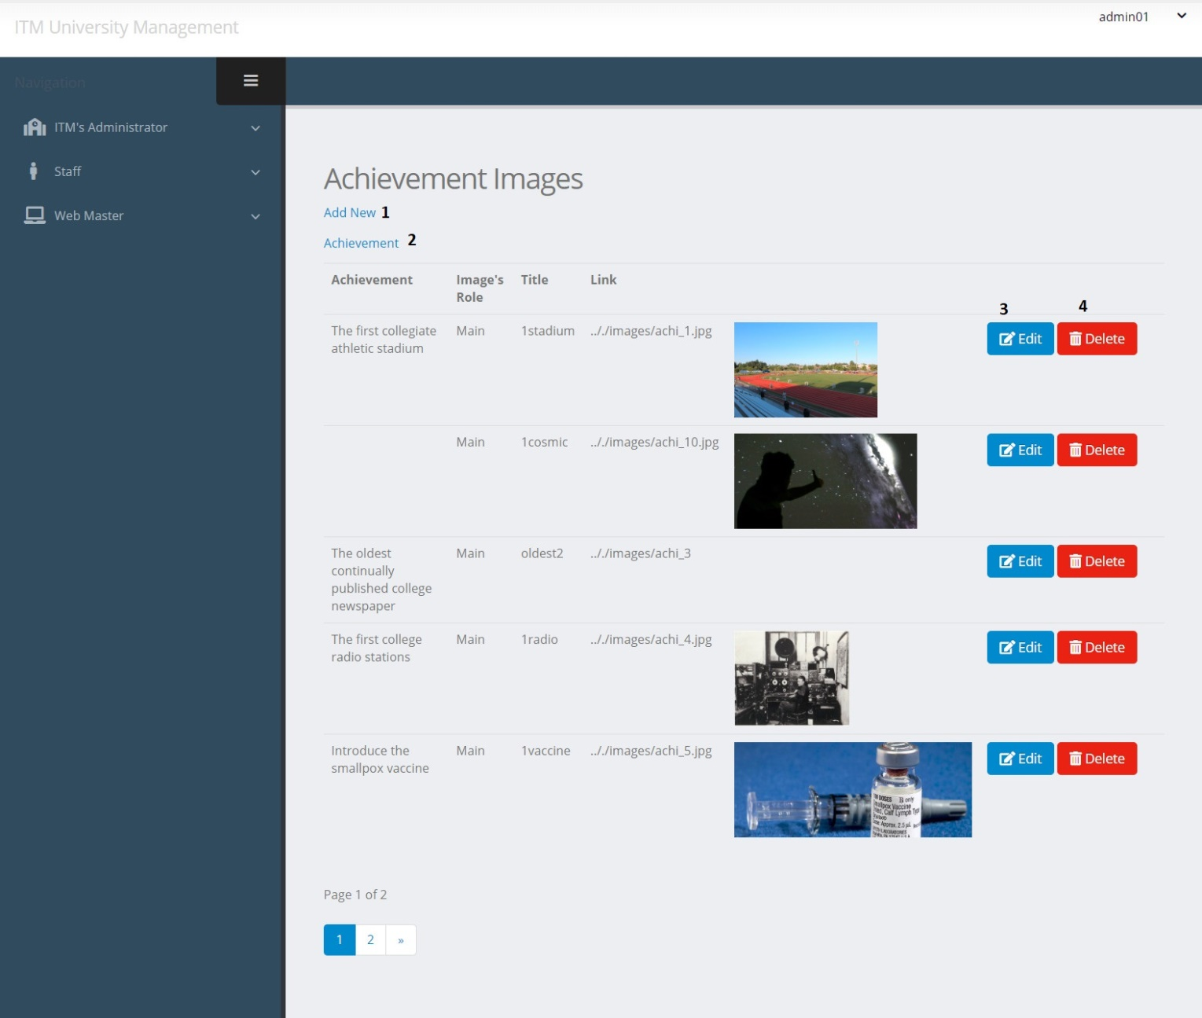

|  |  |  |  |  |  |  |
| --- | --- | --- | --- | --- | --- | --- |
| Achievement Image | | | | | | |
| No. | Name | Type | Validation | Event | Description | Status |
| 1 | btnCreate | Hyperlink |  | Click | Create new Achievement Image | Enable |
| 2 | Achievement | Hyperlink |  |  | View echievement list | Enable |
| 2 | btnEdit | Button |  | Click | Edit Achievement Image | Enable |
| 3 | btnDelete | Button |  | Click | Delete Achievement Image | Enable |

**c. Create Achievement Post**

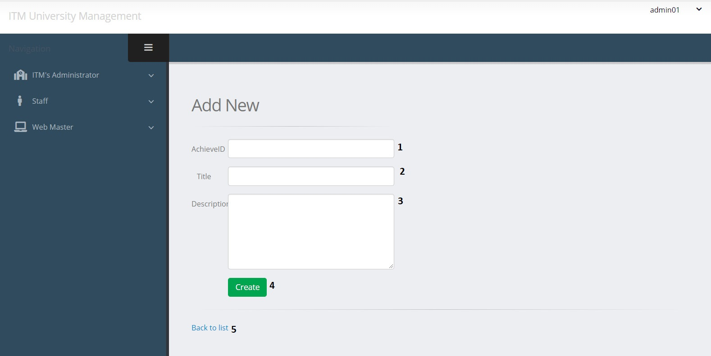

|  |  |  |  |  |  |  |
| --- | --- | --- | --- | --- | --- | --- |
| Create Achievement Post | | | | | | |
| No. | Name | Type | Validation | Event | Description | Status |
| 1 | AchieveID | TextField | 0 <= Length <= 30 | Input | Input Achivemen ID | Enable |
| 2 | Title | TextField | 0 <= Length <= 50 | Input | Input Achievement Title | Enable |
| 3 | Description | TextField |  | Input | Input Description about Achievement | Enable |
| 4 | btnCreate | Button |  | Click | Submit form Create | Enable |
| 5 | Back to list | Hyberlink |  | Click | View achievement list | Enable |

**d. Create Achievement Image**

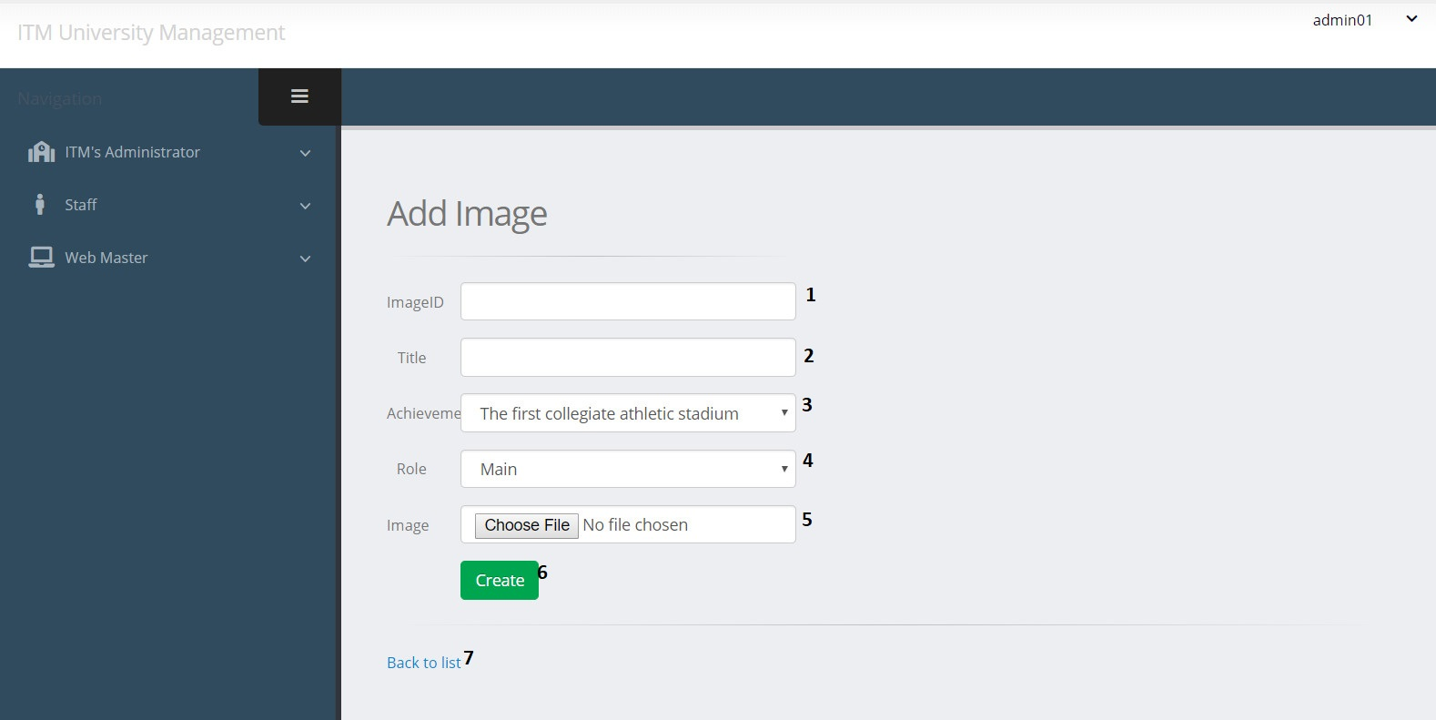

|  |  |  |  |  |  |  |
| --- | --- | --- | --- | --- | --- | --- |
| Create Achievement Image | | | | | | |
| No. | Name | Type | Validation | Event | Description | Status |
| 1 | ImageID | TextField | 0 <= Length <= 30 | Input | Input Image ID | Enable |
| 2 | ImgTitle | TextField | 0 <= Length <= 50 | Input | Input Image Title | Enable |
| 3 | AchievementID | Dropdown |  | Click | Choose Title Achievement | Enable |
| 4 | Role | Dropdown |  | Click | Choose Role | Enable |
| 5 | Link | File | 0 <= Length<= 100 | Click | Path of Image | Enable |
| 6 | btnCreate | Button |  | Click | Submit form Create | Enable |
| 7 | Back to list | Hyberlink |  | Click | View achievement image list | Enable |

**e. Edit Achievement Post**

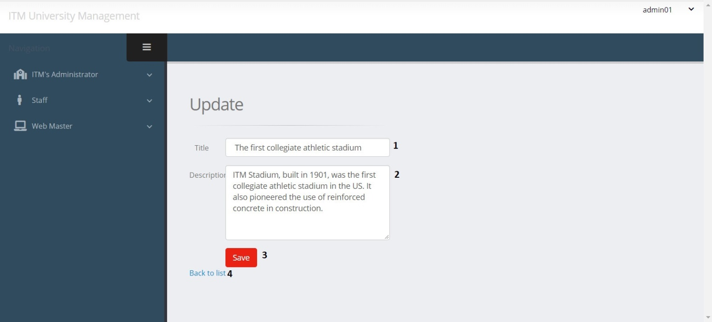

|  |  |  |  |  |  |  |
| --- | --- | --- | --- | --- | --- | --- |
| Edit Achievement Post | | | | | | |
| No. | Name | Type | Validation | Event | Description | Status |
| 1 | Title | TextField | 0 <= Length <= 50 | Input | Input Achievement Title | Enable |
| 2 | Description | TextField | Text | Input | Input Description about Achievement | Enable |
| 3 | btnSave | Button |  | Click | Submit form Edit | Enable |
| 4 | Back to list | Hyberlink |  | Click | View achievement list | Enable |

**f. Edit Achievement Image**

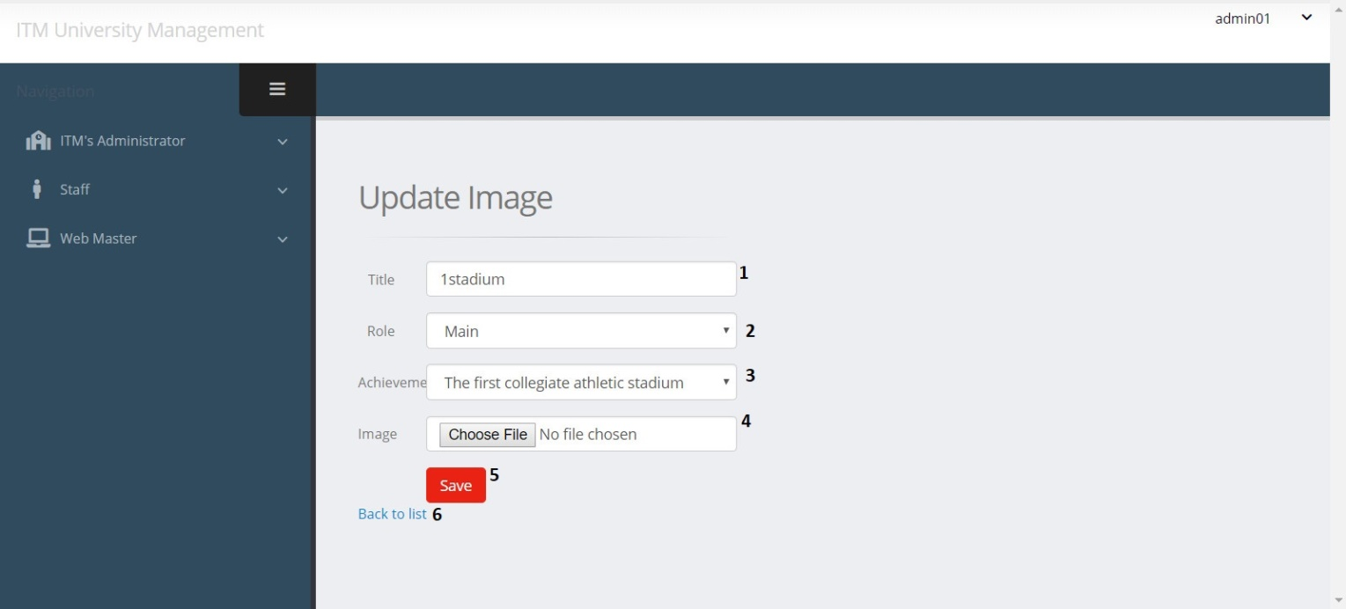

|  |  |  |  |  |  |  |
| --- | --- | --- | --- | --- | --- | --- |
| Edit Achievement Image | | | | | | |
| No. | Name | Type | Validation | Event | Description | Status |
| 1 | ImgTitle | TextField | 0 <= Length <= 30 | Input | Input Image Title | Enable |
| 2 | Role | Dropdown |  | Click | Choose Role | Enable |
| 3 | TitleAchie | Dropdown |  | Click | Choose Title Achievement | Enable |
| 4 | txtLink | File | 0 <= Length<= 100 | Click | Path of Image | Enable |
| 5 | btnSave | Button |  | Click | Submit form Edit | Enable |
| 6 | Back to list | Hyberlink |  | Click | View achievement image list | Enable |

1. Branch management:

**a. Branch Post List**

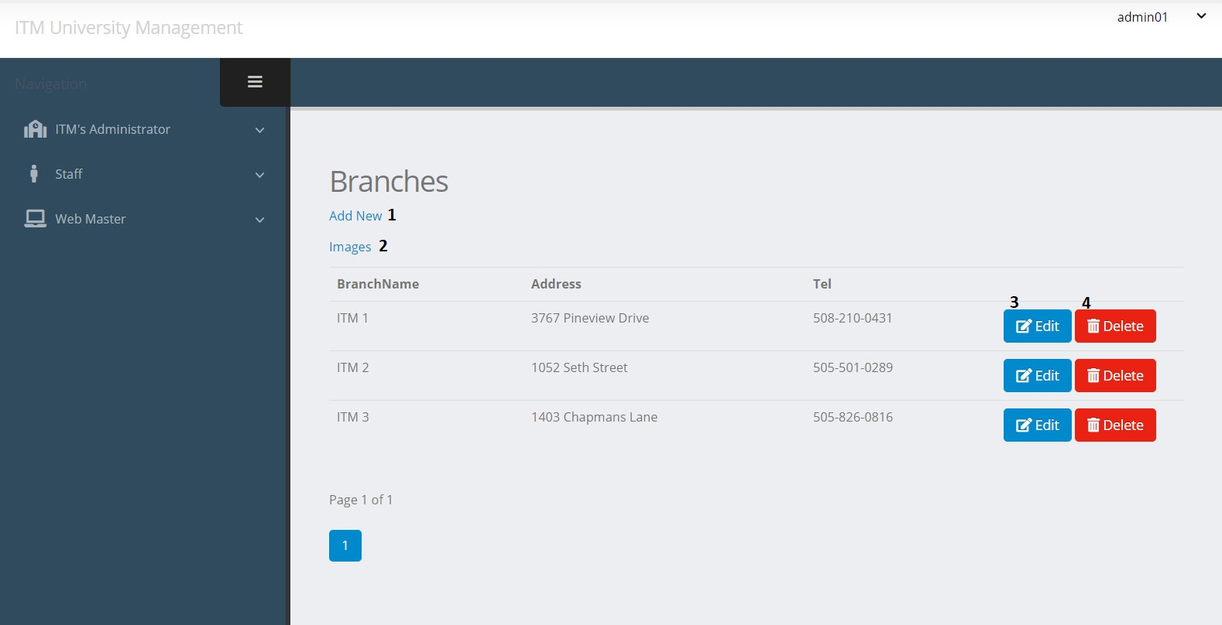

|  |  |  |  |  |  |  |
| --- | --- | --- | --- | --- | --- | --- |
| Branch Post | | | | | | |
| No. | Name | Type | Validation | Event | Description | Status |
| 1 | Create | Hyberlink |  | Click | URL to Create Action | Enable |
| 2 | Images | Hyberlink |  | Click | View branch image list | Enable |
| 3 | btnEdit | Button |  | Click | URL to Edit Action | Enable |
| 4 | btnDelete | Button |  | Click | URL to Delete Action | Enable |

**b. Branch Image List**

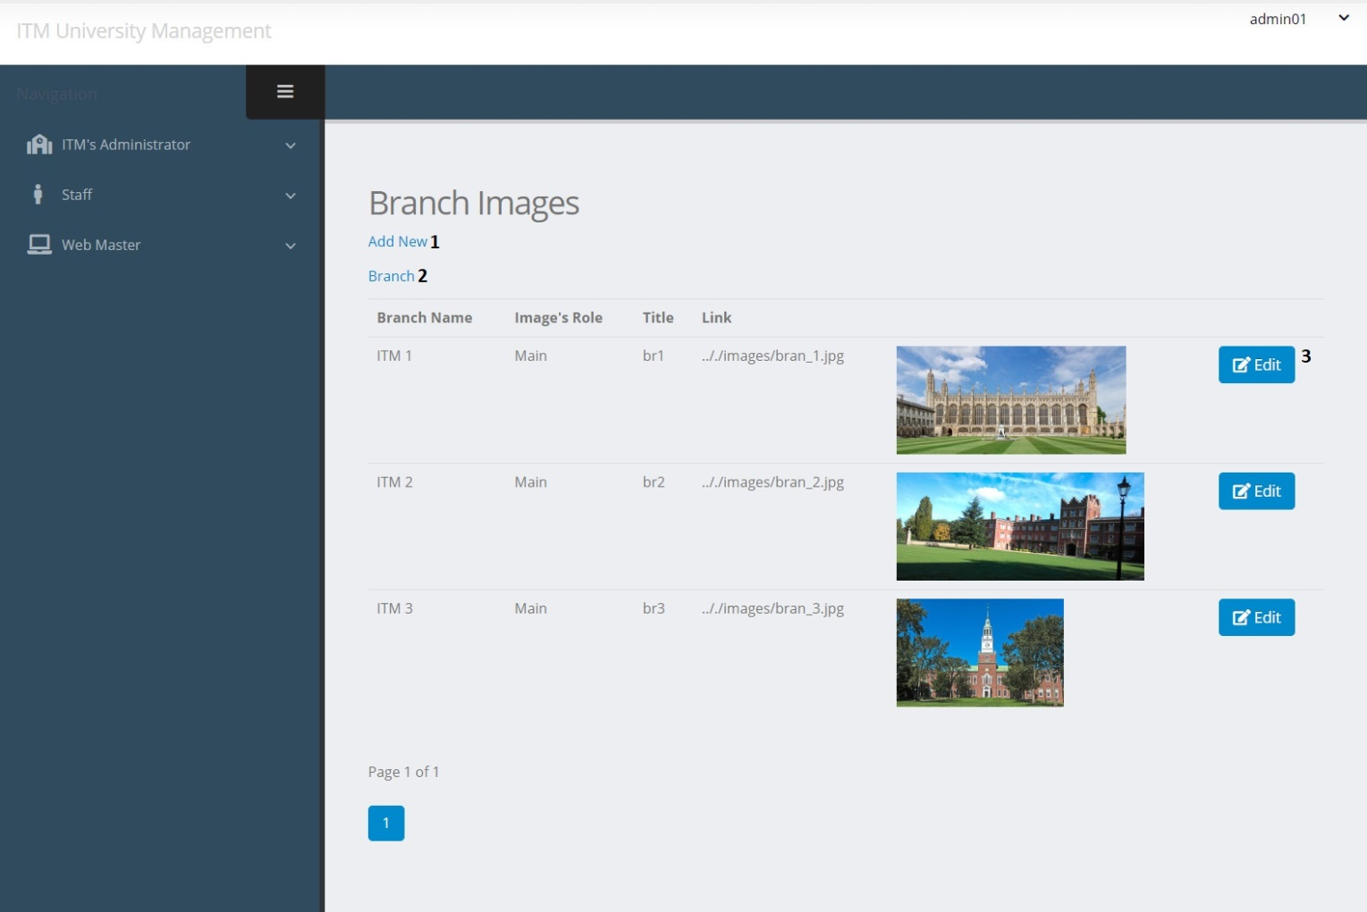

|  |  |  |  |  |  |  |
| --- | --- | --- | --- | --- | --- | --- |
| Branch Image | | | | | | |
| No. | Name | Type | Validation | Event | Description | Status |
| 1 | Create | Hyberlink |  | Click | URL to Create Action | Enable |
| 2 | Branch | Hyberlink |  | Click | View branch list | Enable |
| 2 | btnEdit | Button |  | Click | URL to Edit Action | Enable |
| 3 | btnDelete | Button |  | Click | URL to Delete Action | Enable |

**c. Create Branch Post**

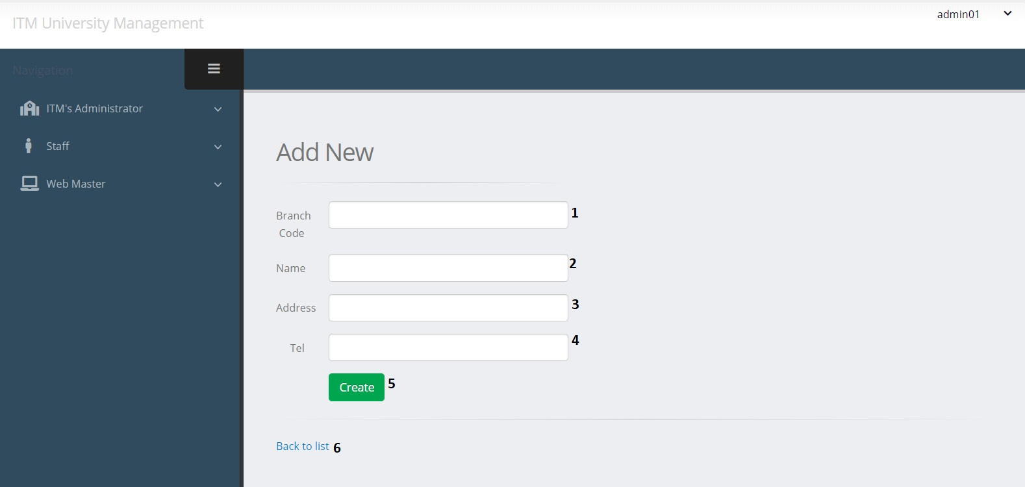

|  |  |  |  |  |  |  |
| --- | --- | --- | --- | --- | --- | --- |
| Create Branch Post | | | | | | |
| No. | Name | Type | Validation | Event | Description | Status |
| 1 | BranchCode | TextField | 0 <= Length <= 30 | Input | Branch ID | Enable |
| 2 | Name | TextField | Stringlength(50) | Input | Branch Name | Enable |
| 3 | Address | TextField | 0 <= Length<= 100 | Input | Branch Address | Enable |
| 4 | Tel | TextField | 0 <= Length <= 20 | Input | Branch Tel | Enable |
| 5 | btnCreate | Button |  | Click | Submit form Create | Enable |
| 6 | Back to list | Hyberlink |  | Click | View branch list | Enable |

**d. Create Branch Image**

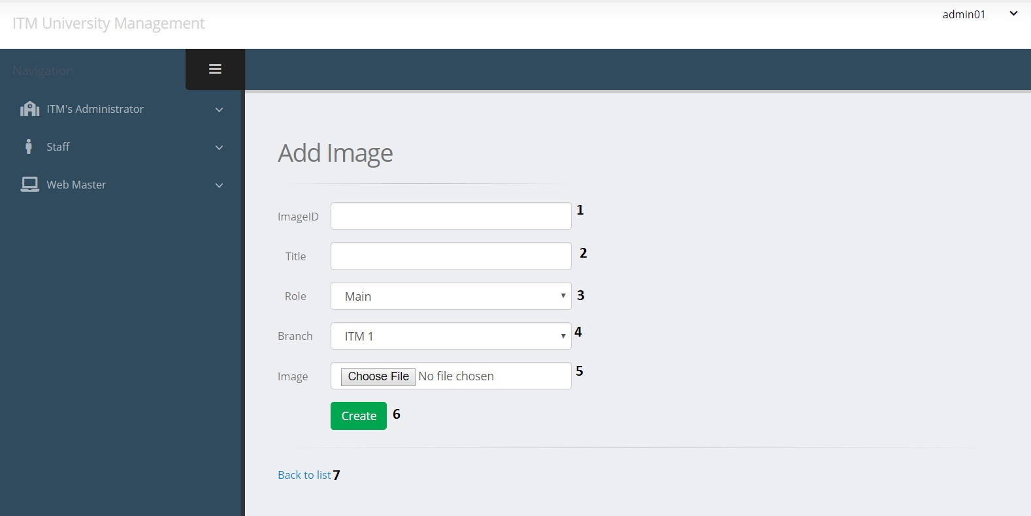

|  |  |  |  |  |  |  |
| --- | --- | --- | --- | --- | --- | --- |
| Create Branch Image | | | | | | |
| No. | Name | Type | Validation | Event | Description | Status |
| 1 | ImageID | TextField | 0 <= Length <= 30 | Input | Image ID | Enable |
| 2 | ImgTitle | TextField | 0 <= Length <= 50 | Input | Image Title | Enable |
| 3 | RoleID | Dropdown |  | Click | Choose Role ID for Image | Enable |
| 4 | BranchID | Dropdown |  | Click | Choose Branch | Enable |
| 5 | Link | File | 0 <= Length<= 100 | Click | Image path | Enable |
| 6 | btnCreate | Button |  | Click | Submit form Create | Enable |
| 7 | Back to list | Hyberlink |  | Click | View branch image list | Enable |

**e. Edit Branch Post**

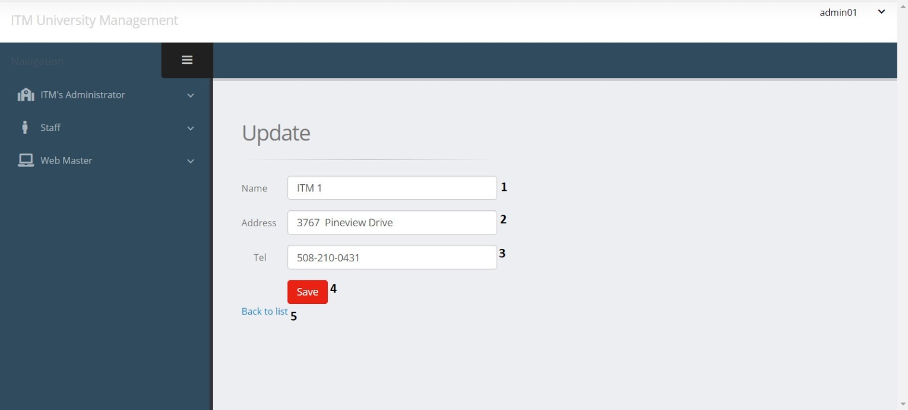

|  |  |  |  |  |  |  |
| --- | --- | --- | --- | --- | --- | --- |
| Edit Branch Post | | | | | | |
| No. | Name | Type | Validation | Event | Description | Status |
| 1 | Name | TextField | 0 <= Length <= 30 | Input | Branch Name | Enable |
| 2 | Address | TextField | 0 <= Length <=100 | Input | Branch Address | Enable |
| 3 | Tel | TextField | 0 <= Length <= 20 | Input | Branch Tel | Enable |
| 4 | btnSave | Button |  | Click | Submit form Edit | Enable |
| 5 | Back to list | Hyberlink |  | Click | View branch list | Enable |

**f. Edit Branch Image**

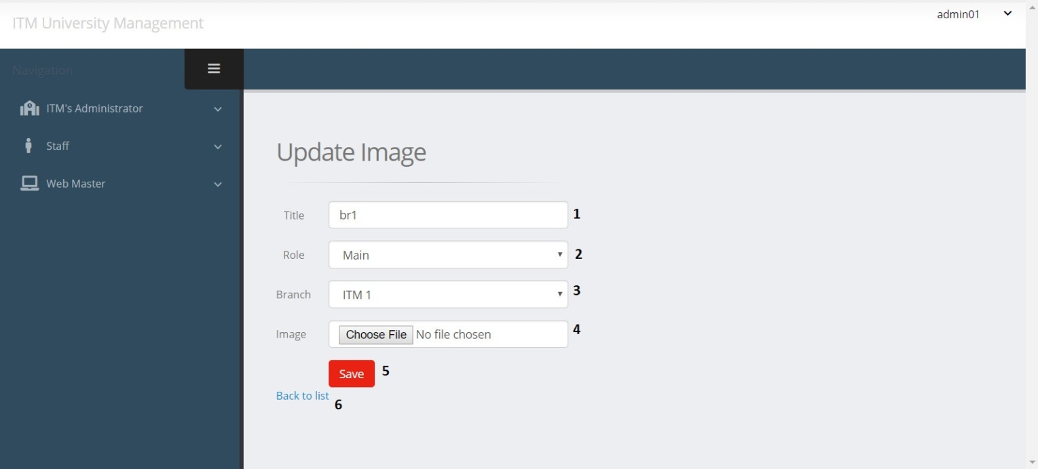

|  |  |  |  |  |  |  |
| --- | --- | --- | --- | --- | --- | --- |
| Edit Branch Image | | | | | | |
| No. | Name | Type | Validation | Event | Description | Status |
| 1 | ImgTitle | TextField | 0 <= Length <= 50 | Input | Image Title | Enable |
| 2 | RoleID | Dropdown |  | Click | Choose Role ID for3Image | Enable |
| 3 | BranchID | Dropdown |  | Click | Choose Branch | Enable |
| 4 | Link | File | 0 <= Length <= 100 | Click | Image path | Enable |
| 5 | btnSave | Button |  | Click | Submit form Edit | Enable |
| 6 | Back to list | Hyberlink |  | Click | View branch image list | Enable |

1. Admission management:

a. Admission List

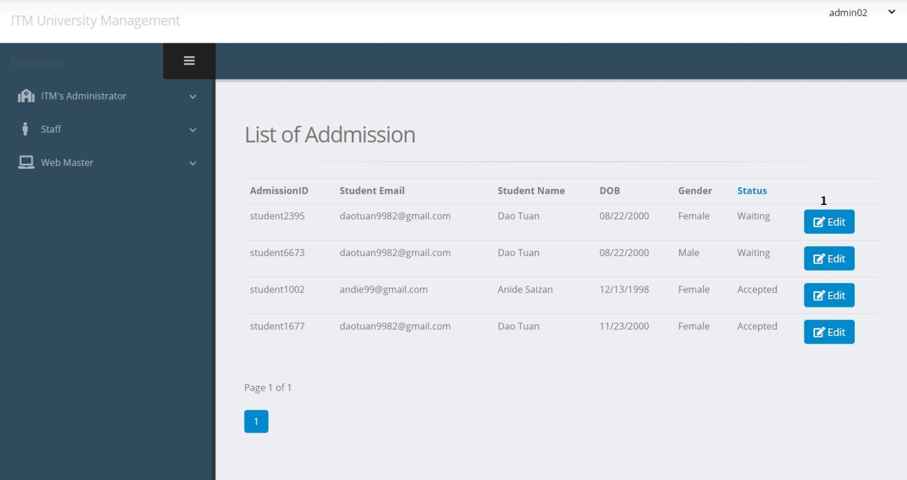

|  |  |  |  |  |  |  |
| --- | --- | --- | --- | --- | --- | --- |
| **Admissions List** | | | | | | |
| **No** | Name | Type | Validation | Event | Description | Status |
| **1** | btnEdit | button |  | Click | URL to Admission action (Staff controller) | Enable |
| **2** |  | button |  | Click | Get another admission | Enable |

b. Change Admission Status

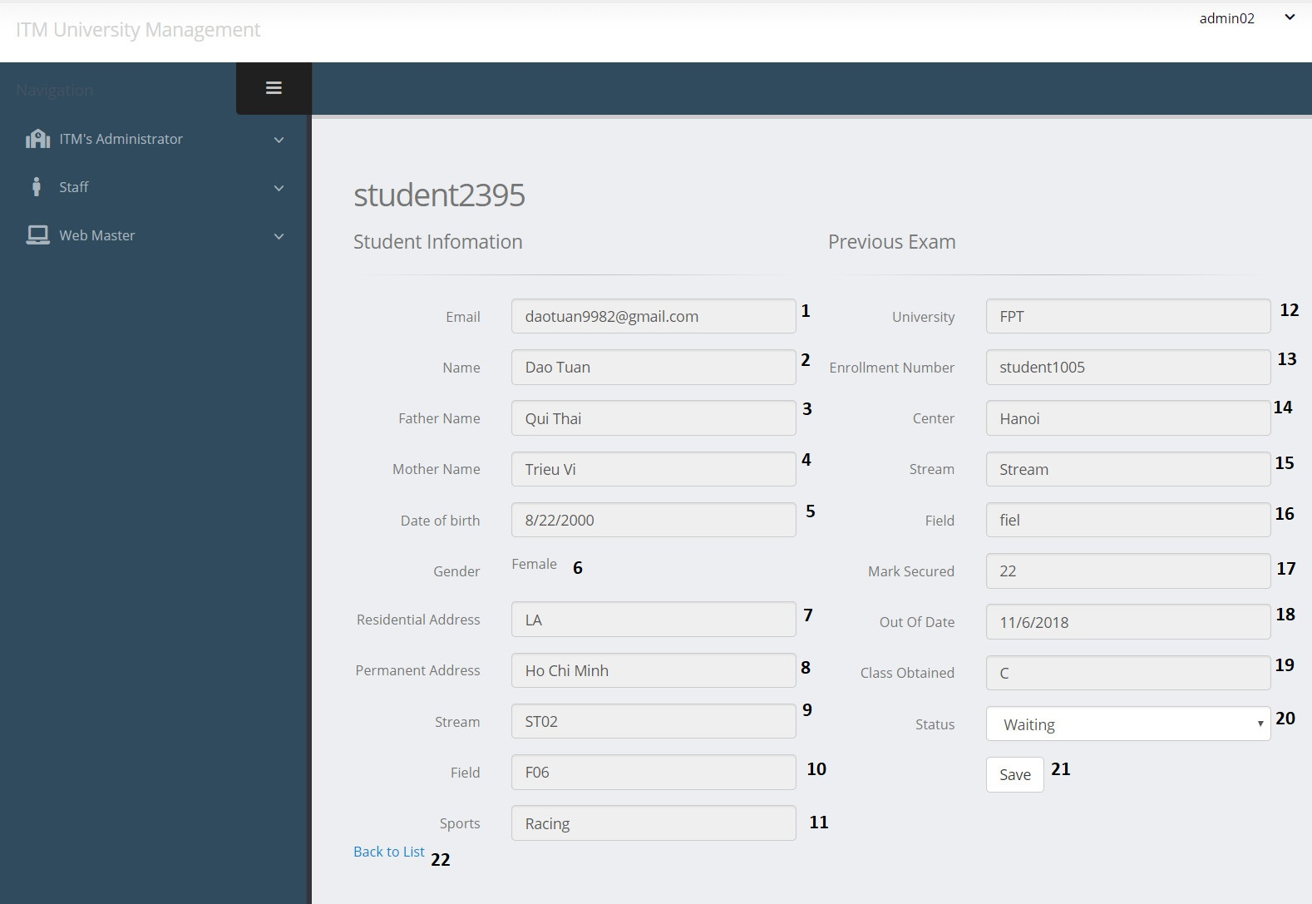

|  |  |  |  |  |  |  |
| --- | --- | --- | --- | --- | --- | --- |
| **Admission Form** | | | | | | |
| **No** | Name | Type | Validation | Event | Description | Status |
|  |  |  |  |  |  |  |
| **1** | StudentEmail | Text box |  |  | Display student email | Readonly |
| **2** | StudentName | Text box |  |  | Display student name | Readonly |
| **3** | FatherName | Text box |  |  | Display father name | Readonly |
| **4** | MotherName | Text box |  |  | Display mother name | Readonly |
| **5** | DoB | Text box |  |  | Display date of birth | Readonly |
| **6** |  | Text |  |  | Display gender | Readonly |
| **7** | Residential Adress | Text box |  |  | Display residential address | Readonly |
| **8** | Permanent Adress | Text box |  |  | Display permanent address | Readonly |
| **9** | tbStream.Name | Text box |  |  | Display stream name | Readonly |
| **10** | tbField.Name | Text box |  |  | Display field name | Readonly |
| **11** | SportsDetails | Text box |  |  | Display sports | Readonly |
| **12** | ExUniversity | Text box |  |  | Display previous university | Readonly |
| **13** | ExEnrollmentNumber | Text box |  |  | Display enrollment number (Previous Exam) | Readonly |
| **14** | ExCenter | Text box |  |  | Display center name (Previous Exam) | Readonly |
| **15** | ExStream | Text box |  |  | Display stream (Previous Exam) | Readonly |
| **16** | ExField | Text box |  |  | Display field  (Previous Exam) | Readonly |
| **17** | ExMarkSecured | Text box |  |  | Display mark secured  (Previous Exam) | Readonly |
| **18** | OutOfDate | Text box |  |  | Display out of date of previous exam | Readonly |
| **19** | ClassObtained | Text box |  |  | Display class obtained  (Previous Exam) | Readonly |
| **20** | StatusID | Dropdown list |  | Select option | Input status (default = 0 : Waiting,  -1: Rejected,  1: Accepted) | Enable |
| **21** | btnSave | Button |  | Click | Save admission | Enable |

1. Admin management:

a. Admin List

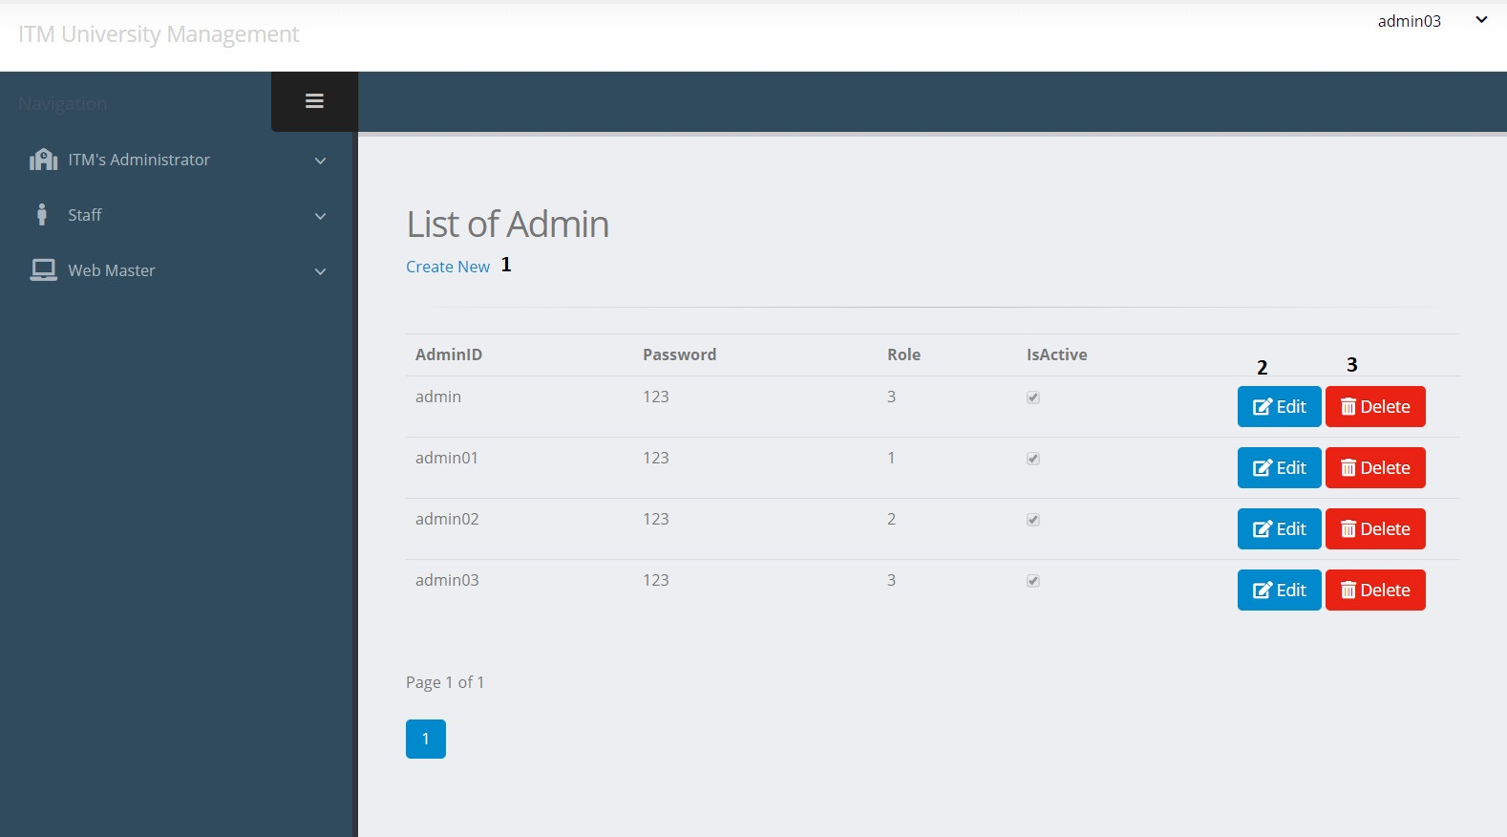

|  |  |  |  |  |  |  |
| --- | --- | --- | --- | --- | --- | --- |
| **Admins page** | | | | | | |
| **No** | Name | Type | Validation | Event | Description | Status |
| **1** | btnCreate | Hyperlink |  | Click | Create new admin account | Enable |
| **2** | btnEdit | Button |  | Click | URL to edit action | Enable |
| **3** | btnDelete | Button |  | Click | URL to Delete action | Enable |

b. Create Admin Account

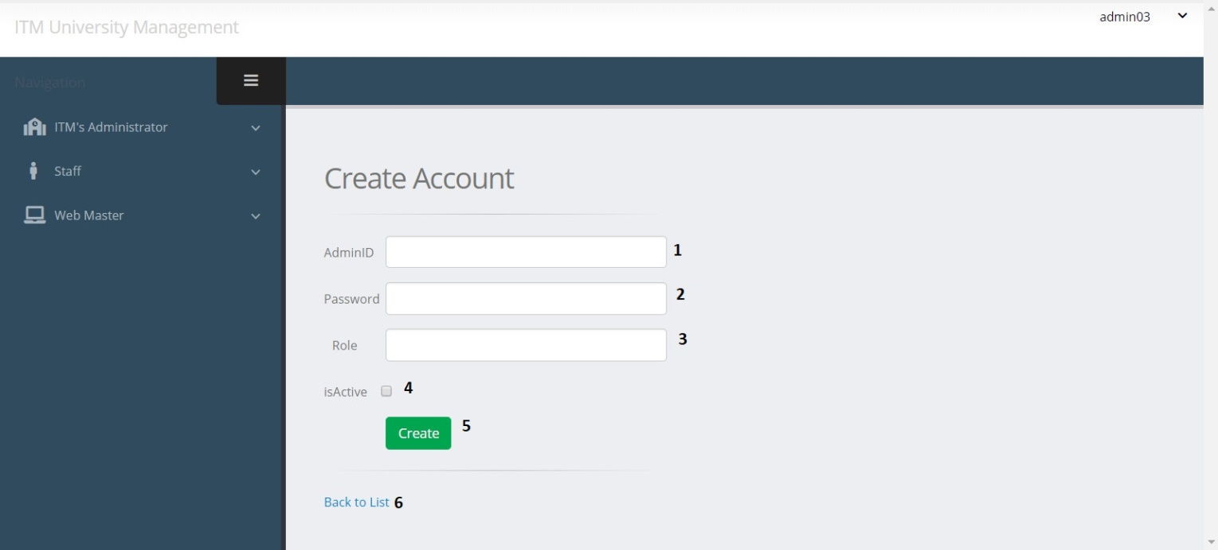

|  |  |  |  |  |  |  |
| --- | --- | --- | --- | --- | --- | --- |
| **Create admin form** | | | | | | |
| **No** | Name | Type | Validation | Event | Description | Status |
| **1** | AdminID | Text box | Not null | Input | Input admin ID | Enable |
| **2** | Password | Text box | Not null | Input | Input admin password | Enable |
| **3** | Role | Text box | 0<value<4 | Input | Input admin role | Enable |
| **4** | isActive | Check box |  | Click | Input account status | Enable |
| **5** | btnCreate | Button |  | Click | Submit form | Enable |
| **6** | btnLink | button |  | Click | URL to AdminList action | Enable |

c. Edit Admin Account

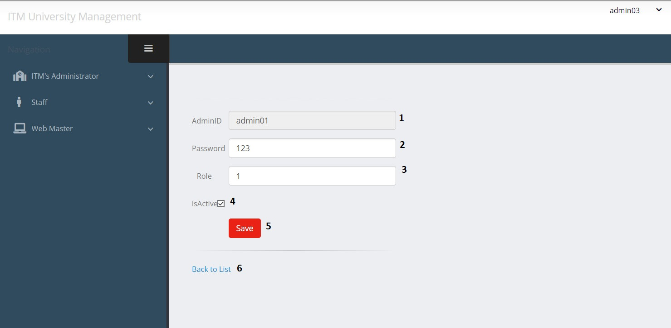

|  |  |  |  |  |  |  |
| --- | --- | --- | --- | --- | --- | --- |
| **Create admin form** | | | | | | |
| **No** | Name | Type | Validation | Event | Description | Status |
| **1** | AdminID | Text box |  |  | Display Admin ID | Disable |
| **2** | Password | Text box | Not null | Input | Input admin password | Enable |
| **3** | Role | Text box | 0<value<4 | Input | Input admin role | Enable |
| **4** | isActive | Check box |  | Click | Input account status | Enable |
| **5** | btnSave | Button |  | Click | Submit form | Enable |
| **6** | btnLink | button |  | Click | URL to AdminList action (Admin controller ) | Enable |

**Task Sheet Review III**

|  |  |  |  |  |  |
| --- | --- | --- | --- | --- | --- |
| Project Ref. No: 4 | Project Title:  Railway Reservation Manage System | Date of Preparation of Activity Plan | | | |
| No. | Task | Actual Start Date | Actual Days | Team Member Names | Status |
| 01 | Database Diagram | Nov-13,2018 | 2 | Thach Bao Toan | Completed |
| 02 | Database Structure | Tran Ha Hung | Completed |
| 03 | GUI Design Front-End | Hac Ngoc Linh | Completed |
| 04 | GUI Design Back-End | Vuong Ba Phi | Completed |

|  |  |  |
| --- | --- | --- |
|  | Prepare By: Group 4 | Approved By: Faculty |
| Date: Nov-13,2018 | Team Leader  Hac Ngoc Linh | Mr. Tran Phuoc Sinh |